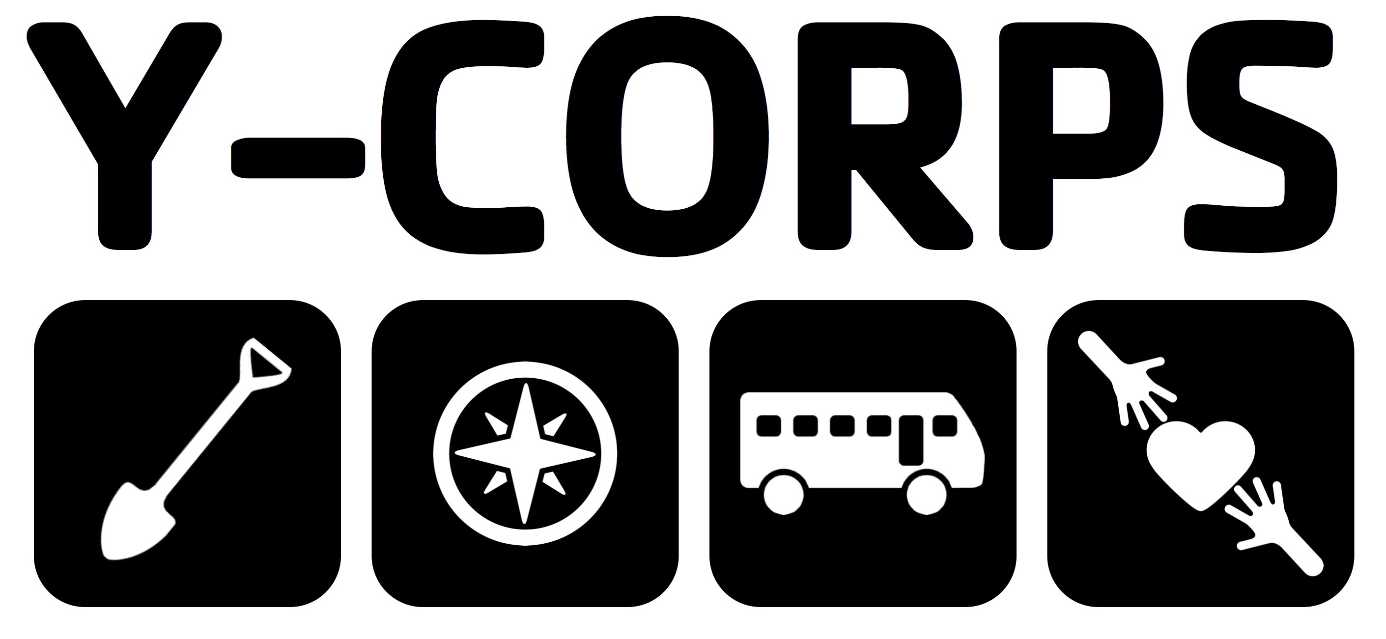
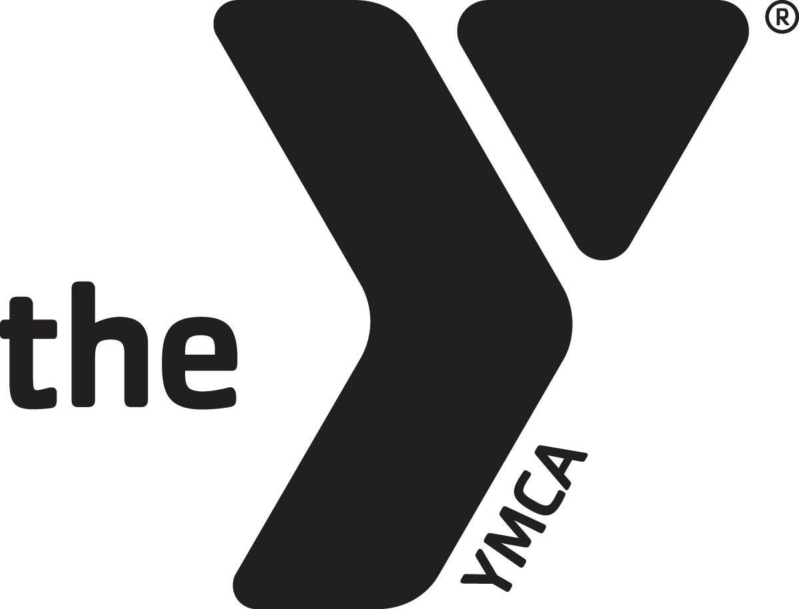

Month Date, Year

Dear Donor Name,

My name is Your Name and I am a Your Grade at Your School. This year, I’ve been selected to serve as part of Y-Corps, a service-learning program of the Kentucky YMCA.

As a member of Y-Corps, I’ll be performing Your Goal # hours service in my community, raising money to create Your Goal # of scholarships for the YMCA’s scholarship fund, and serving as an advocate for the Y movement. At the end of the program, I’ll travel with my Y-Corps Service to the Team Name team performing service projects, staying at local YMCAs, and learning about the communities we serve.

To reach my goal of creating # scholarships, I’ll need to fundraise at least $, and I am reaching out to members of my community like you to help provide students around Kentucky with the opportunity to participate in YMCA programs.

Every penny we raise through Y-Corps goes directly to students who otherwise could not afford to attend our YMCA Youth and Government and Leadership Development programs.

Share your Y-Story – Ex: When I started attending our Kentucky United Nations Assembly (KUNA) in 6th grade, I was unable to grasp how so many cultures could be so different than the one I’d grown up in. Through KUNA, I saw the world from a new perspective, and learned how different cultures can come together to make positive change.

I want to ensure that other students have the same opportunities I’ve had, and I’m asking you to help make that possible! $65 sends a student one of our many YMCA programs, and $125 provides a scholarship to both our Kentucky Youth Assembly (KYA) and Kentucky United Nations Assembly. Any gift – of any amount – can make a world of difference, and all donations are tax-deductible.

There are two ways you can give:

1. Online – donate via my personal fundraising page: give.kyymca.org/yourname
2. Mail Cash/Check – mail donations to my address at the bottom of this letter!

Please feel free to contact me directly if you have any questions about the Kentucky YMCA, Y-Corps, or the impact of your support!

Gratefully,

Your Name (Leave space above for your signature!)

Your Street Address
City, KY Zip Code
Your Email Address
Your Cell Phone #

Change the highlighted fields to match your personal information. Feel free to make additional edits so you’re comfortable sending this to your supporters!

