

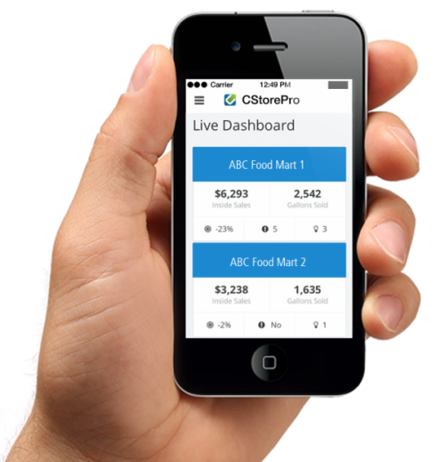
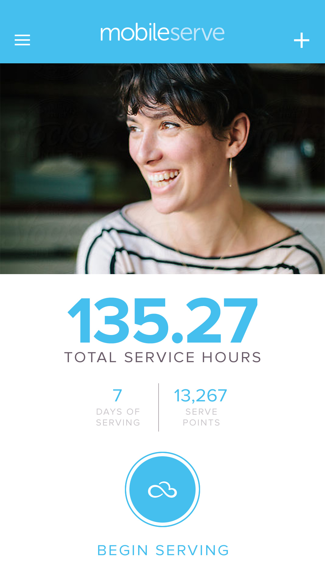

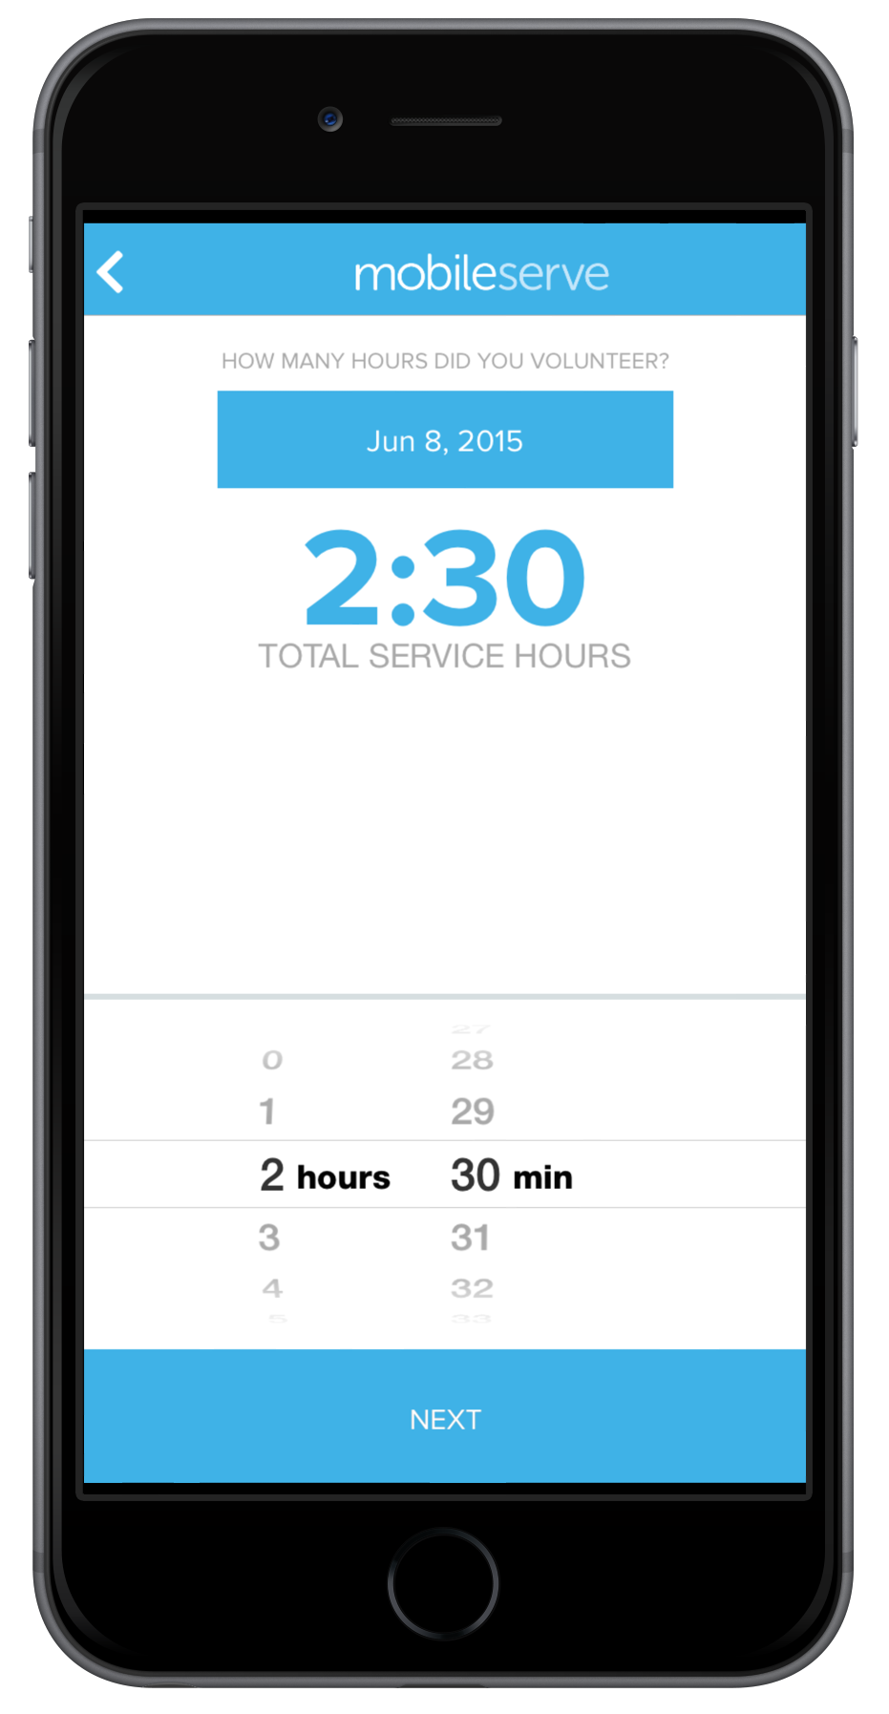
Product Overview
Log, Verify, Aggregate
MobileServe allows users to easily check-in to service sites and log volunteer hours in real-time. Users can document location, duration and a description of their volunteer experience. Hours can be verified both through our GPS check-in and email confirmations with volunteer supervisors. Hours logged by your MobileServe users are logged, aggregated and organized for you to access throughout the year.

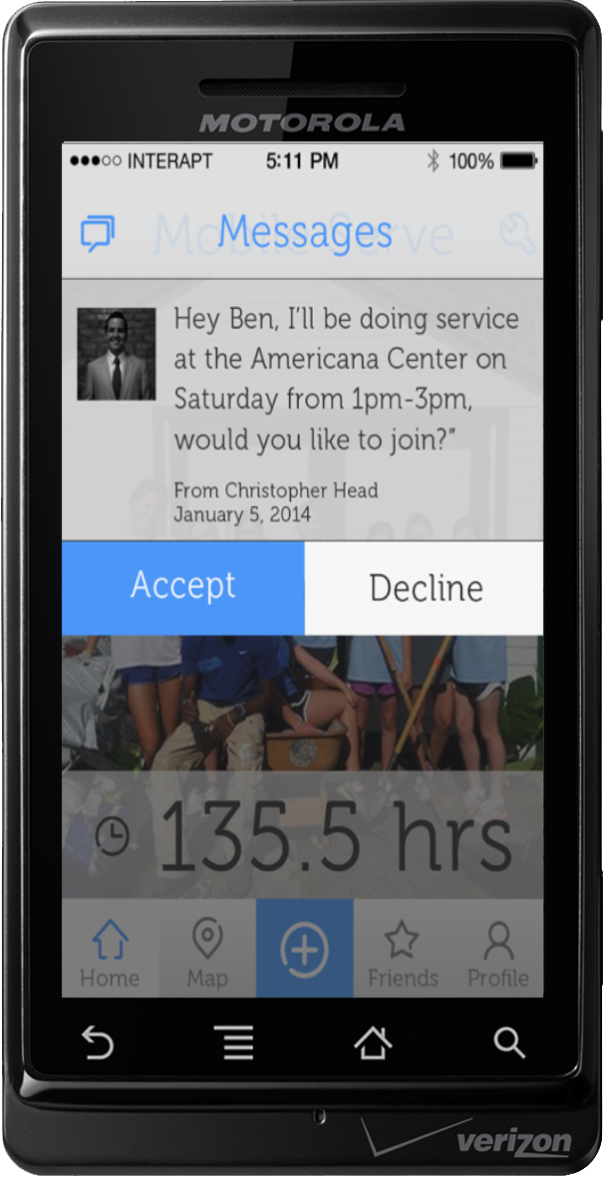
Connect, Communicate, Share
MobileServe’s social network connects users to each other and to the broader service community. Users can invite friends to service opportunities, see where their friends are serving and join in, and challenge other student organizations to do service. Users can also post real-time updates and photos to social media sites, while MobileServe streams those posts to your organization’s website.


Narrate, Encourage, Inspire!
MobileServe’s integration with social media sites helps each of your users become an agent of change. Users will help you tell the story of the work your organization is doing in the community. Encourage others to explore ways of positively impacting their communities by creating space for your organization to publicly model a culture of service.



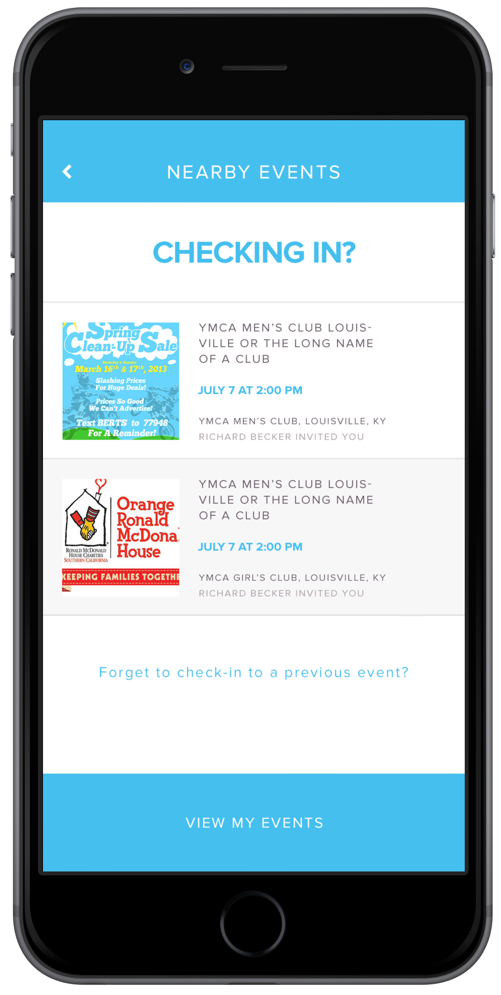
Promote, Manage, Track Attendance
MobileServe allows you to send calendar invites for service opportunities to your entire group. Users can accept/decline invitations for easy attendance tracking. Admin can modify events and send updates to attendees. Event participants receive periodic reminders and updates about upcoming projects on their calendar.

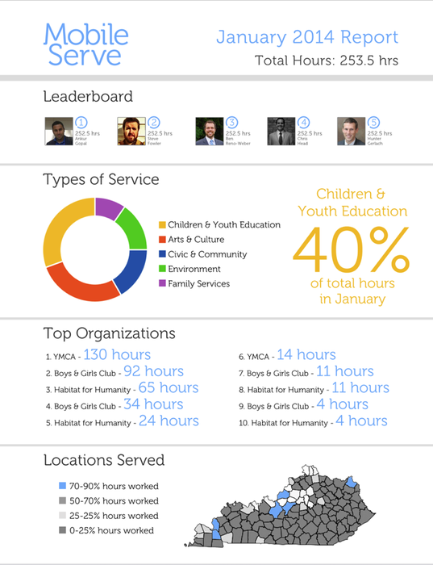
Organize, Report, Publish
MobileServe helps you build service into your organization’s branding, marketing and communications. Our administrative dashboard aggregates and organizes all your service data and generates a visually compelling service report. Tell the story of your organization’s service by displaying the data your audience is most interested in: total hours served, types of service completed, areas and populations reached. Easily download, export or publish your report to newsletters, annual reports, and recruiting materials.

