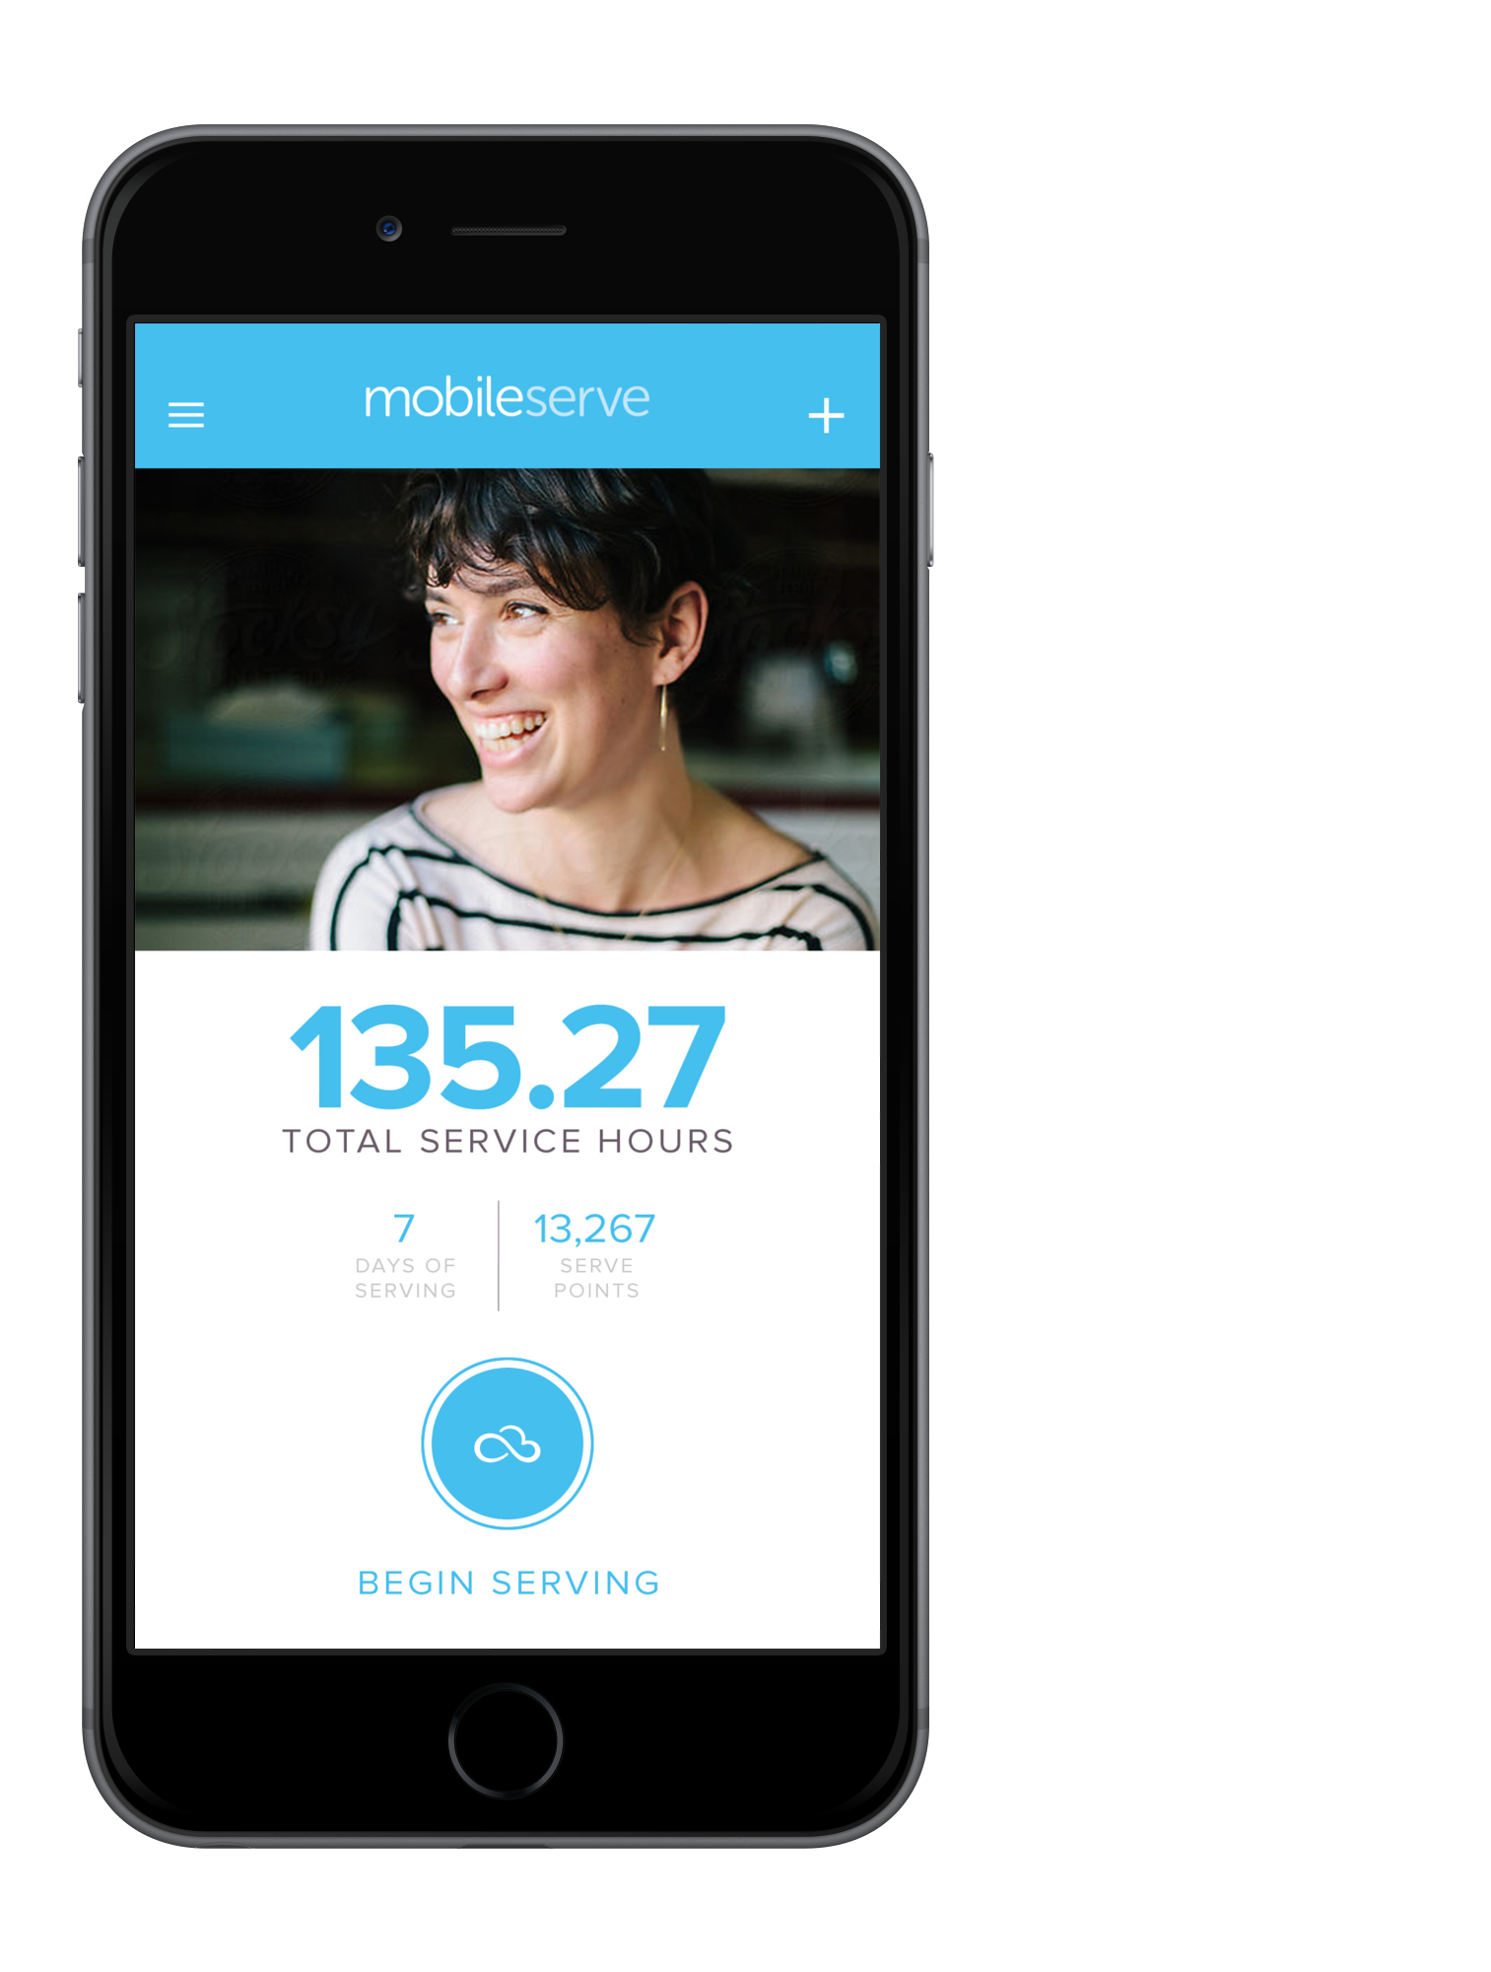
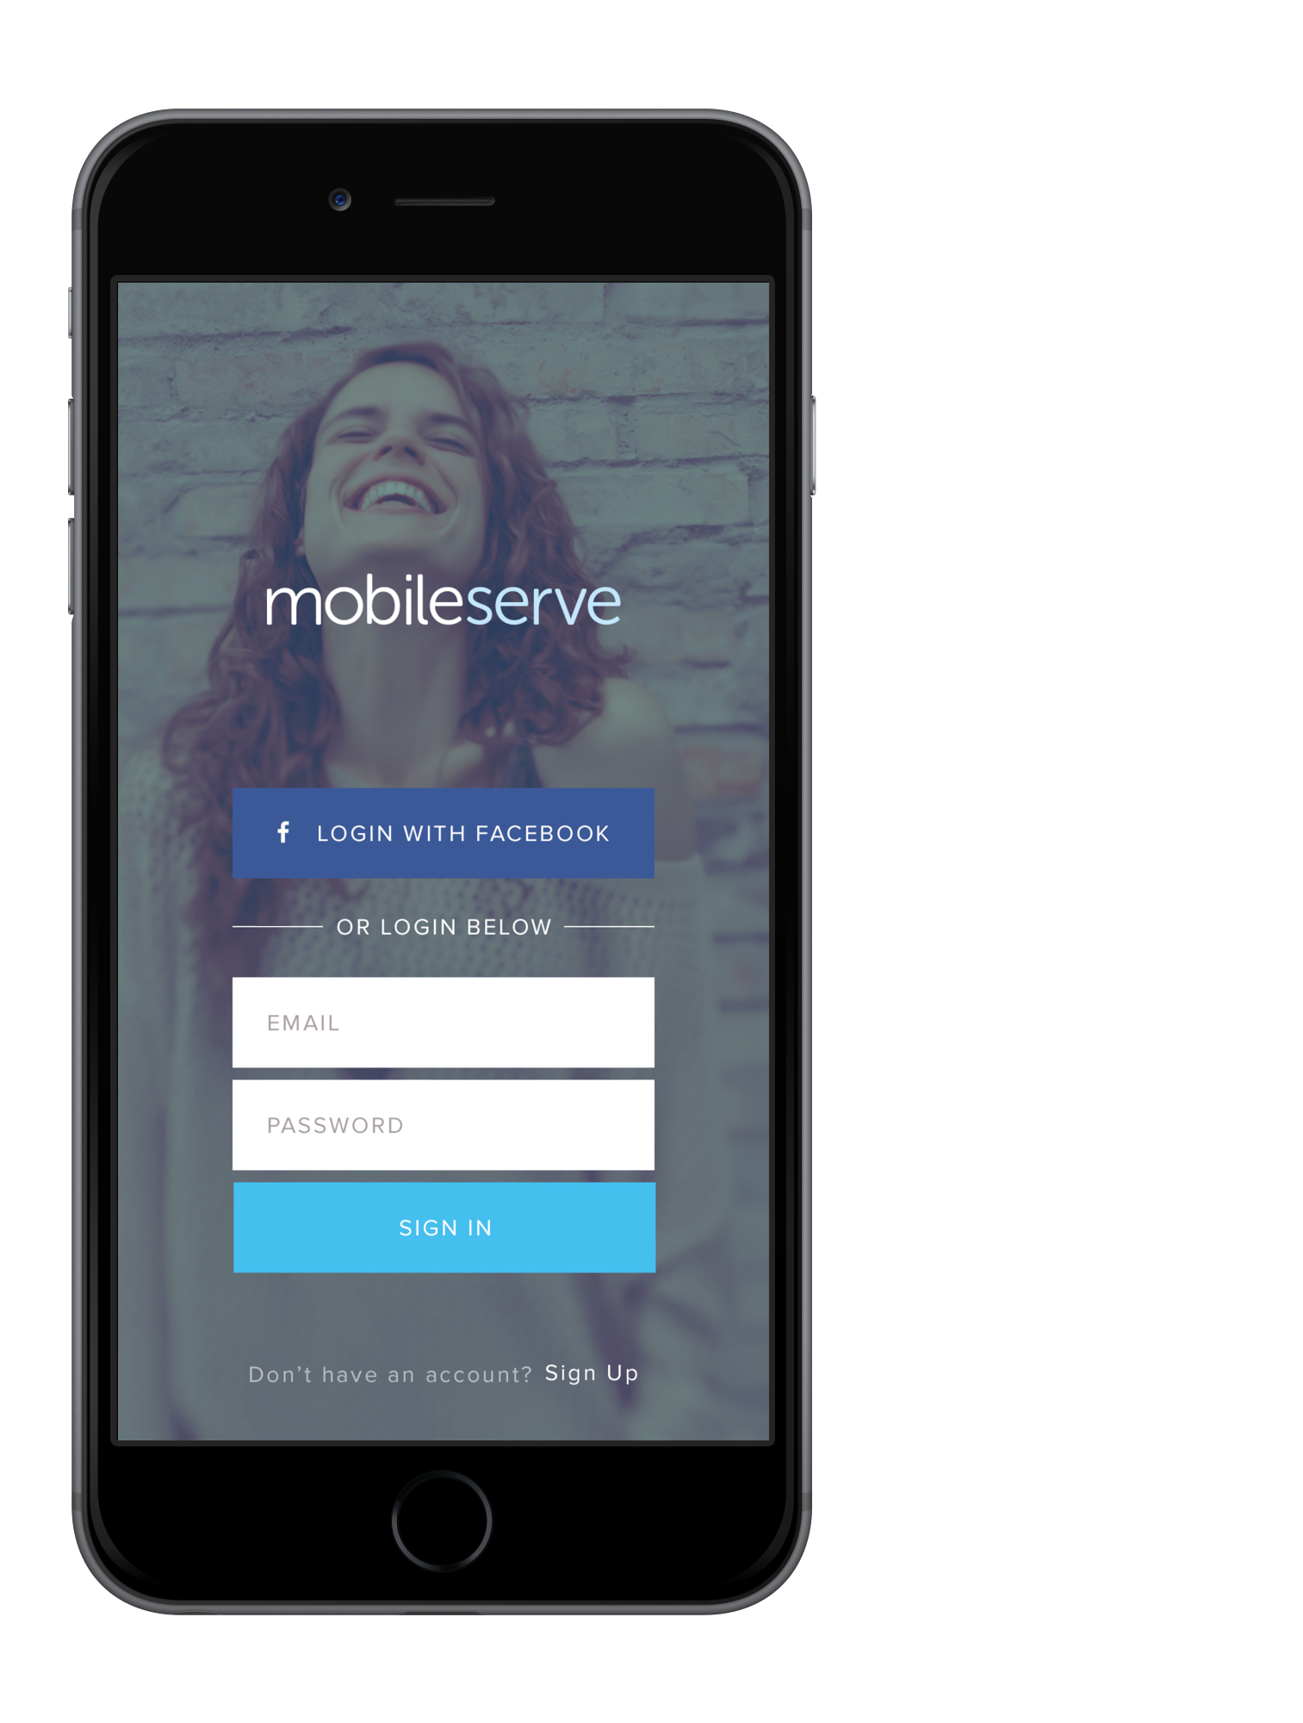
Step 1:
Go to
App.MobileServe.org
Or Download from IOS Store

Step 2:
Create Account and
Enter Organization’s Code

Step 3:
Volunteer!

Step 4:
Log Your Hours

Step 5:
Take Photos and Share on Social Media!

