Case No. 837

Case Concerning the Arrest Warrant of 11 April 2000: Democratic Republic of the Congo v. Belgium (2002)

Applicant: Democratic Republic of the Congo

Respondent: Kingdom of Belgium

Case No. 837 is a closed case. The enclosed record contains the only references permissible to bring forth before the United Nations International Court of Justice. Mention of materials outside this record constitute grounds for dismissal.

Table of Contents

Case Brief

Statement of Fact

Questions before the Court

Opinions of the Court
Summary of Opinions
Judgment (Majority Opinion)
Dissenting Opinion, Judge Van Den Wyngaert

Appendix I: Universal Declaration of Human Rights

Case Brief
Citation. I.C.J. 2002 I.C.J. 3.
Synopsis of Rule of Law. Where a foreign minister is suspected of humanitarian violations, such a minister enjoys full immunity from criminal jurisdiction in another state’s court.
Facts. The Belgian law provides for universal jurisdiction in the case of grave breaches of the Geneva Conventions, crimes against humanity and other serious offenses. Relying on this law, a Belgian judge issued an international arrest warrant for the foreign minister of the D.R.C (P) on the premise of grave violations of humanitarian laws to be tried in Belgium. The Belgium law also denotes that any immunity which is conferred by an individual’s official capacity does not curtail the application of universal jurisdiction.
The arrest warrant was circulated internationally and the International Criminal Police Organization (Interpol) was also notified. This action of Belgium was therefore the basis of D.R.C. (P) suit against it at the International Court of Justice (I.C.J.). The D.R.C. (P) asserted that the warrant against its foreign minister was a clear violation of international law because Belgium purported by this act to exercise jurisdiction over its foreign minister.
D.R.C. (P) also claimed that its minister should also enjoy immunity equivalent to that enjoyed by diplomats and heads of states. In addition to this, the plaintiff also sought an order of provisional measures of protection on the ground that the warrant effectively curtailed the foreign minister from leaving the D.R.C. (p). The I.C.J. thus gave its judgment on this case.
Issue. Where a foreign minister is suspected of humanitarian violations, does such a minister enjoy full immunity from criminal jurisdiction in another state’s court?
Held. Yes. Where a foreign minister is suspected of humanitarian violations and even war crimes, such a minister enjoys full immunity from criminal jurisdiction in another state’s court. Acting as the state’s representative in international meeting and negotiations, travelling internationally and overseeing the smooth running of the state’s diplomatic activities are duties which a foreign minister performs. The foreign minister also has the power to bind the state in the course of his duties and he must be in constant communication with his state and its diplomatic missions around the world as well as with representatives of other states. Hence, because of the office he holds and not because of his person, a minister is recognized under international law as a representative of the state.
Drawing from this submission, it can therefore be established that an acting Minister of Foreign Affairs enjoys full immunity from criminal jurisdiction and inviolability so that he or she may not be hindered in the discharge of his or her duties. The safety nest provided by this immunity is regardless of whether the purported crimes were committed in the minister’s “official or private” capacity and regardless of when the offense occurred. Hence on this premise, the argument of Belgium that immunities is not applicable to foreign ministers when they are accused of committing war crimes or crimes against humanity is nullified.
However and with much emphasis, immunity from jurisdiction which a serving minister enjoys does not imply that such minister take pleasure for the crimes he or she commits of have committed. As jurisdictional immunity is procedural, so too is criminal responsibility a matter of substantive law, so that jurisdictional immunity does not operate to exempt the minister who may under certain circumstances, be held accountable for his crimes.
The minister may thus be brought before the courts in his/her own state and may lose his/her immunity once his/her state waives it. The minister also do not enjoy such immunity after he vacates office and may subsequently be charged for acts committed prior to or subsequent to the time he/she was in office as well as in respect of acts committed during the time he/she was in office in a private capacity. The International criminal courts may also try the minister where they have the jurisdiction to do so.

CaseBriefs

Statement of Fact

On 11 April 2000 an investigating judge of the Brussels Tribunal de première instance issued "an international arrest warrant in abstentia" against Mr. Abdulaye Yerodia Ndombasi, charging him, as perpetrator or co-perpetrator, with offences constituting grave breaches of the Geneva Conventions of 1949 and of the Additional Protocols thereto, and with crimes against humanity.

At the time when the arrest warrant was issued Mr. Yerodia was the Minister for Foreign. Affairs of the Congo.

The arrest warrant was transmitted to the Congo on 7 June 2000, being received by the Congolese authorities on 12 July 2000. According to Belgium, the warrant was at the same time transmitted to the International Criminal Police Organization (Interpol), an organization whose function is to enhance and facilitate cross.border criminal police co-operation worldwide; through the latter, it \vas circulated internationally.

In the arrest warrant, Mr. Yerodia is accused of having made various speeches inciting, racial hatred during the month of August 1998. The crimes with which Mr. Yerodia was charged were punishable in Belgium under the Law of 16 June 1993 "concerning the Punishment of Grave Breaches of the International Geneva Conventions of 12 August 1949 and of Protocols 1 and II of 8 June 1977 Additional Thereto", as amended by the Law of 10 February 1999 "concerning the Punishment of Serious Violations of International Humanitarian Law" (hereinafter referred to as the "Belgian Law").

Article 7 of the Belgian Law provides that "The Belgian courts shall have jurisdiction in respect of the offences provided for in the present Law. wheresoever they may have been committed". In the present case, according to Belgium. the complaints that initiated the proceedings as a result of which the arrest warrant was issued emanated from 12 individuals all resident in Belgium, five of whom were of Belgian nationality. It is not contested by Belgium, however, that the alleged acts to which the arrest warrant relates were committed outside Belgian territory, that Mr. Yerodia was not a Belgian national at the time of those acts, and that Mr. Yerodia was not in Belgian territory at the time that the arrest warrant was issued and circulated. That no Belgian nationals were victims of the violence that was said to have resulted from Mr. Yerodia's alleged offences was also uncontested.

Article 5, paragraph 3, of the Belgian Law further provides that "[immunity attaching to the official capacity of a person shall not prevent the application of the present Law".

At the hearing, Belgium further claimed that it offered "to entrust the case to the competent authorities [of the Congo] for enquiry and possible prosecution", and referred to a certain nu~nber of steps which it claimed to have taken in this regard from September 2000, that is, before the filing of the Application instituting proceedings. The Congo for its part stated the following: "We have scant information concerning the form [of these Belgian proposals]." It added that "these proposals . . . appear to have been made very belatedly, namely after an arrest warrant against Mr. Yerodia had been issued".

On 17 October 2000, the Congo filed in the Registry an Application instituting the present proceedings (see paragi aph 1 above), in which the Court was requested "to declare that the Kingdom of Belgium shall annul the international arrest warrant issued o~i 11 April 2000". The Congo relied in its, Application on two separate legal grounds. First, it claimed that "[t]he universal jurisdiction that the Belgian State attributes to itself under Article 7 of the Law in question" constituted a

"[v]iolation of the principle that a State may not exercise its authority on the territory of another State and of the principle of sovereign equality among all Members of the United Nations, as laid down in Article 2, paragraph 1, of the Charter of the United Nations".

Secondly, it claimed that "[t]he non-recognition, on the basis of Article 5 . . . of the Belgian Law, of the immunity of a Minister for Foreign Affairs in office" constituted a "[v]iolation of the diplomatic immunity of the Minister for Foreign Affairs of a sovereign State, as recognized by the jurisprudence of the Court and following from Article 41, paragraph 2, of the Vienna Convention of 18 April 1961 on Diplomatic Relations".

On the same day that it filed its Application instituting proceedings, the Congo submitted a request to the Court for the indication of a provisional measure under Article 41 of the Statute of the Court. During the hearings devoted to consideration of that request, the Court was informed that in November 2000 a ministerial reshuffle had taken place in the Congo, following which Mr. Yerodia had ceased to hold office as Minister for Foreign Affairs and had been entrusted with the portfolio of Minister of Education. Belgium accordingly claimed that the Congo's Application had become moot and asked the Court, as has already been recalled, to remove the case from the List. By Order of 8 December 2000, the Court rejected both Belgium's submissions to that effect and also the Congo's request for the indication of provisional measures (see paragraph 4 above).

From mid-April 2001, with the formation of a new Government in the Congo, Mr. Yerodia ceased to hold the post of Minister of Education. He no longer holds any ministerial office today.

On 12 September 2001, the Belgian National Central Bureau of Interpol requested the Interpol General Secretariat to issue a Red Notice in respect of Mr. Yerodia. Such notices concern individuals whose arrest is requested with a view to extradition. On 19 October 2001, at the public sittings held to hear the oral arguments of the Parti-s in the case, Belgium informed the Court that Interpol had responded on 27 September 2001 with a request for additional information, and that no Red Notice had yet been circulated.

Although the Application of the Congo originally advanced two separate legal grounds, the submissions of the Congo in its Memorial and the final submissions which it presented at the end of the oral proceedings refer only to a violation "in regard to the . . . Congo of the rule of customary international law concerning the absolute inviolability and immunity from criminal process of incumbent foreign ministers.”

Questions before the Court

- Does the issue against Mr. Abdulaye Yerodia Ndombasi of the arrest warrant of 11 April 2000, and its international circulation, constitute a violation of a legal obligation of the Kingdom of Belgium towards the Democratic Republic of the Congo?

- If the issue constitutes a violation, must the Kingdom of Belgium, by means of its own choosing, cancel the arrest warrant of 11 April 2000 and so inform the authorities to whom that warrant was circulated?

Opinions of the Court

Summary of Opinions
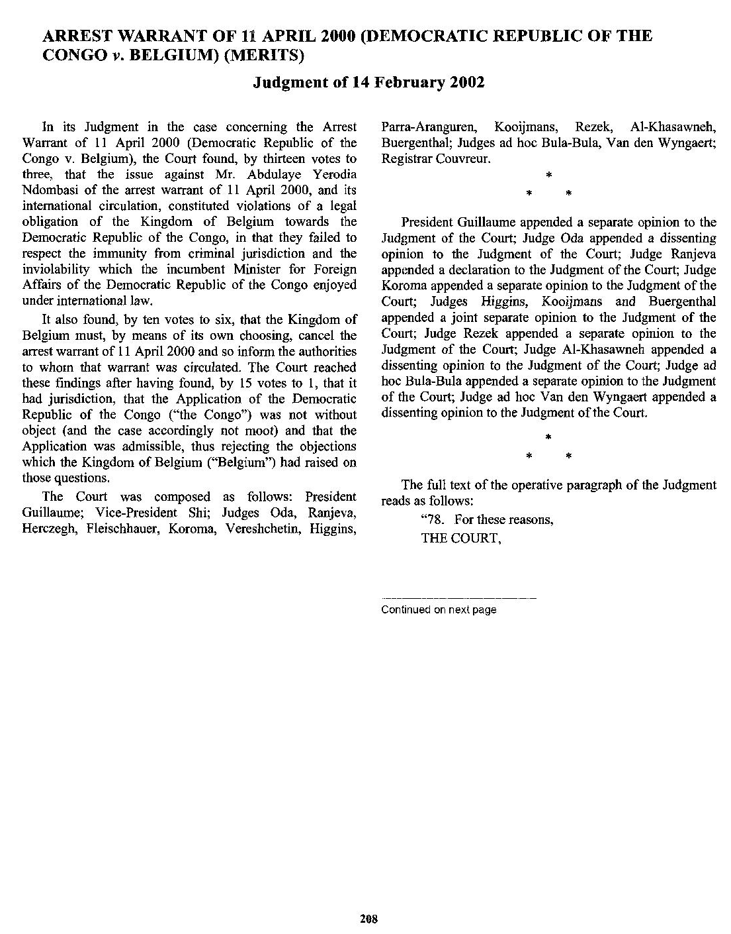

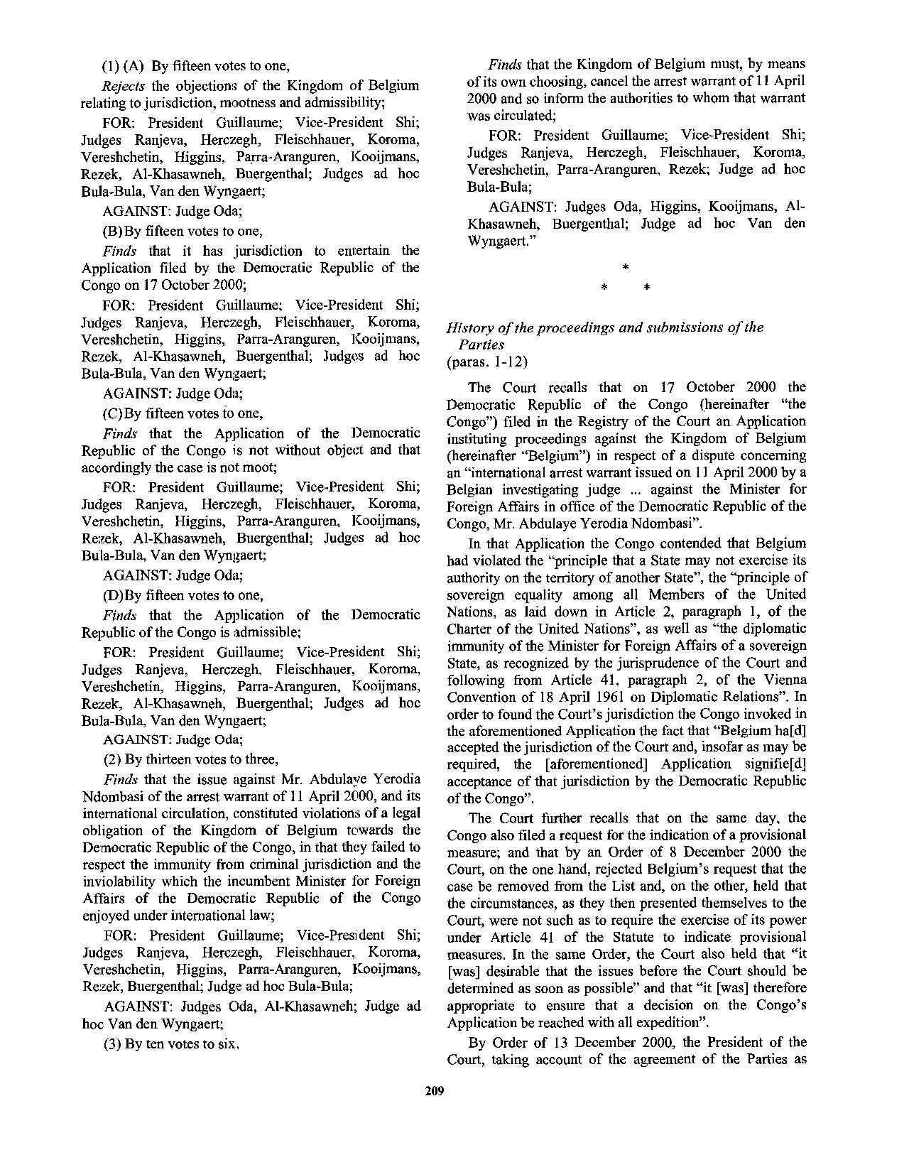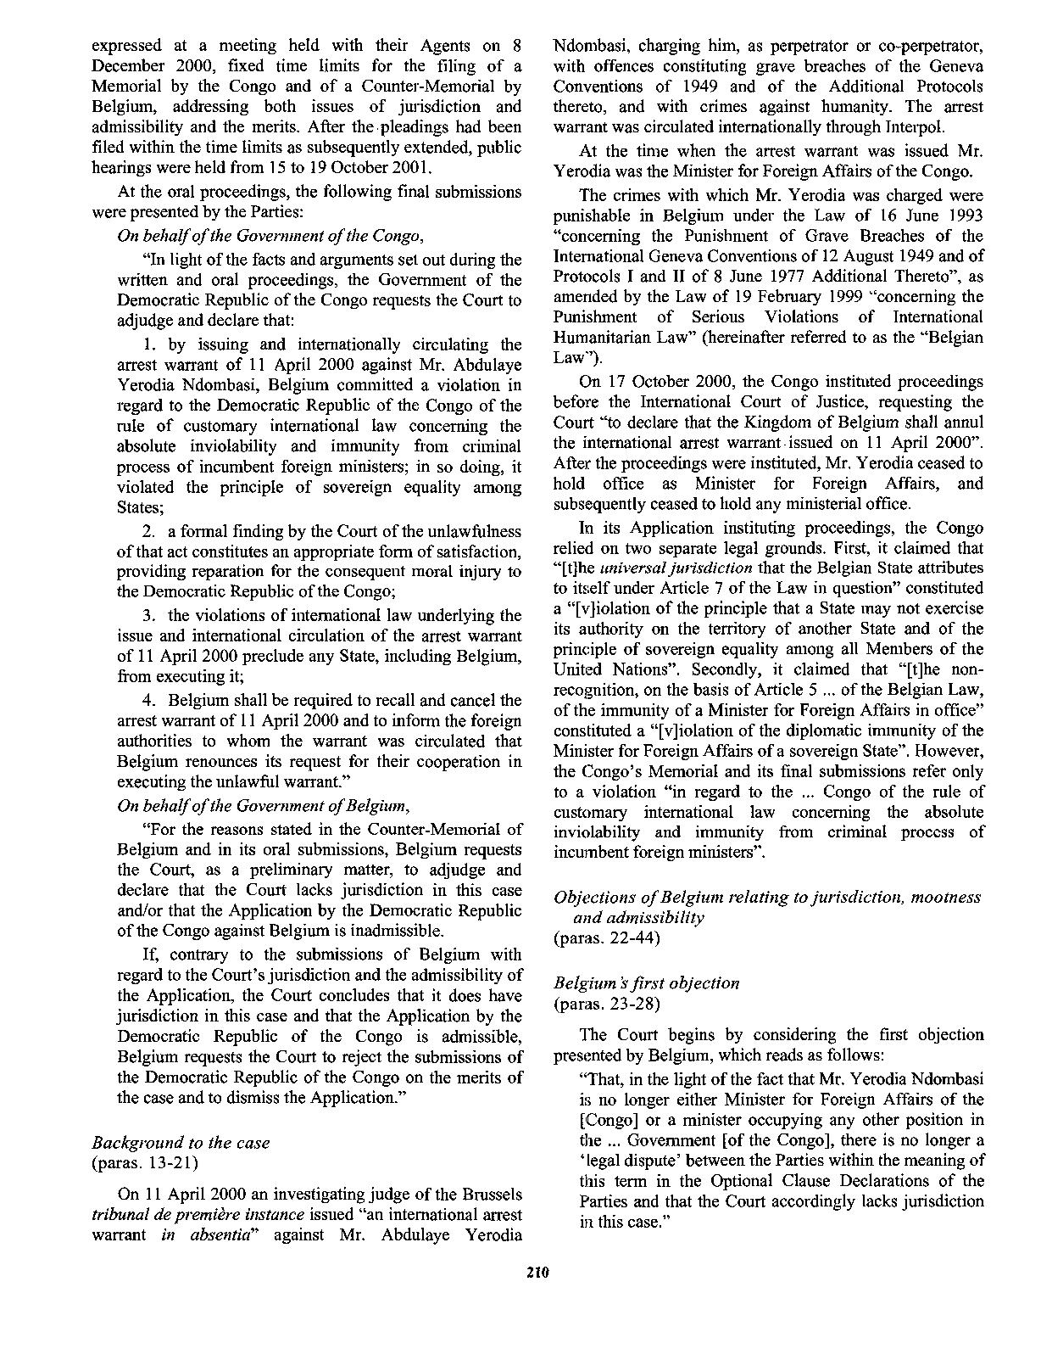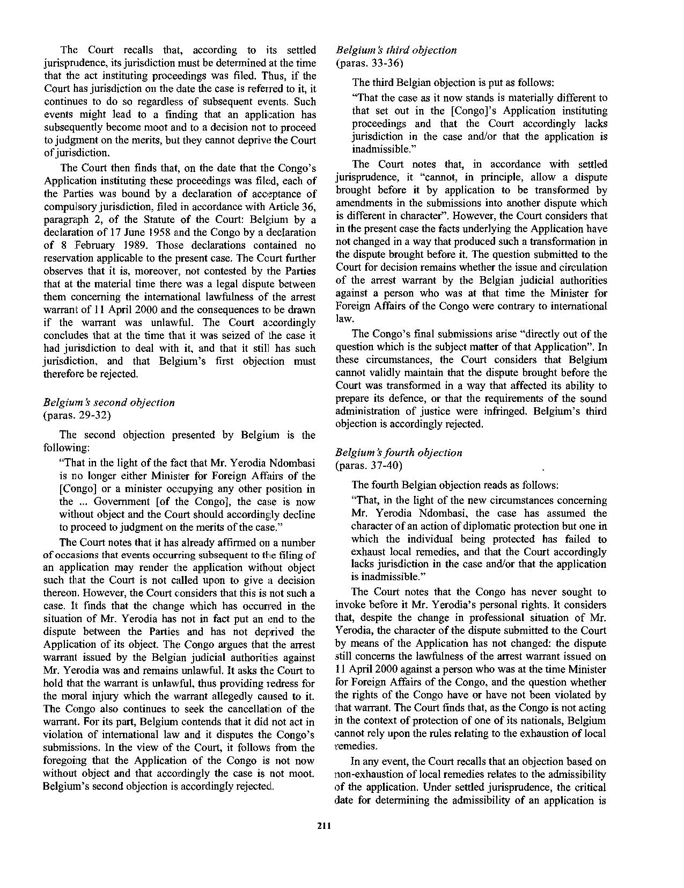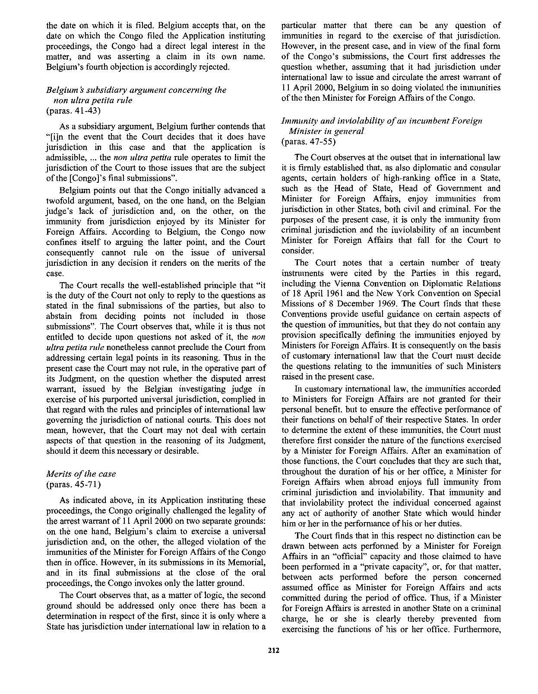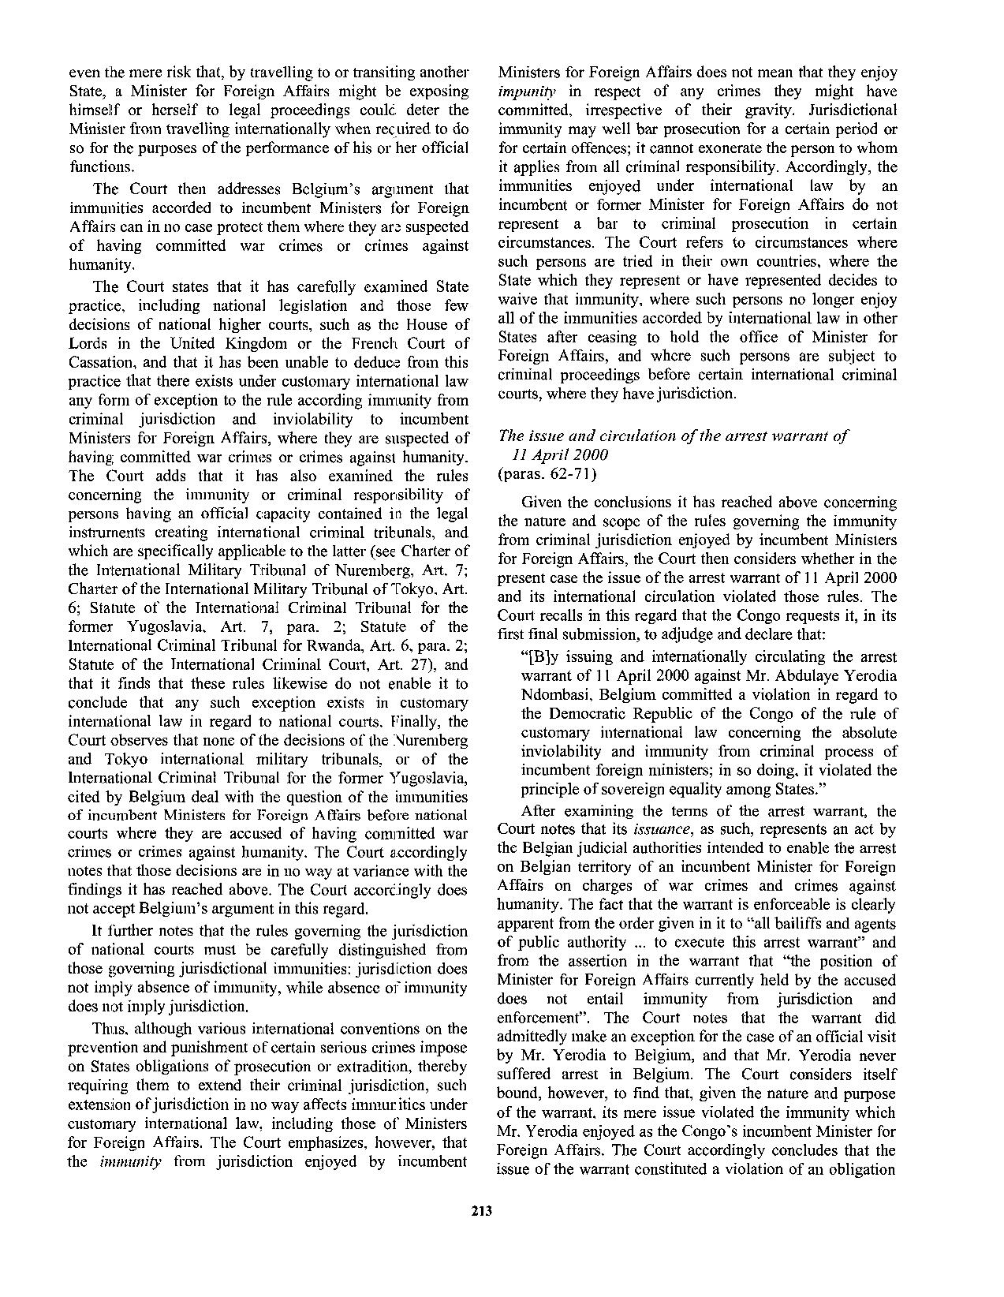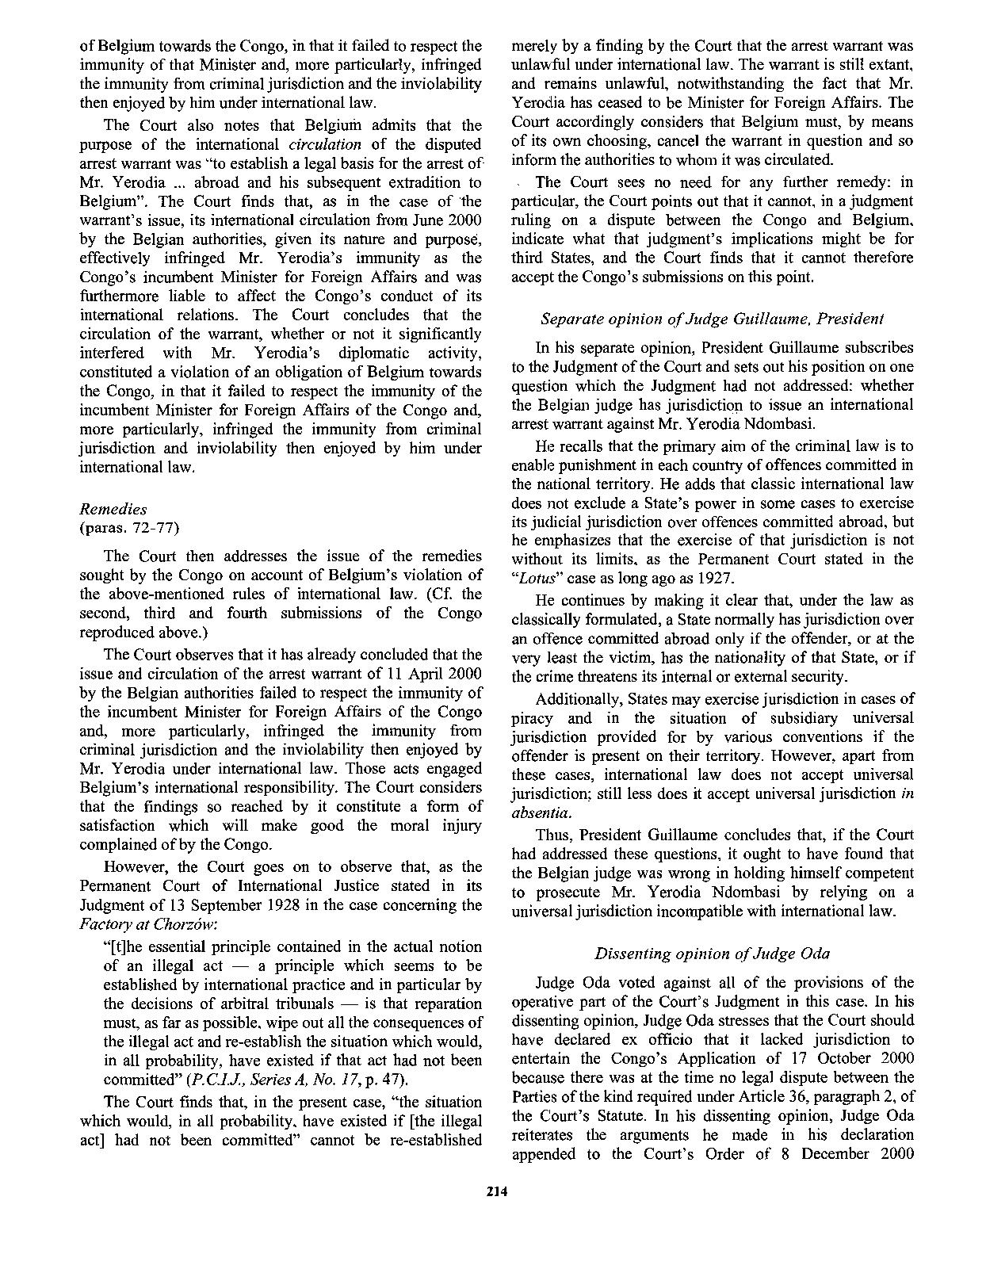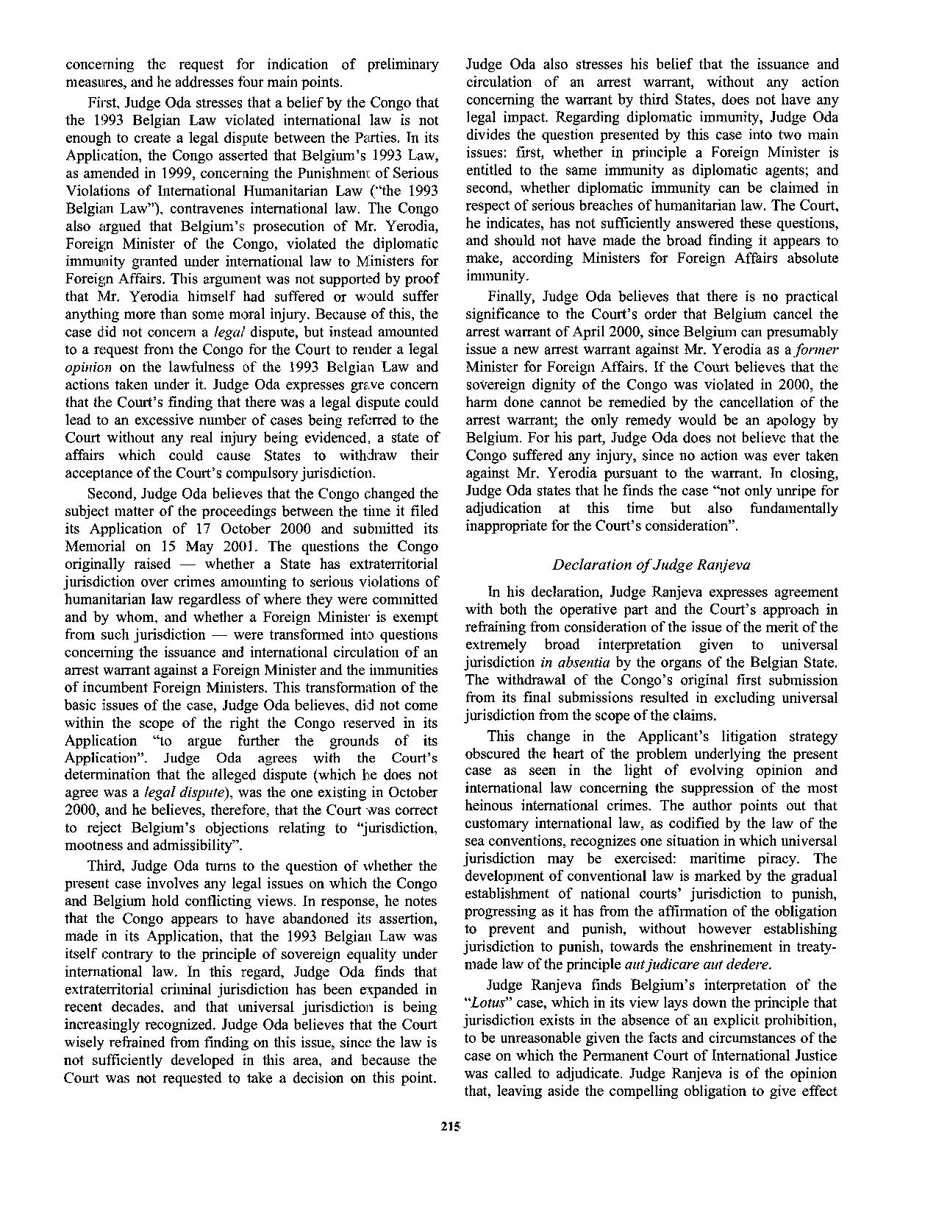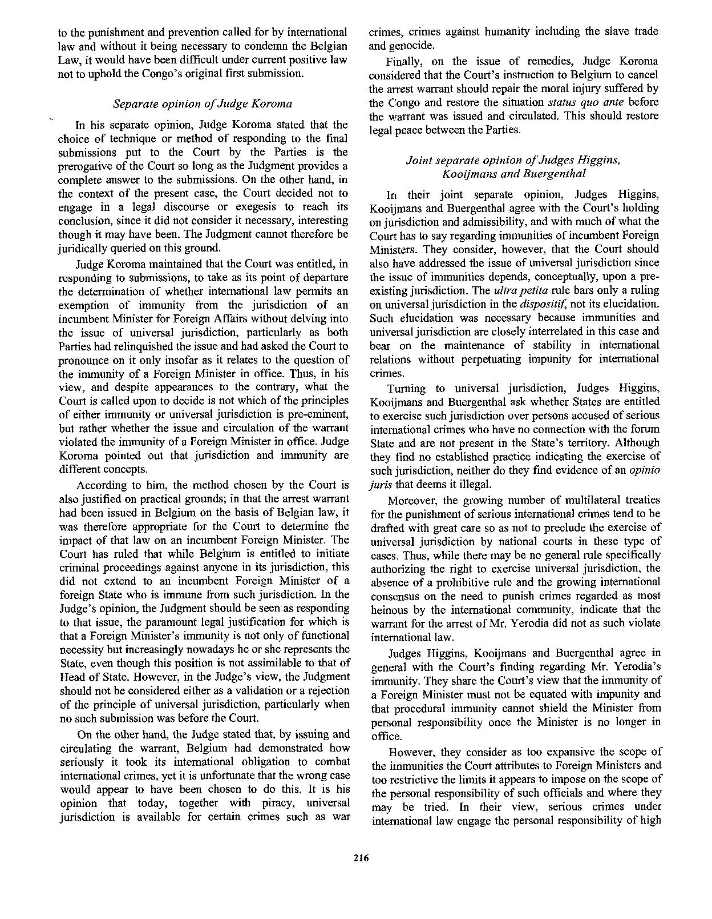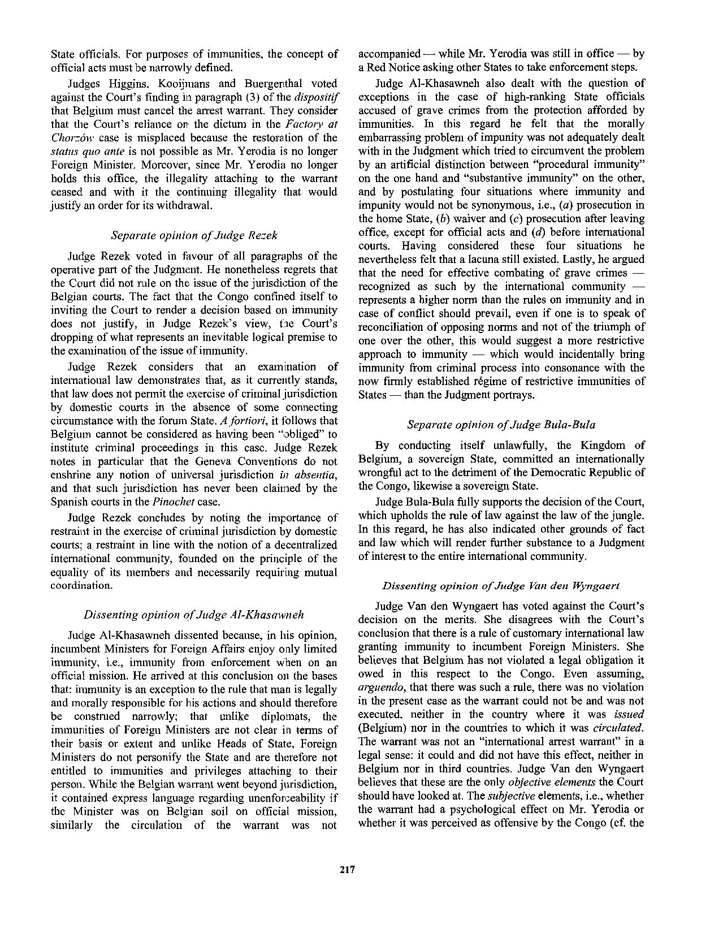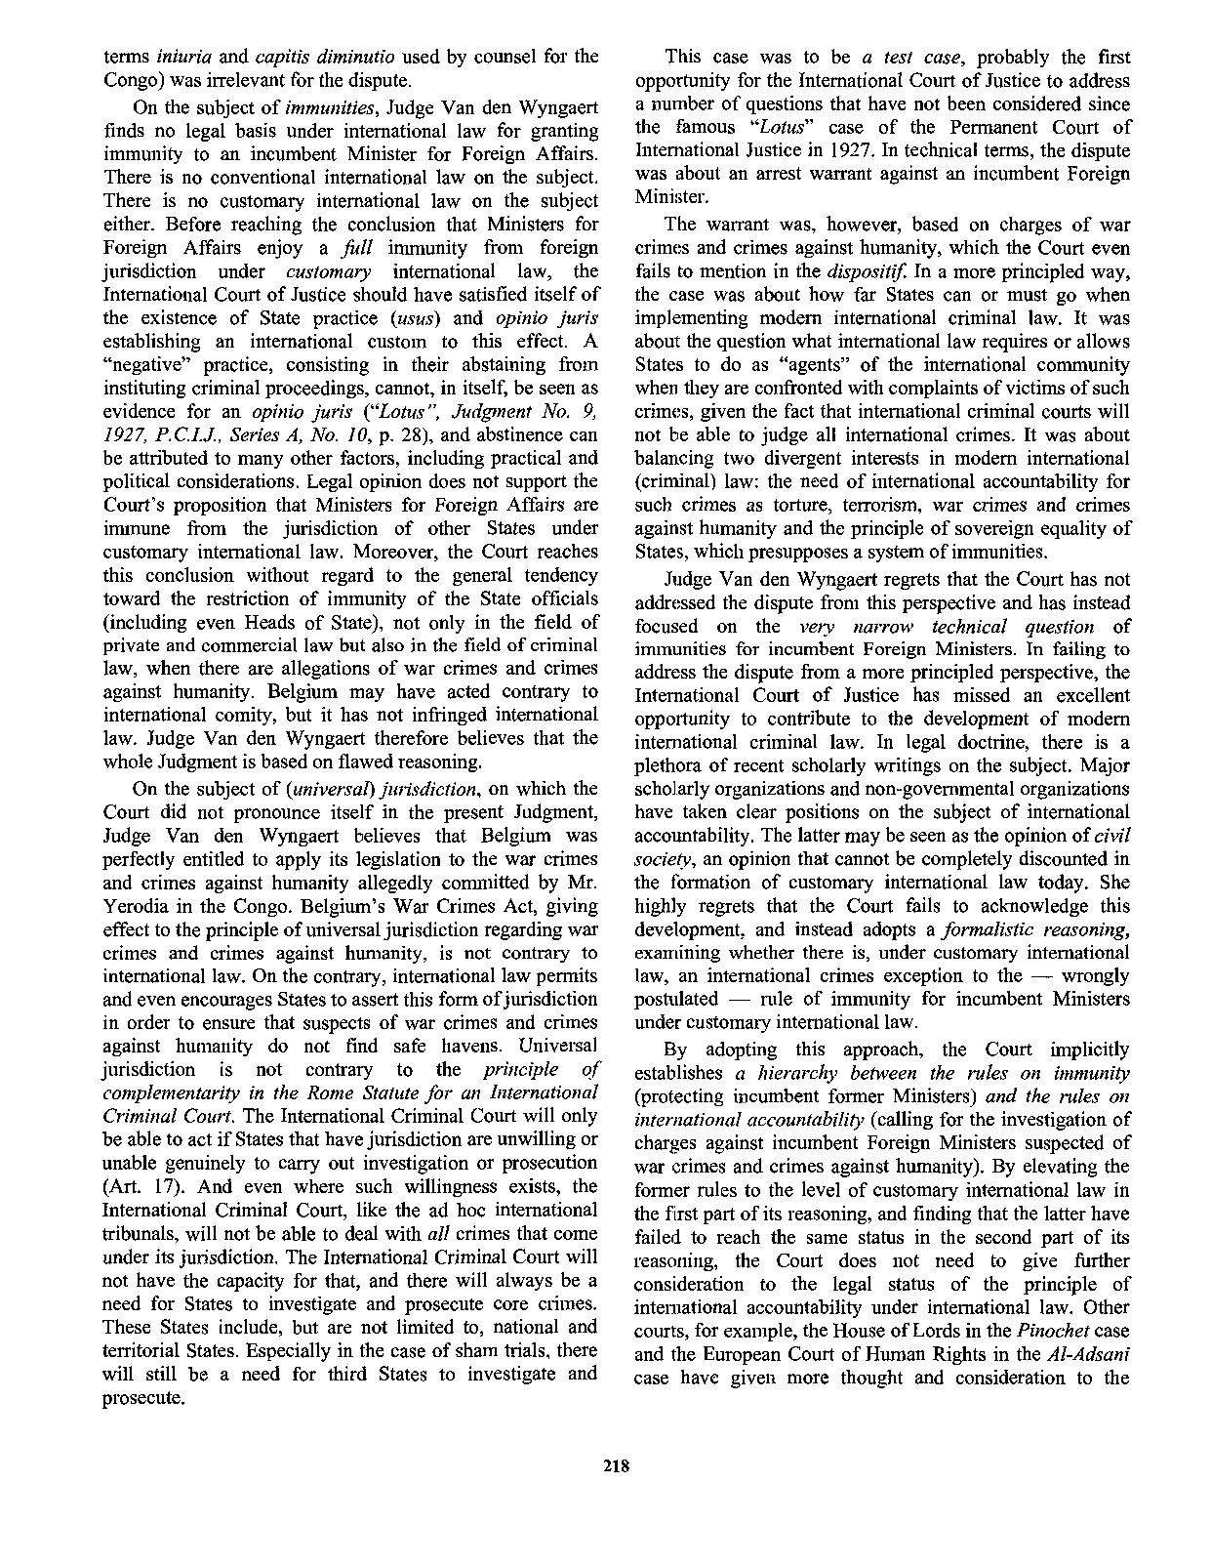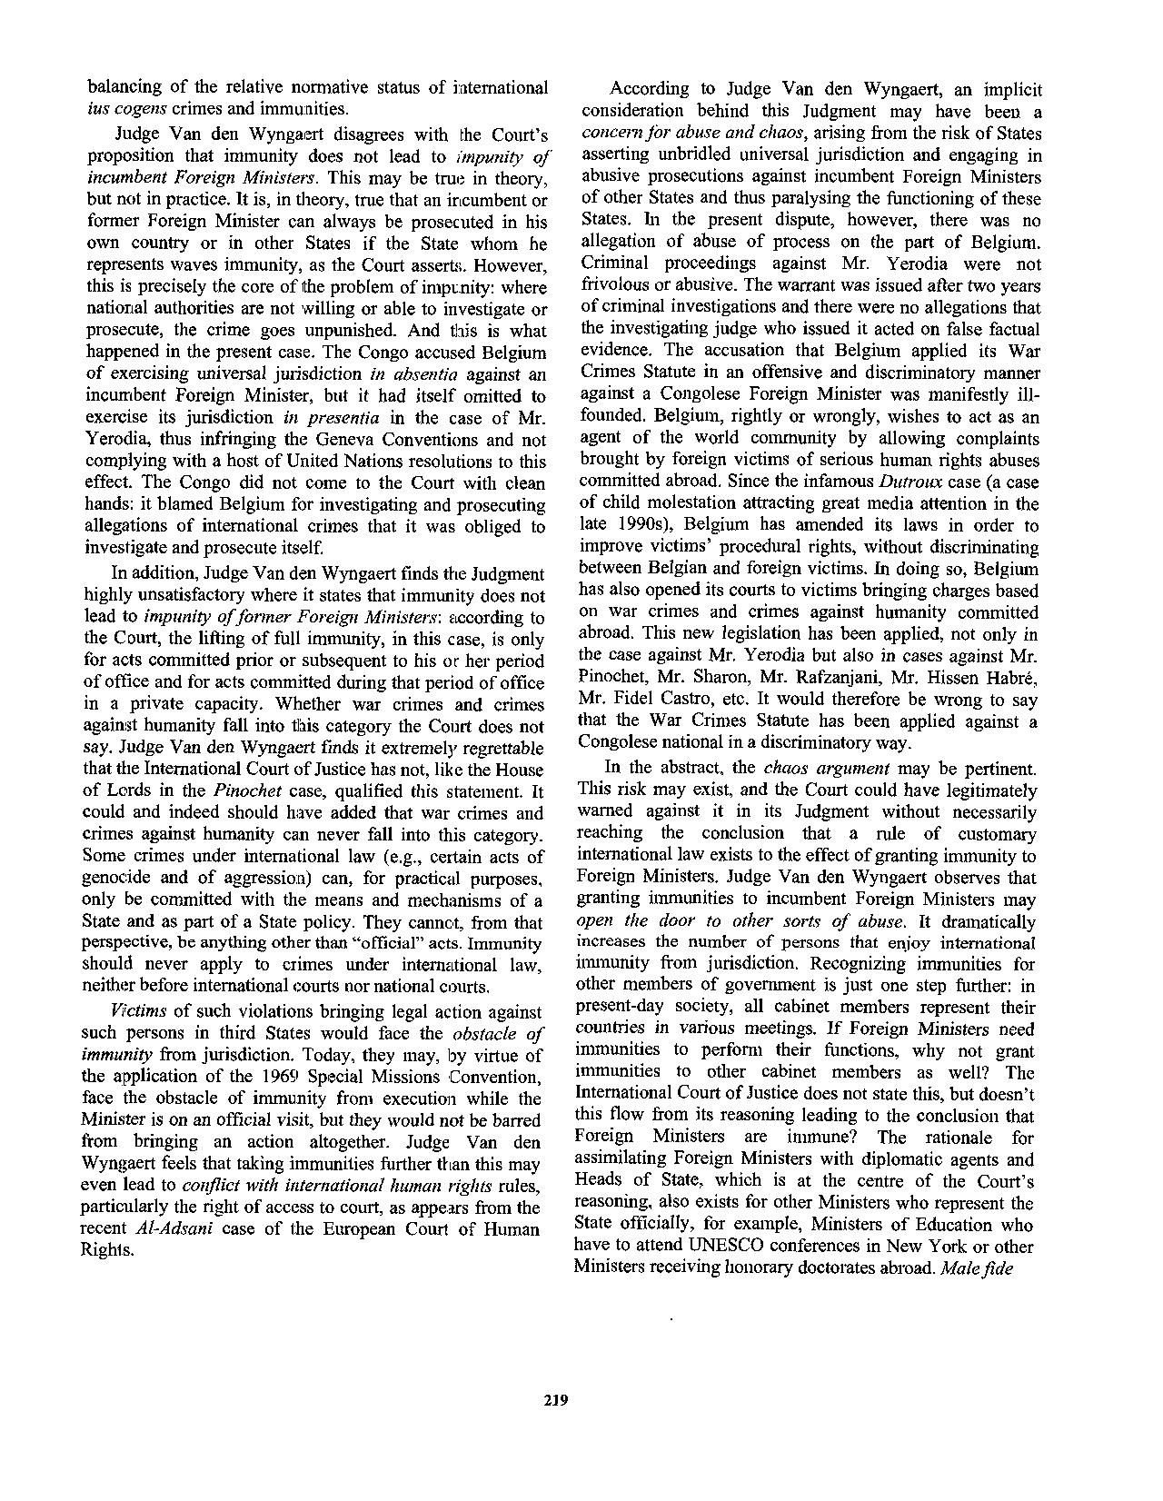

Judgment (Majority Opinion)

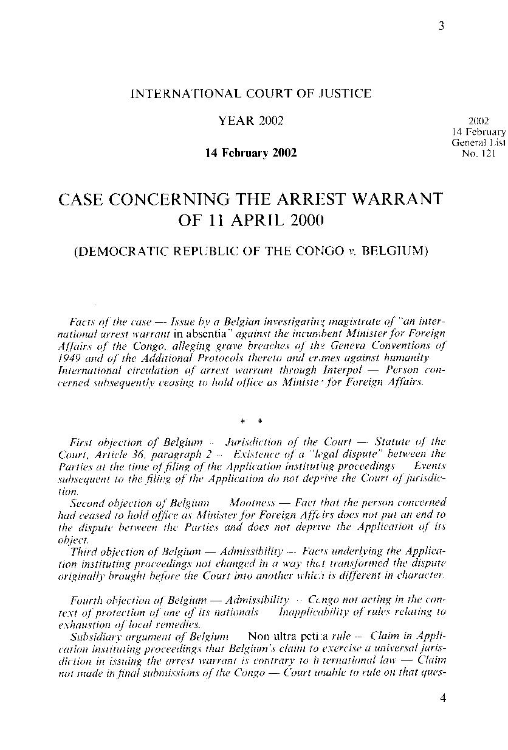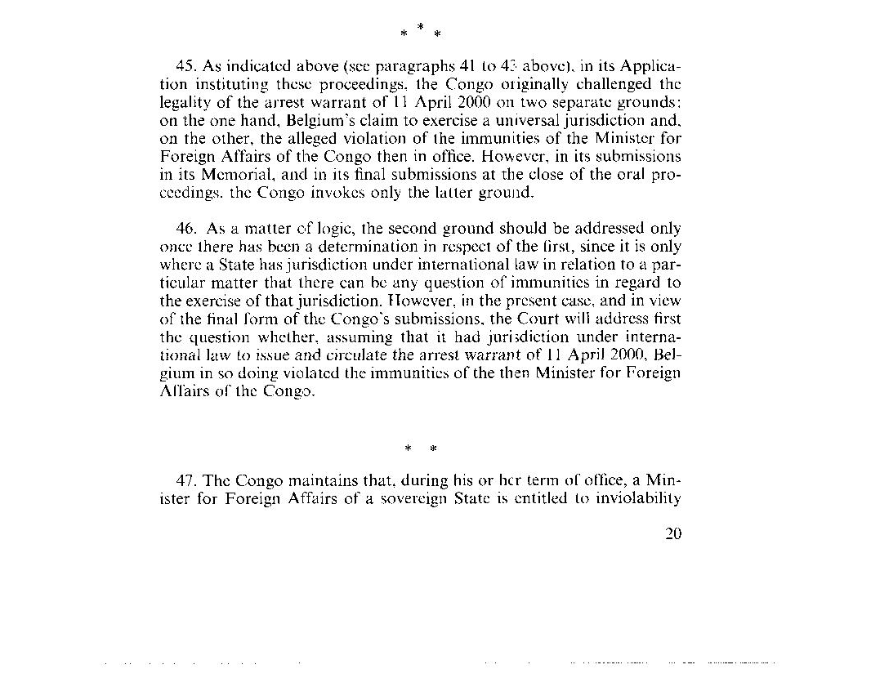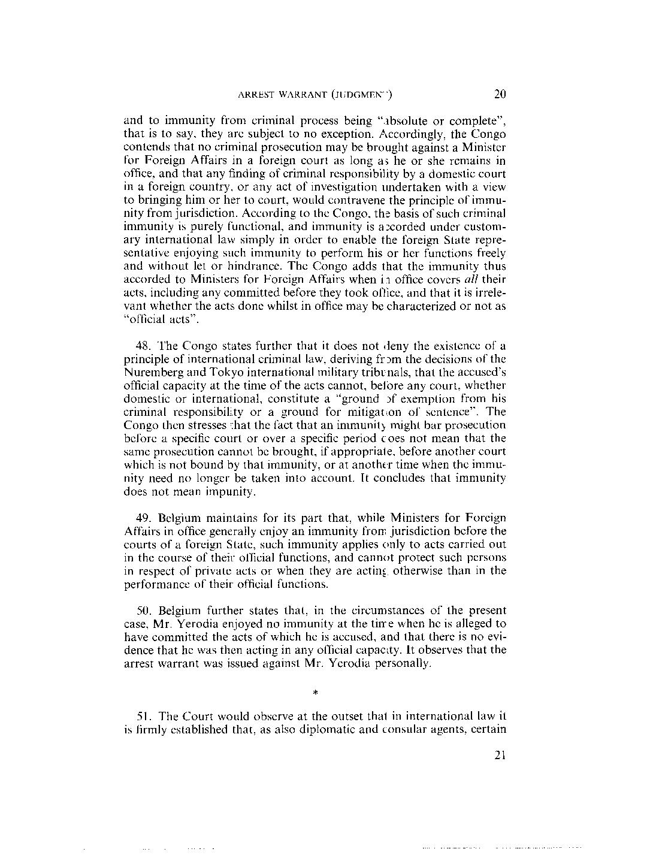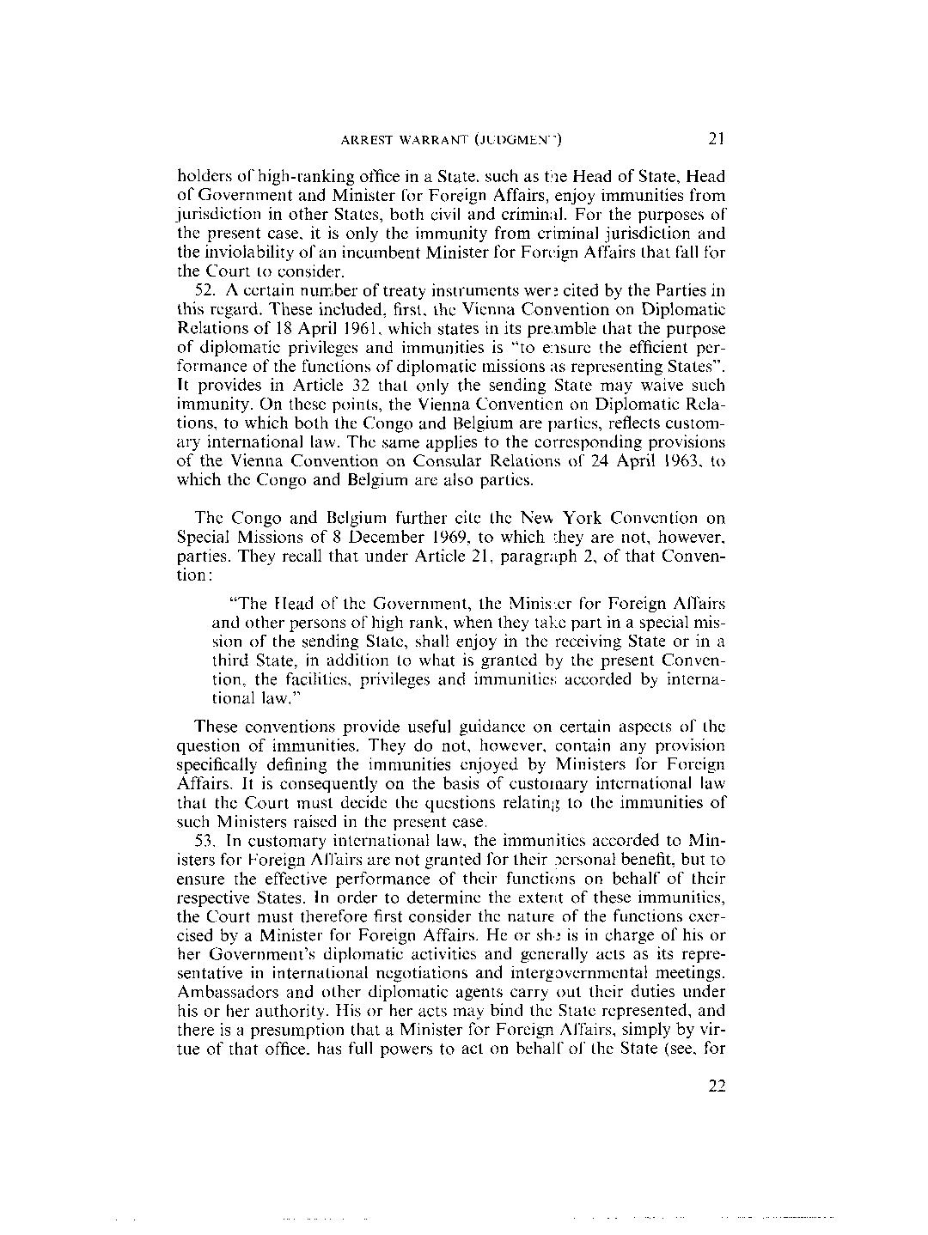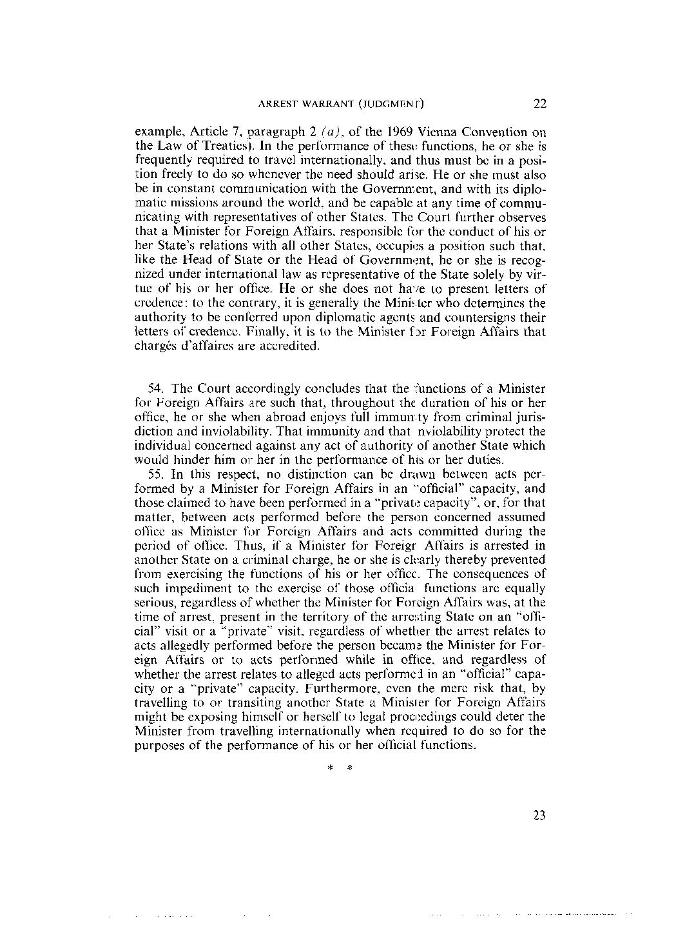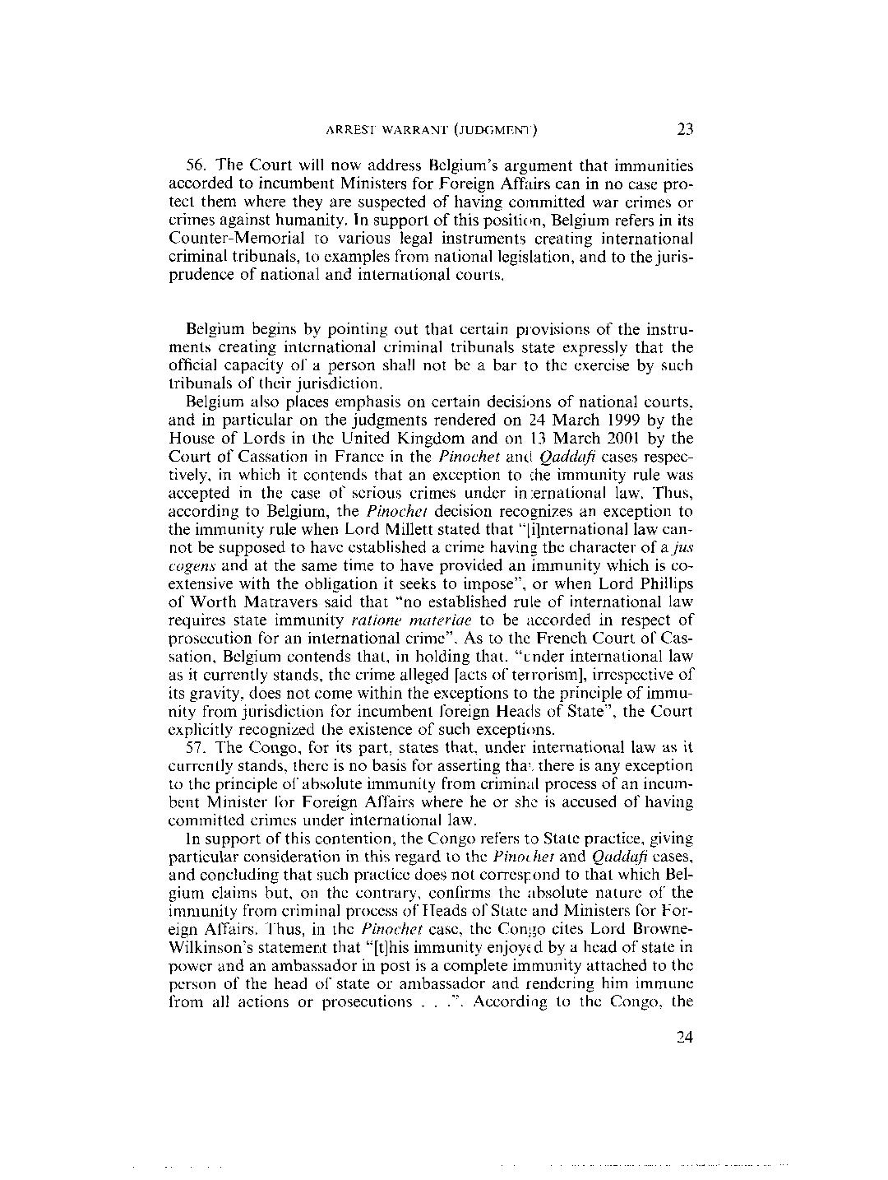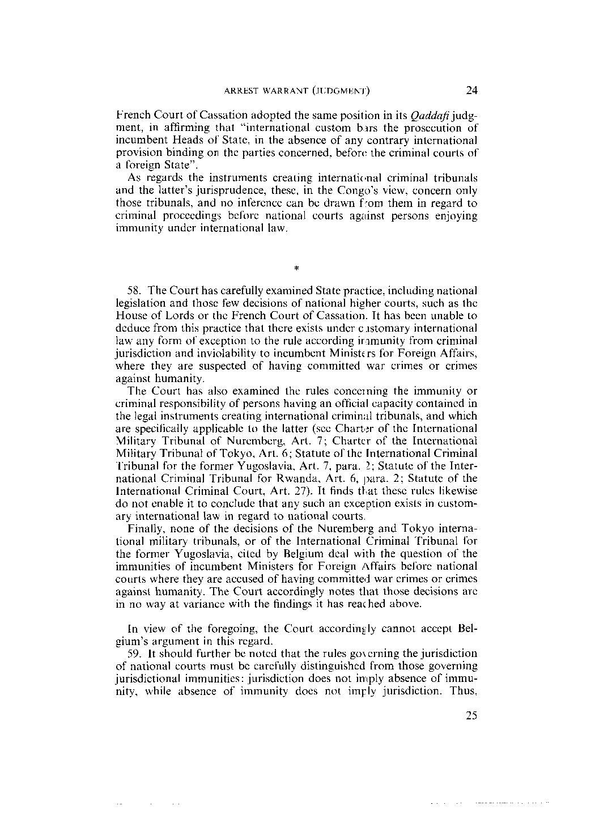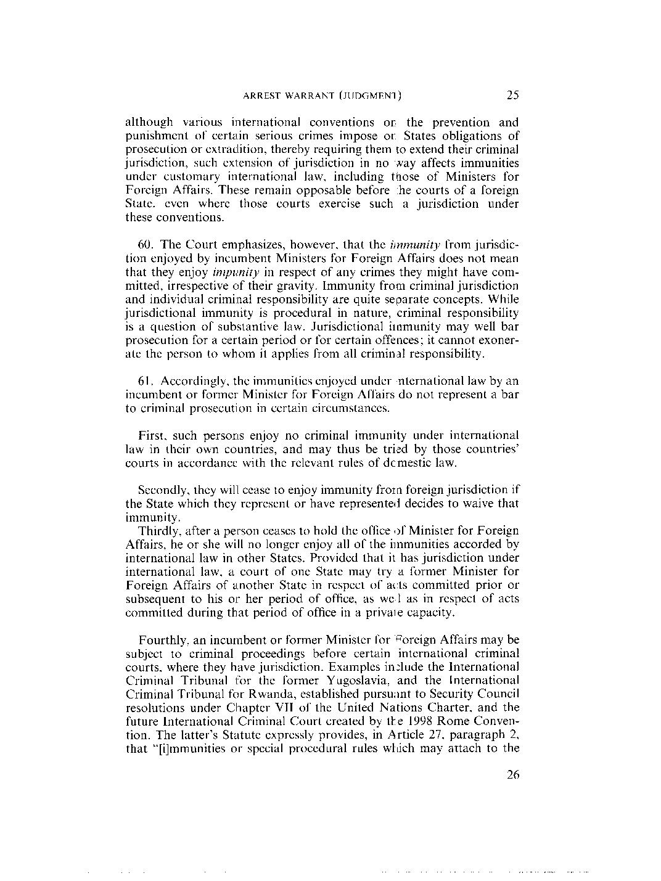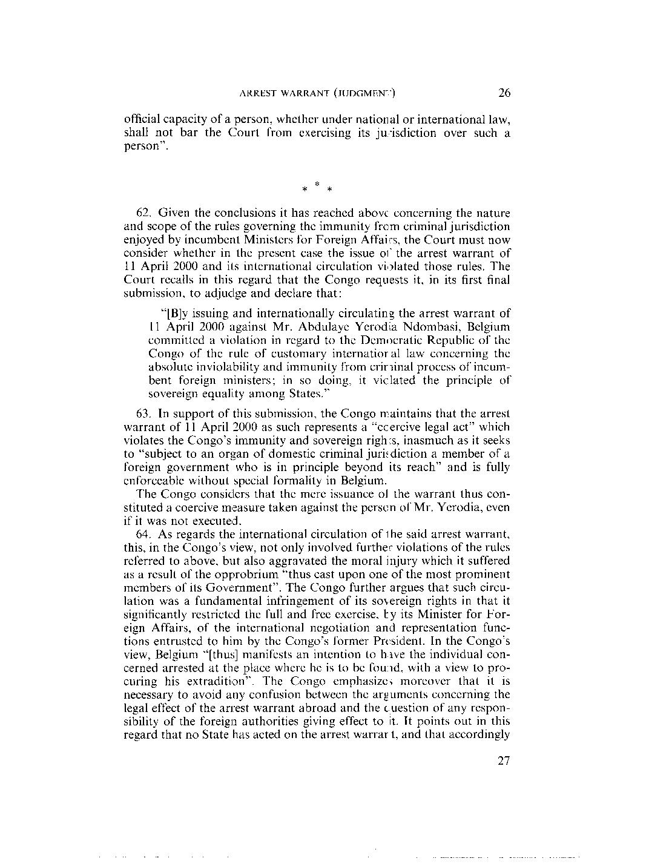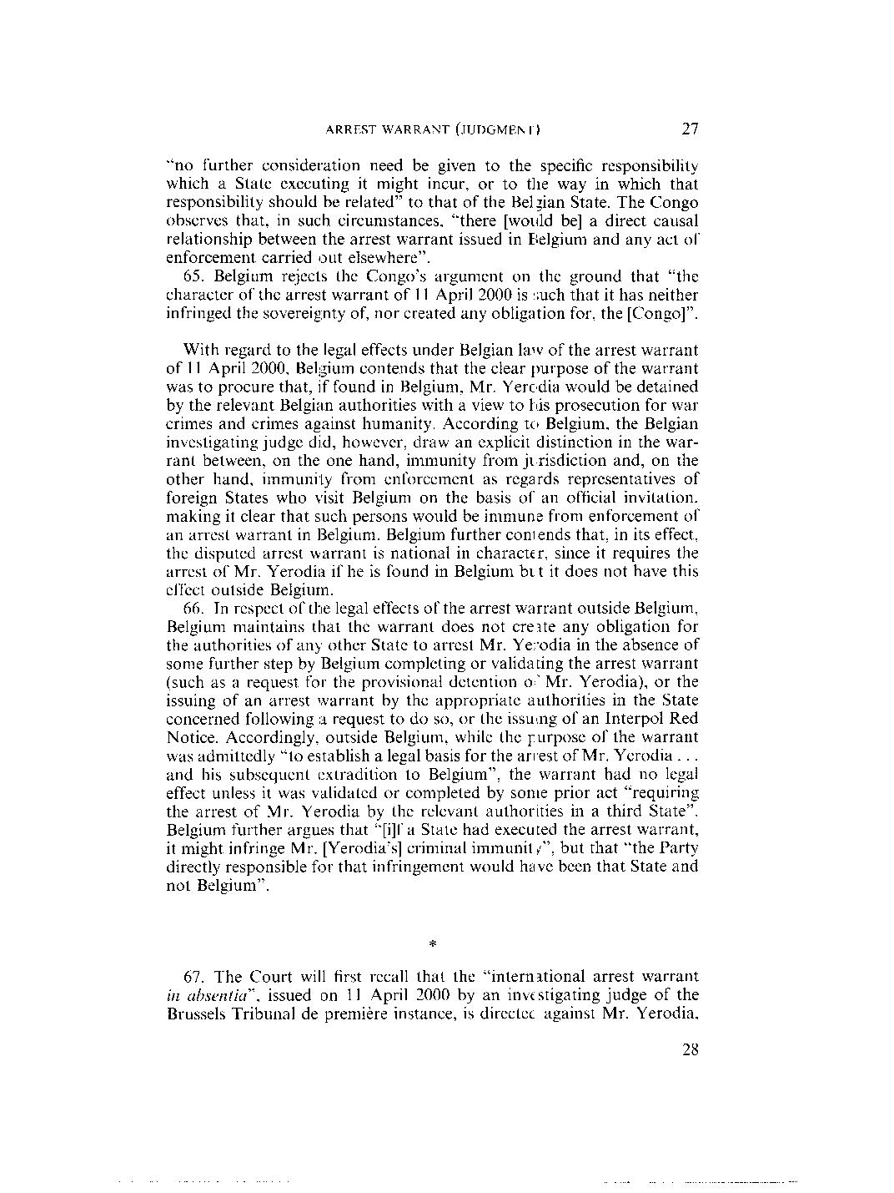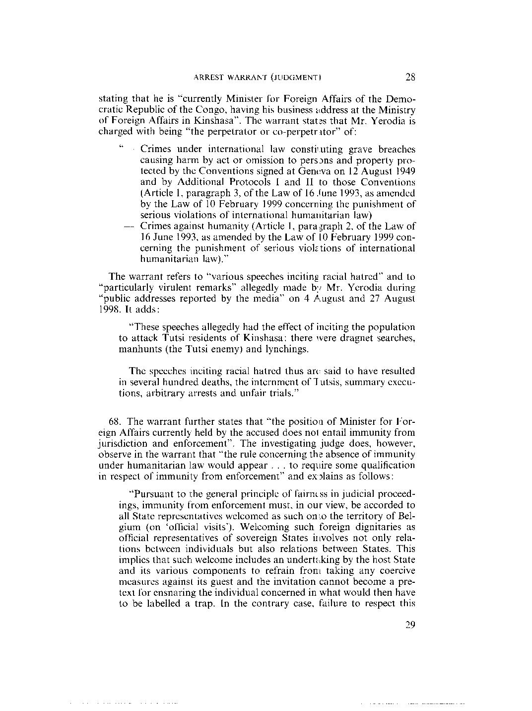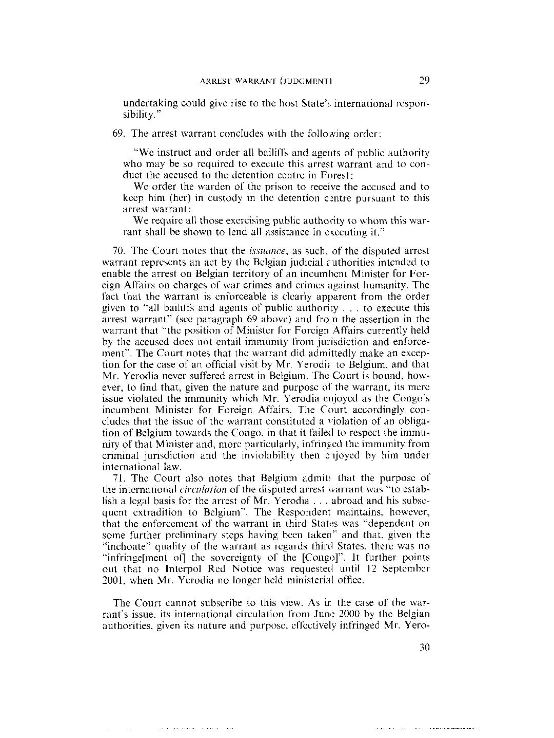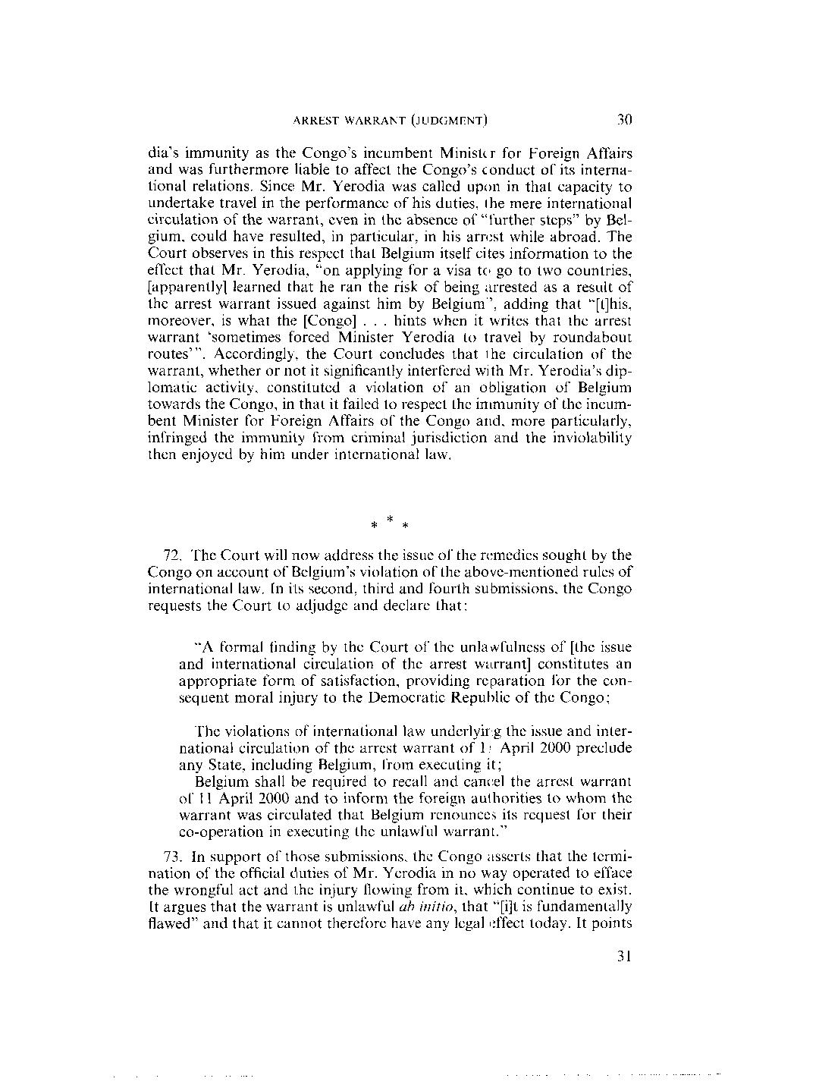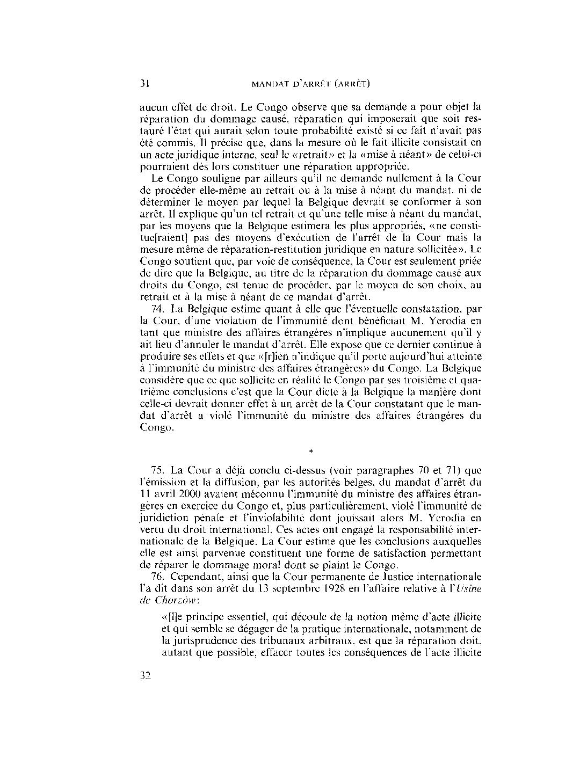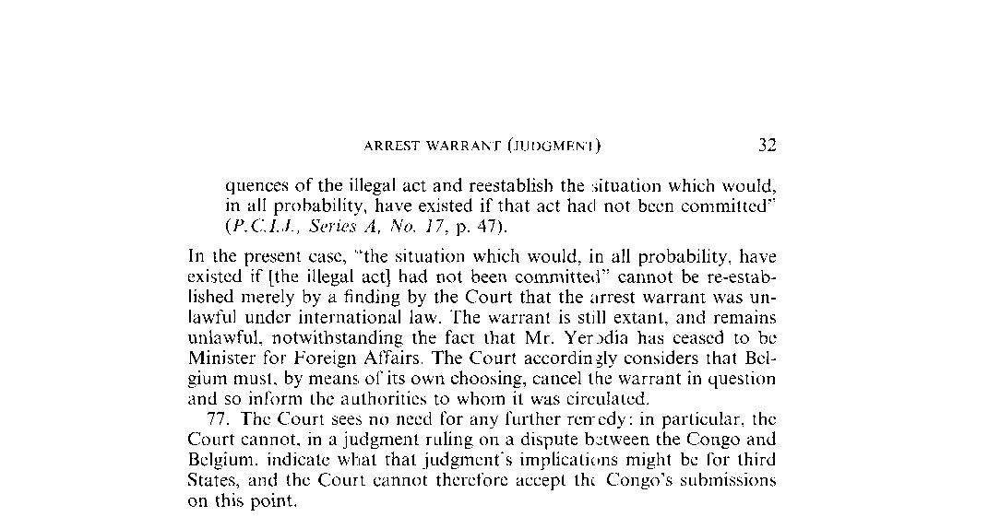

Dissenting Opinion, Judge Van Den Wyngaert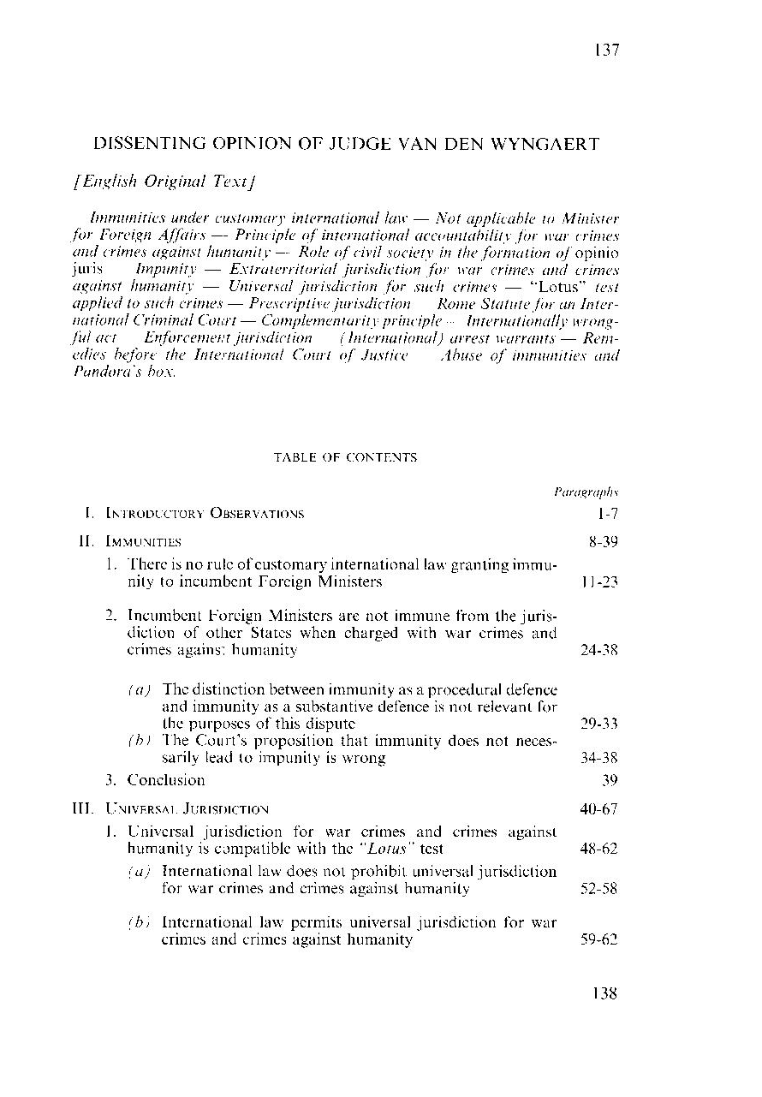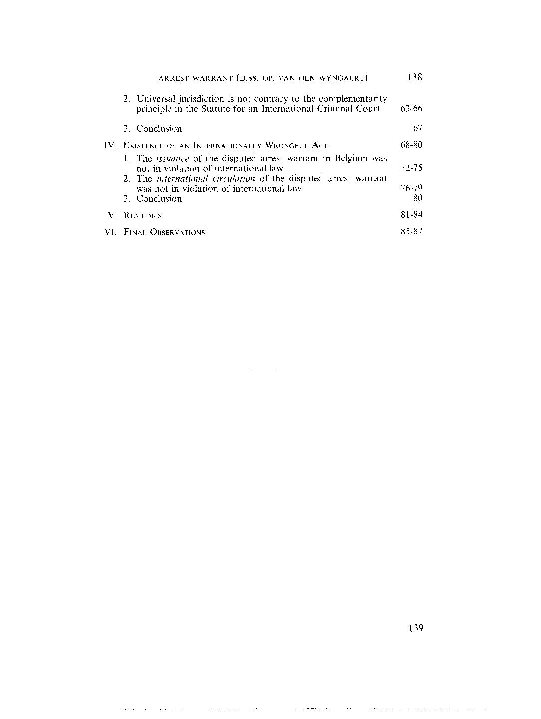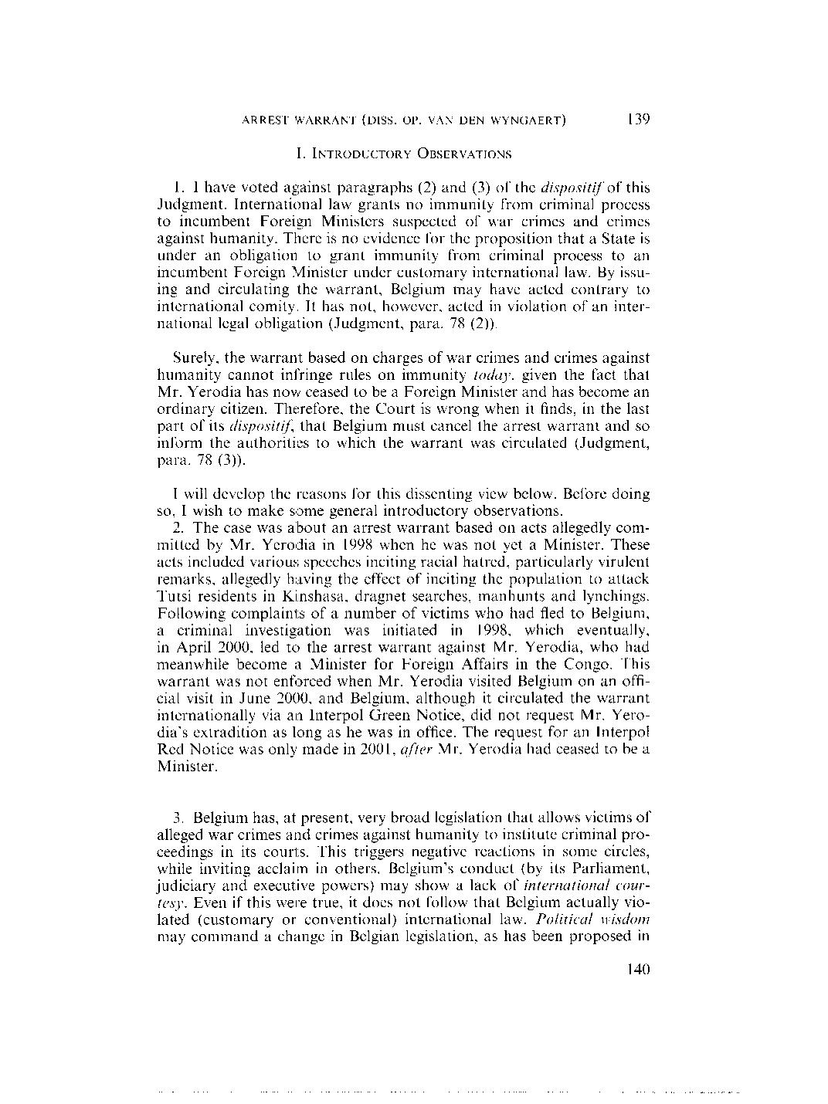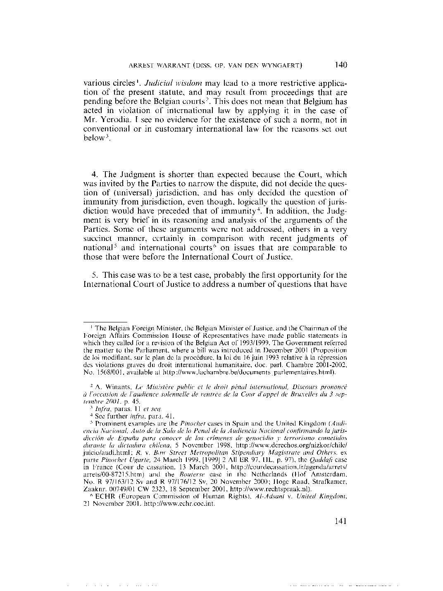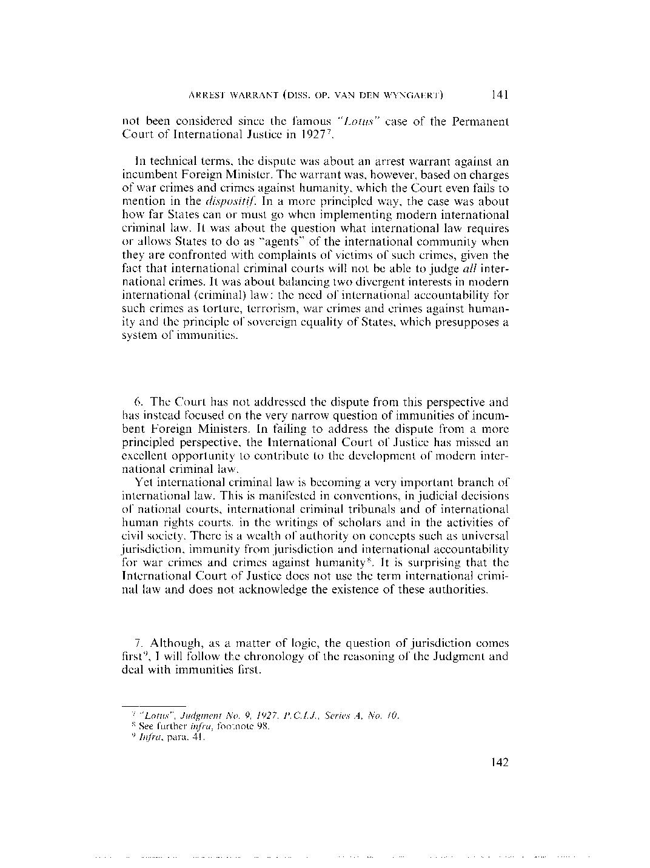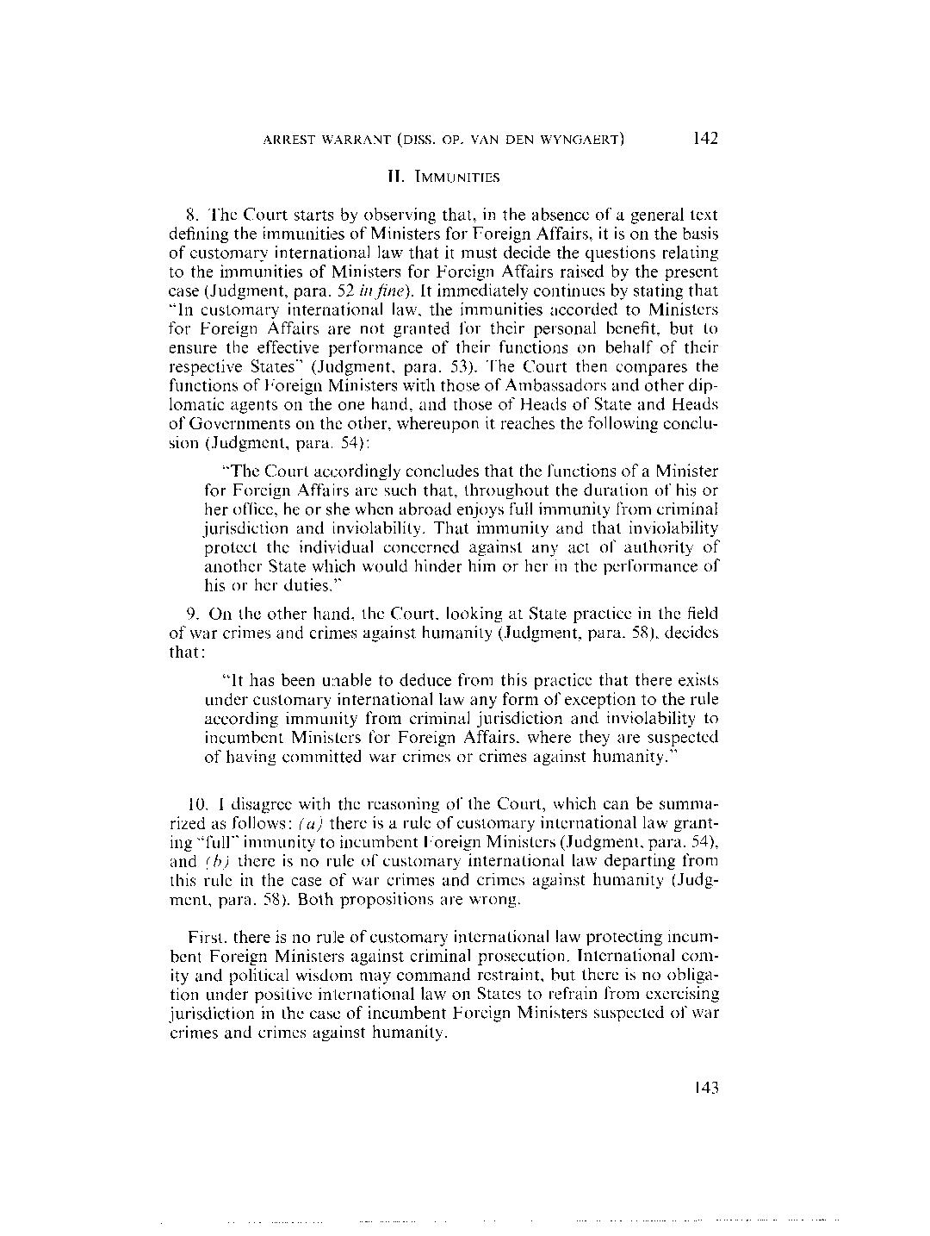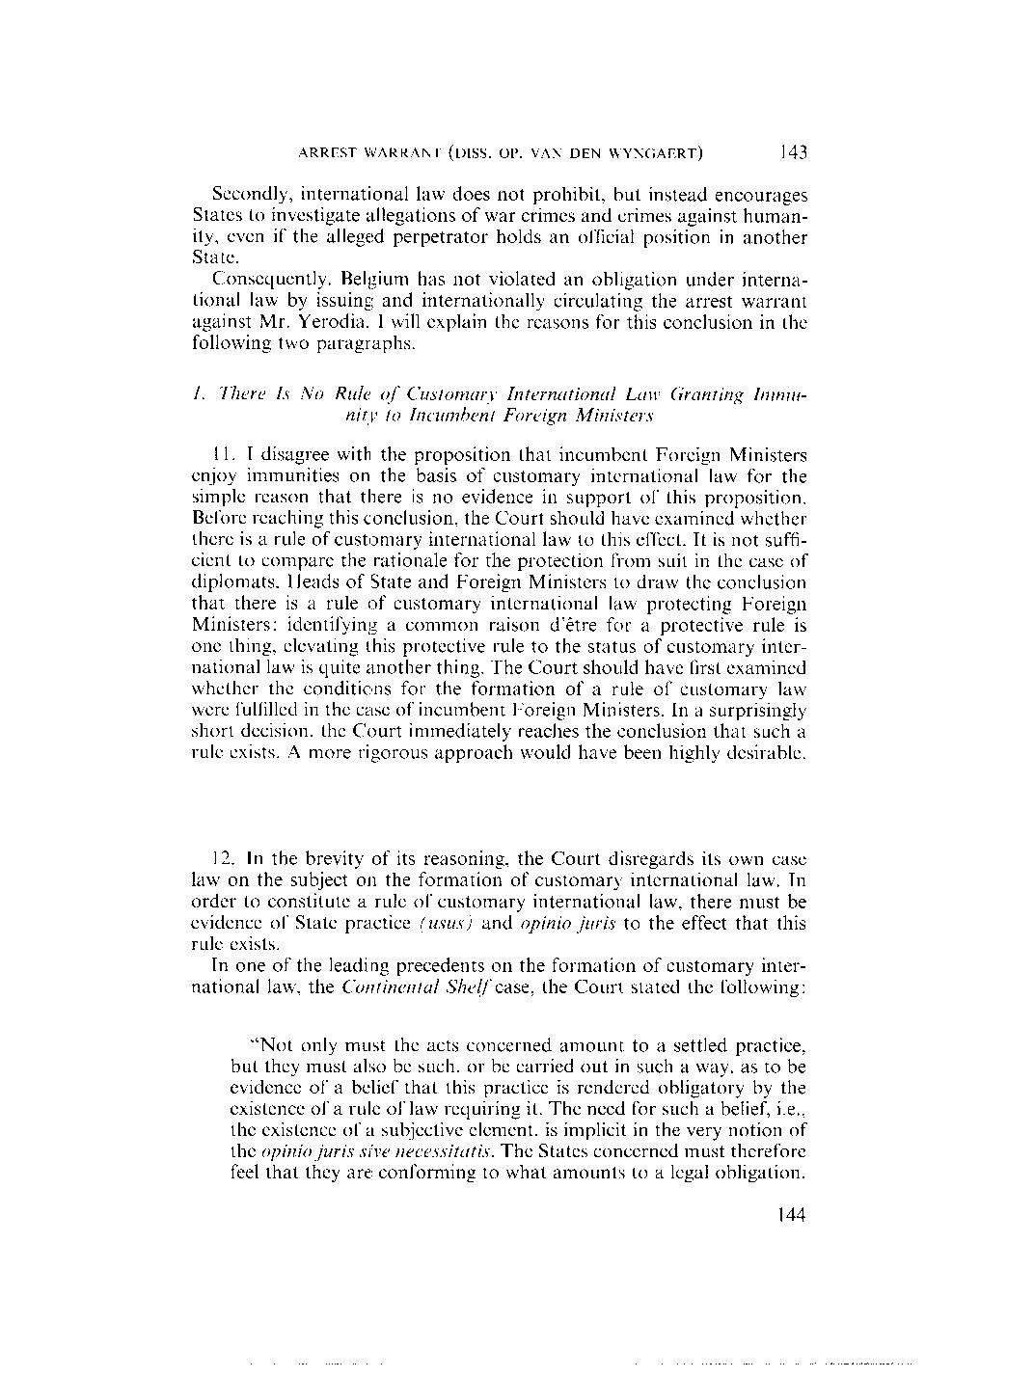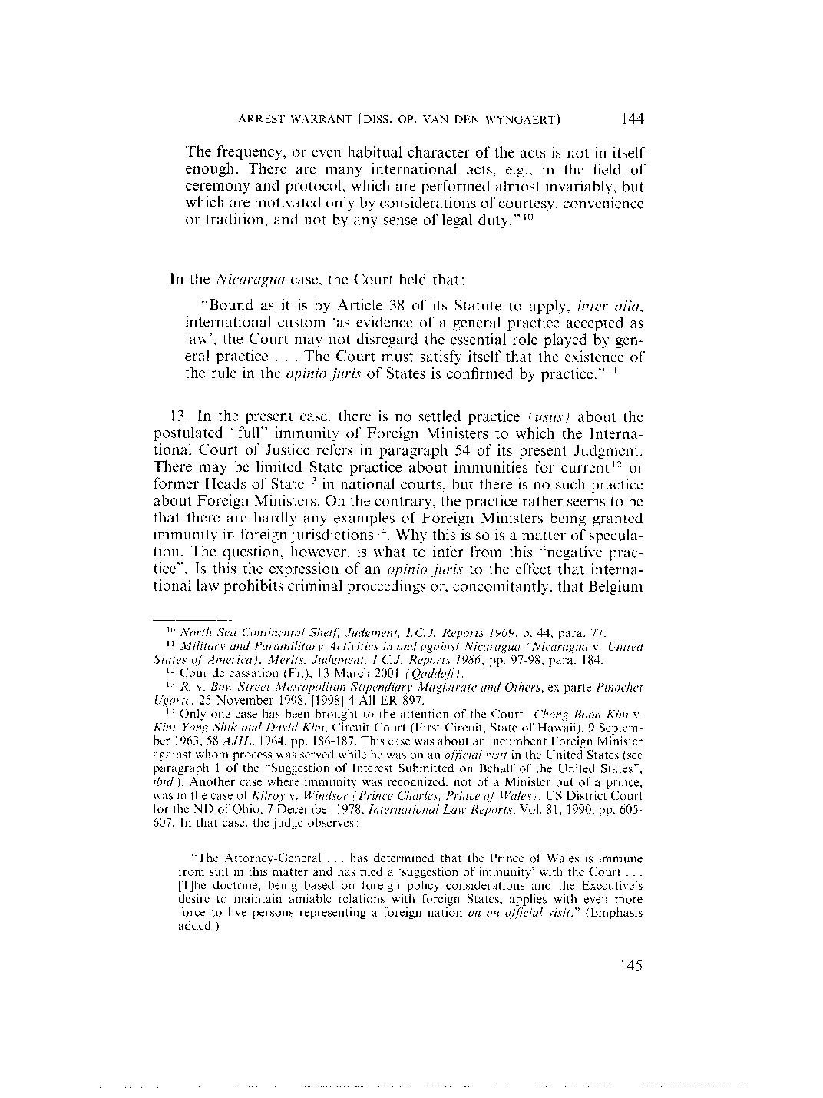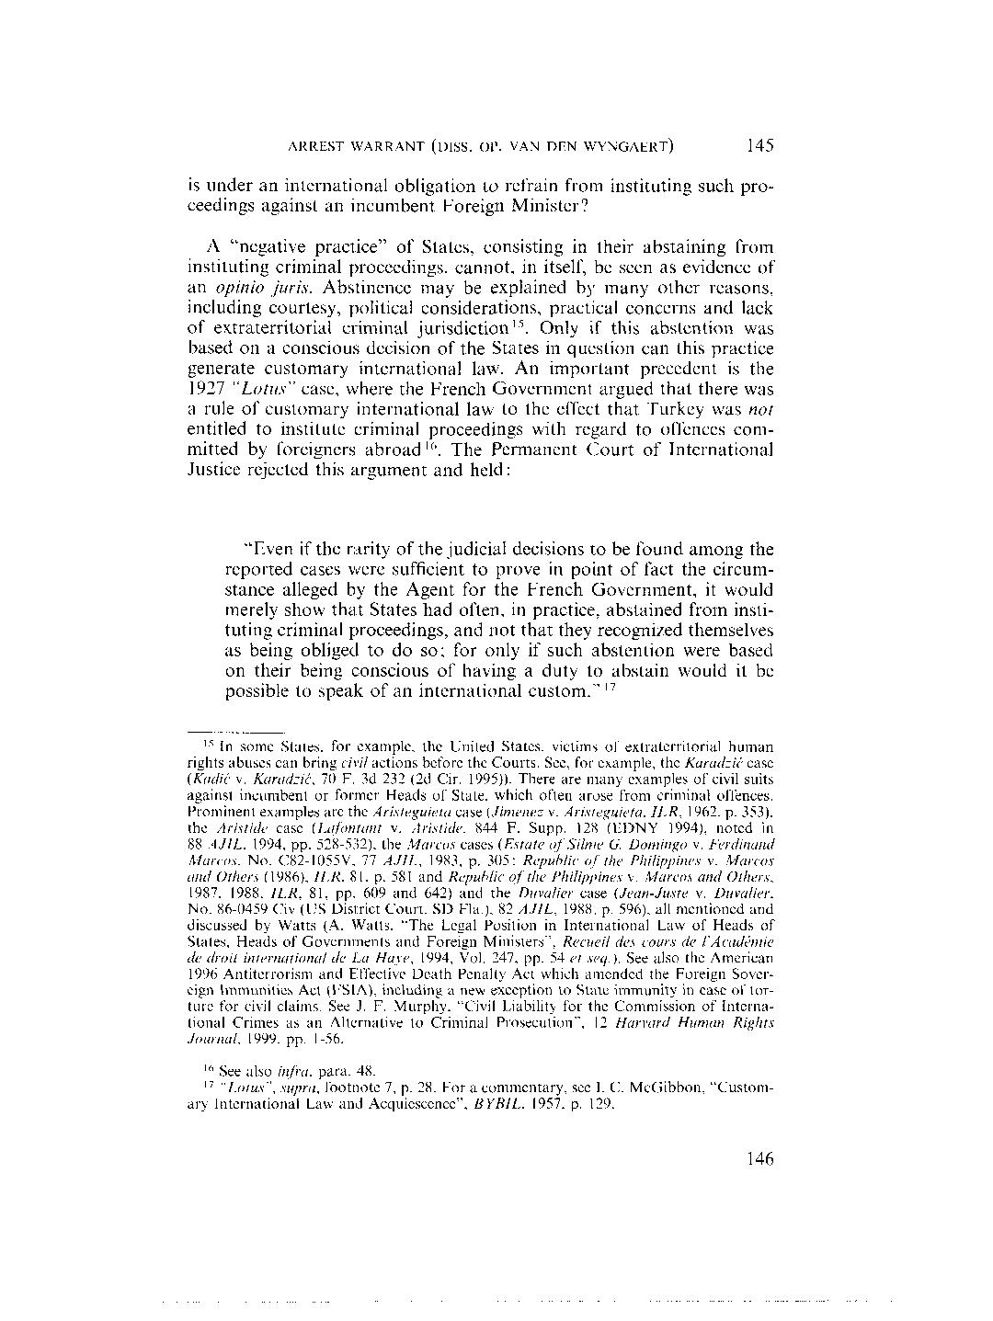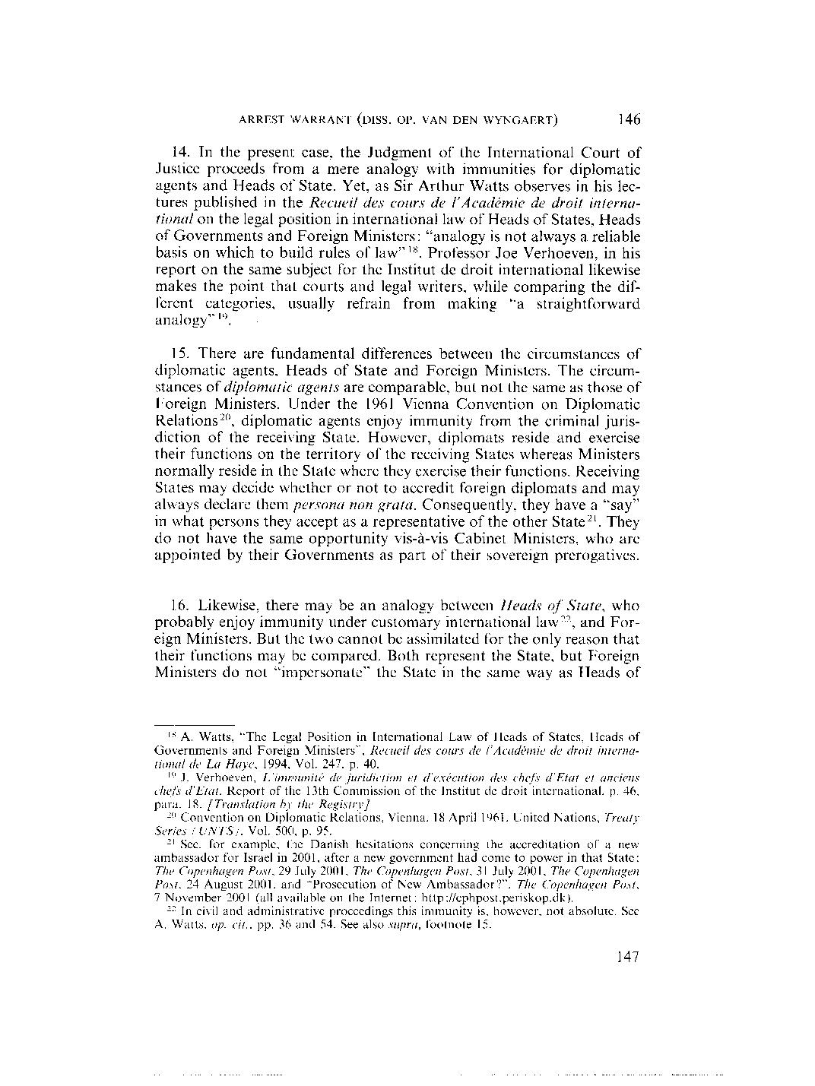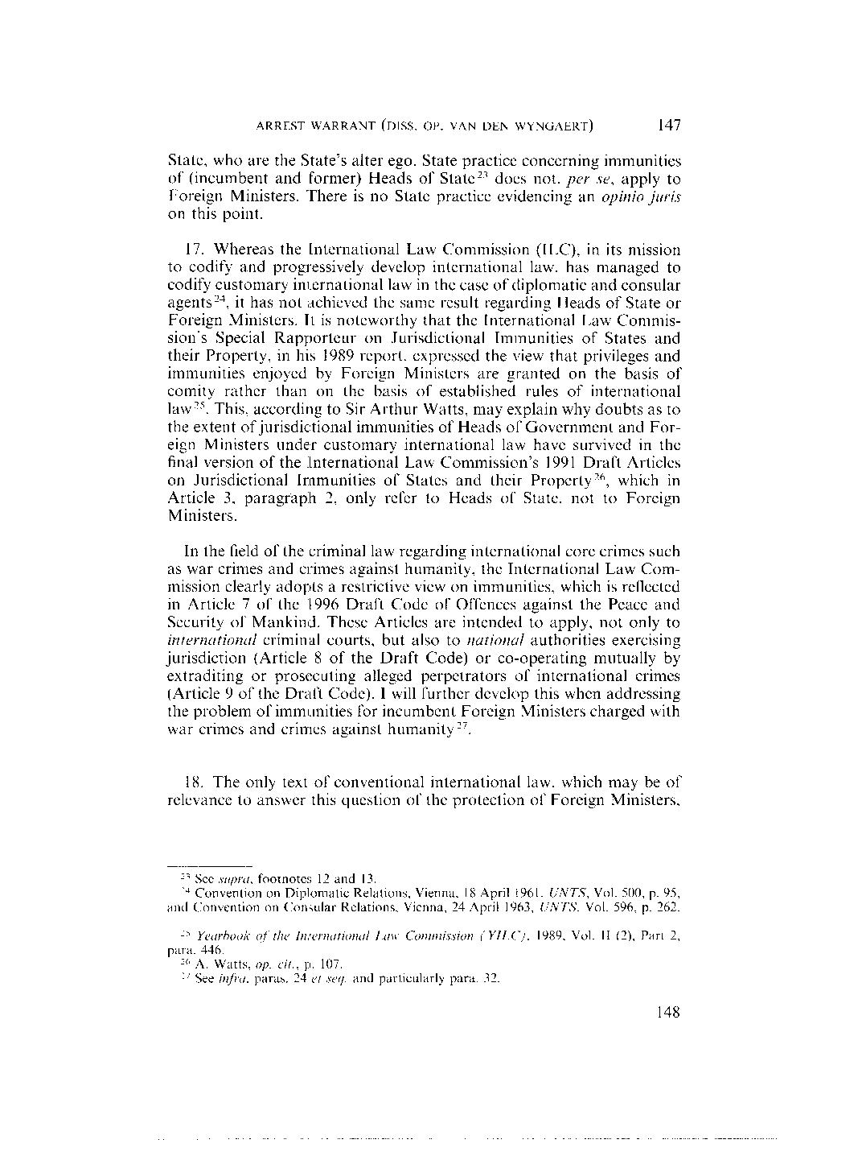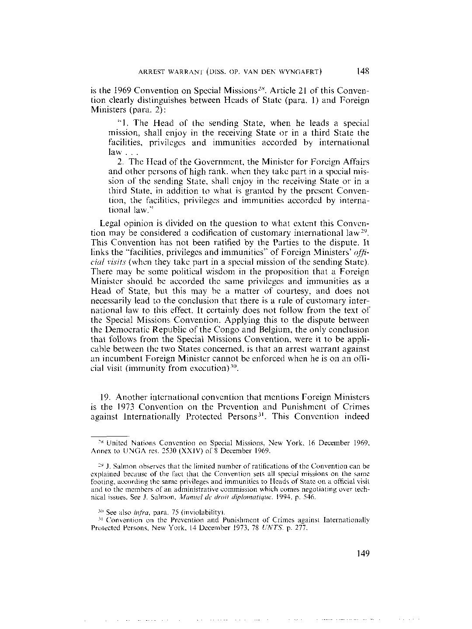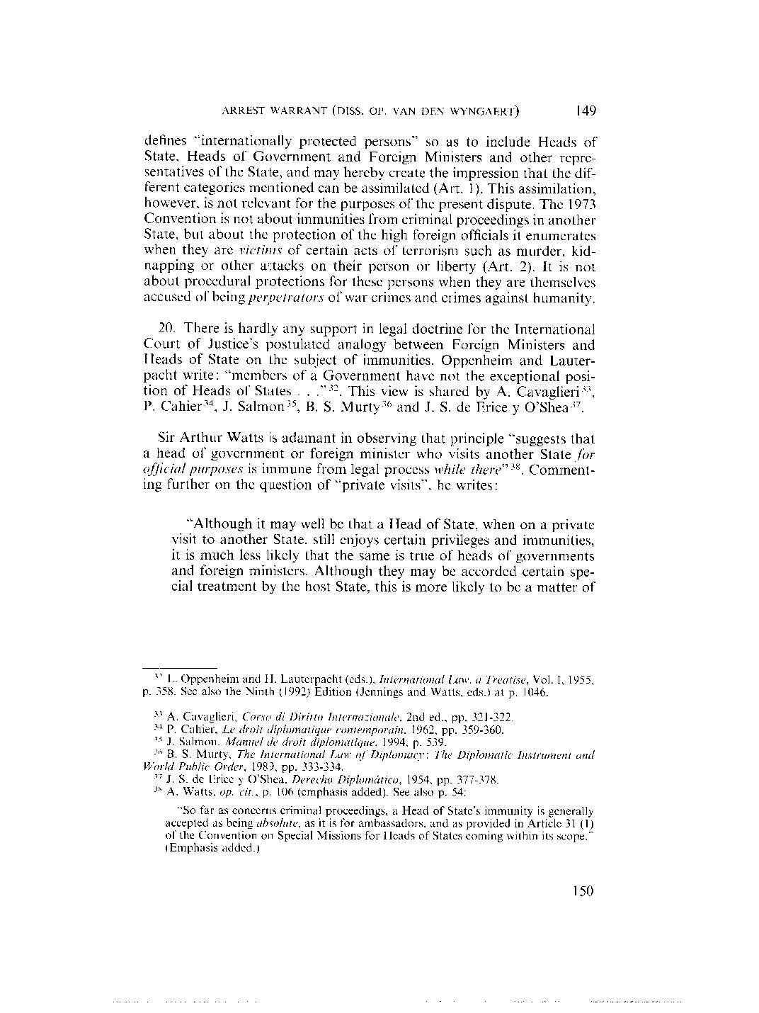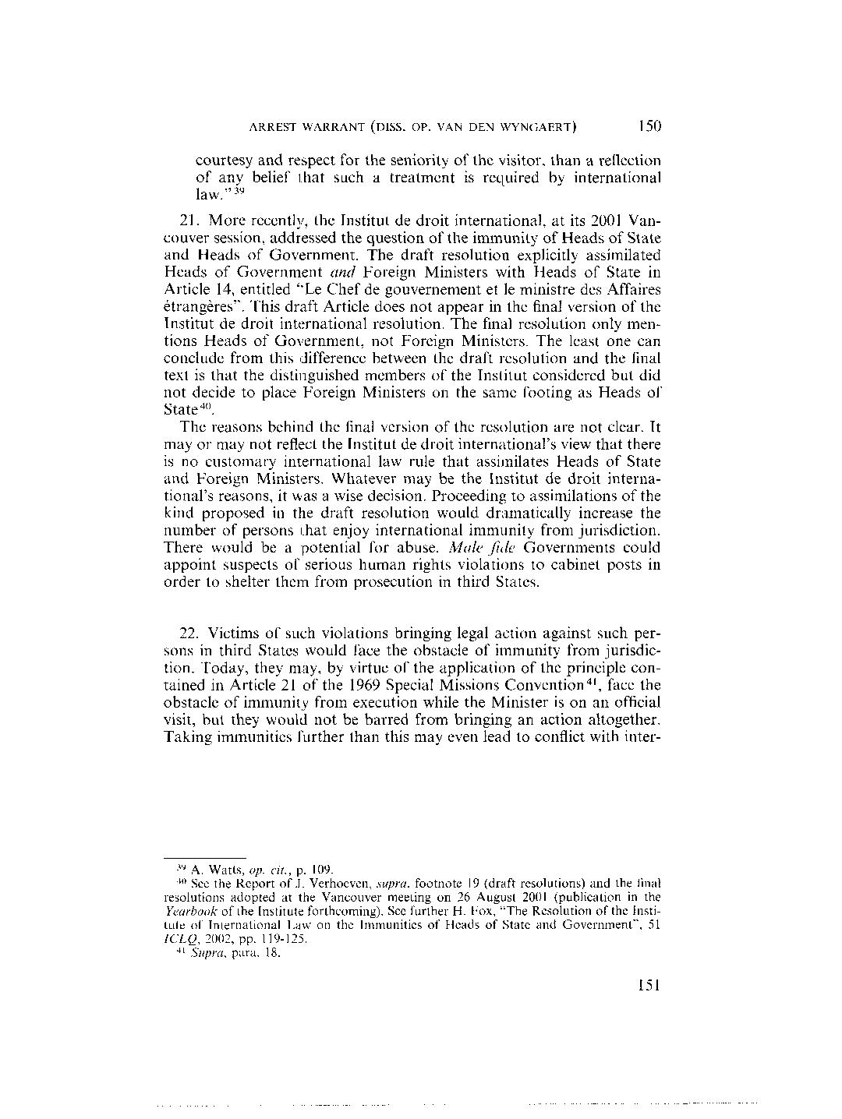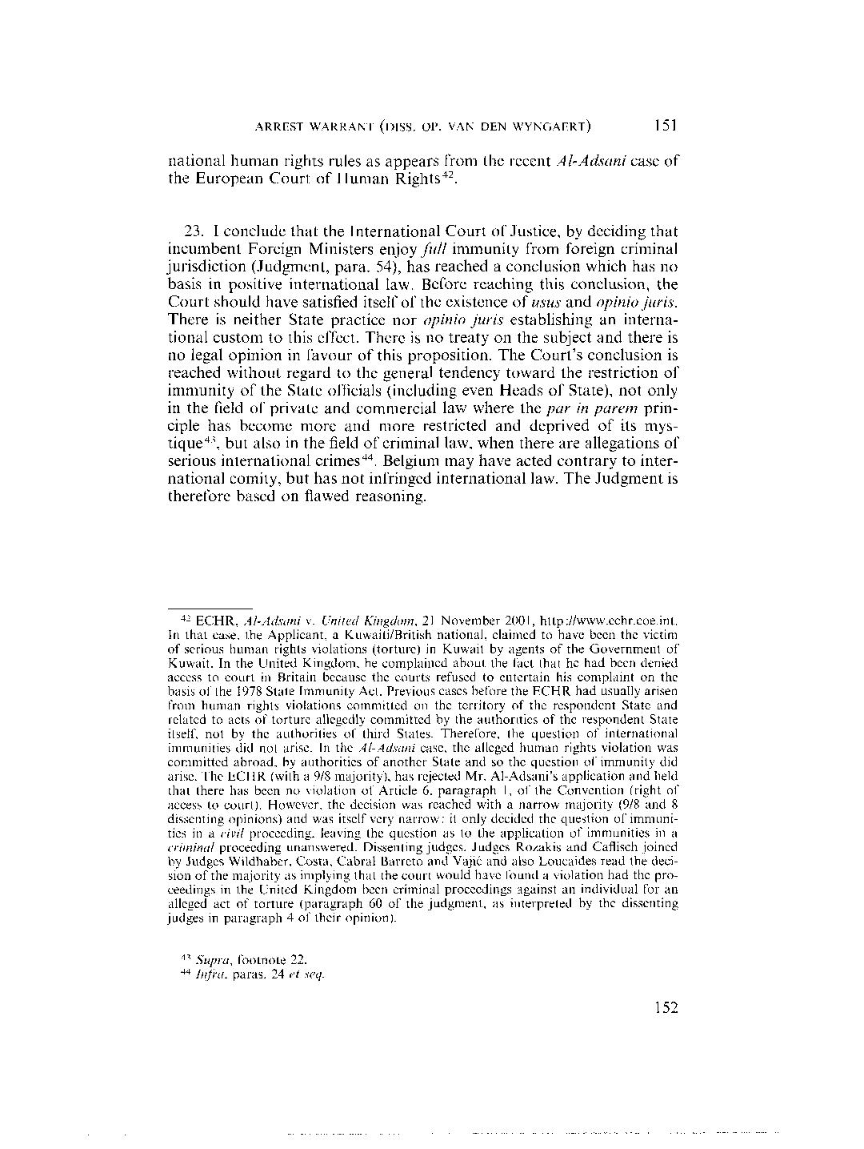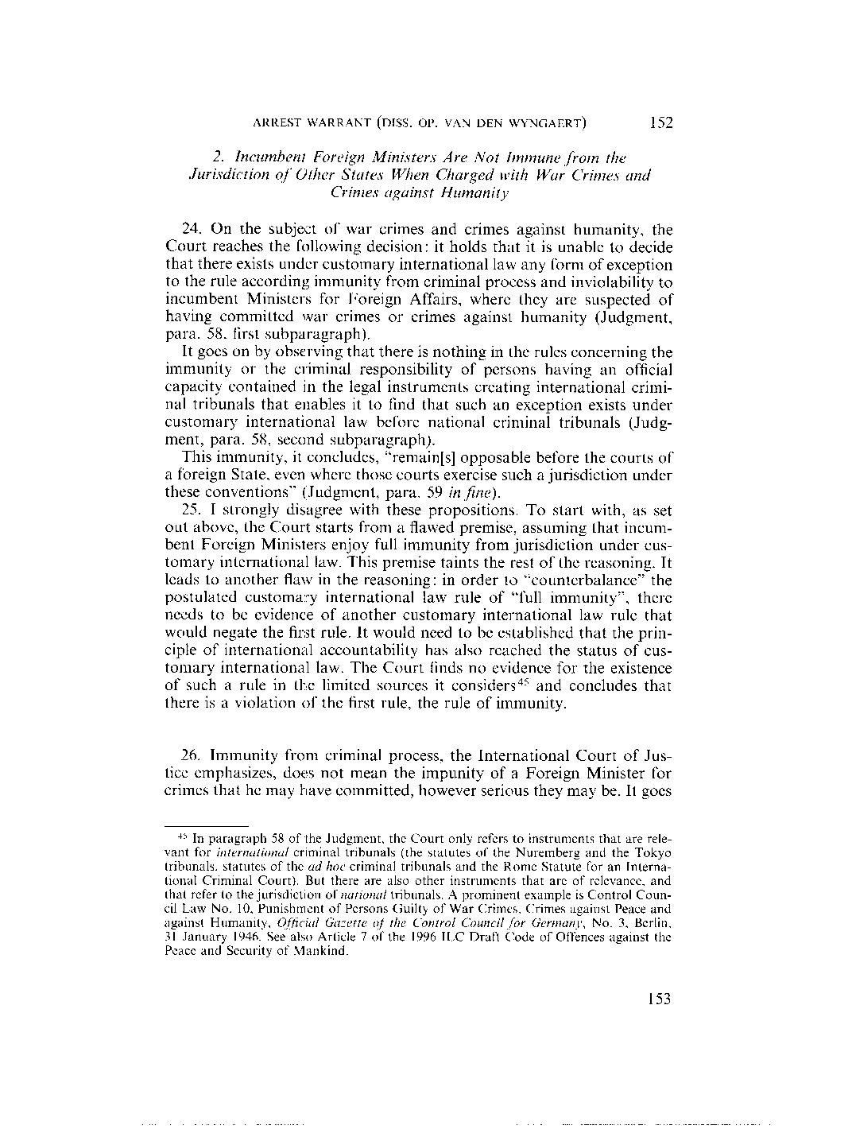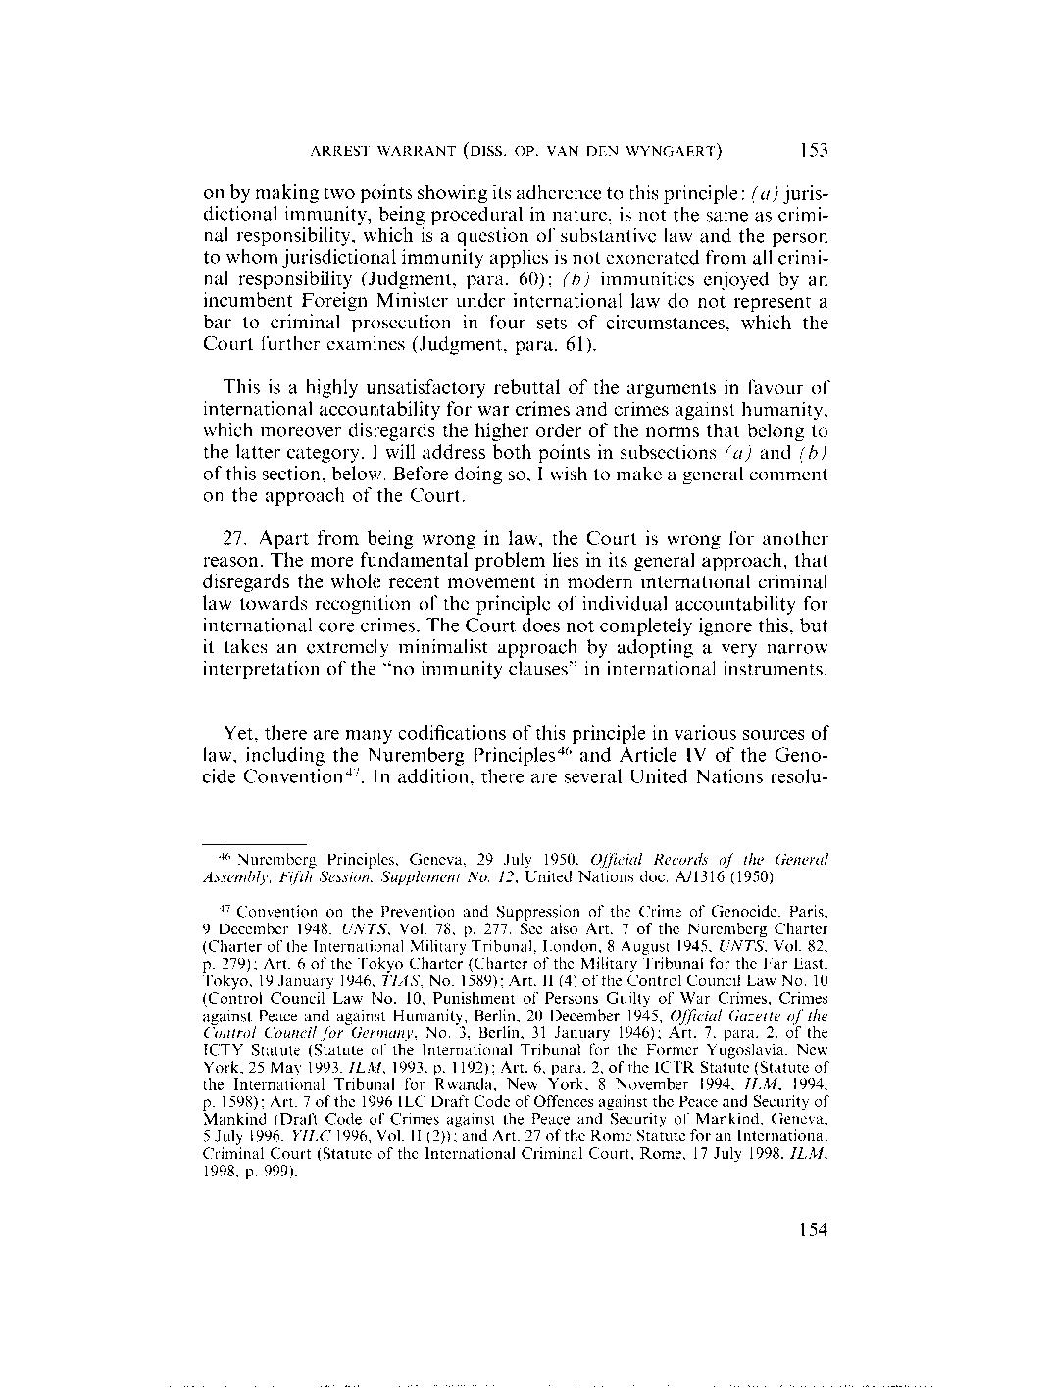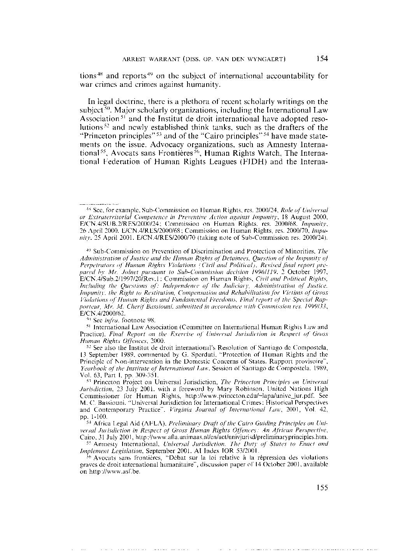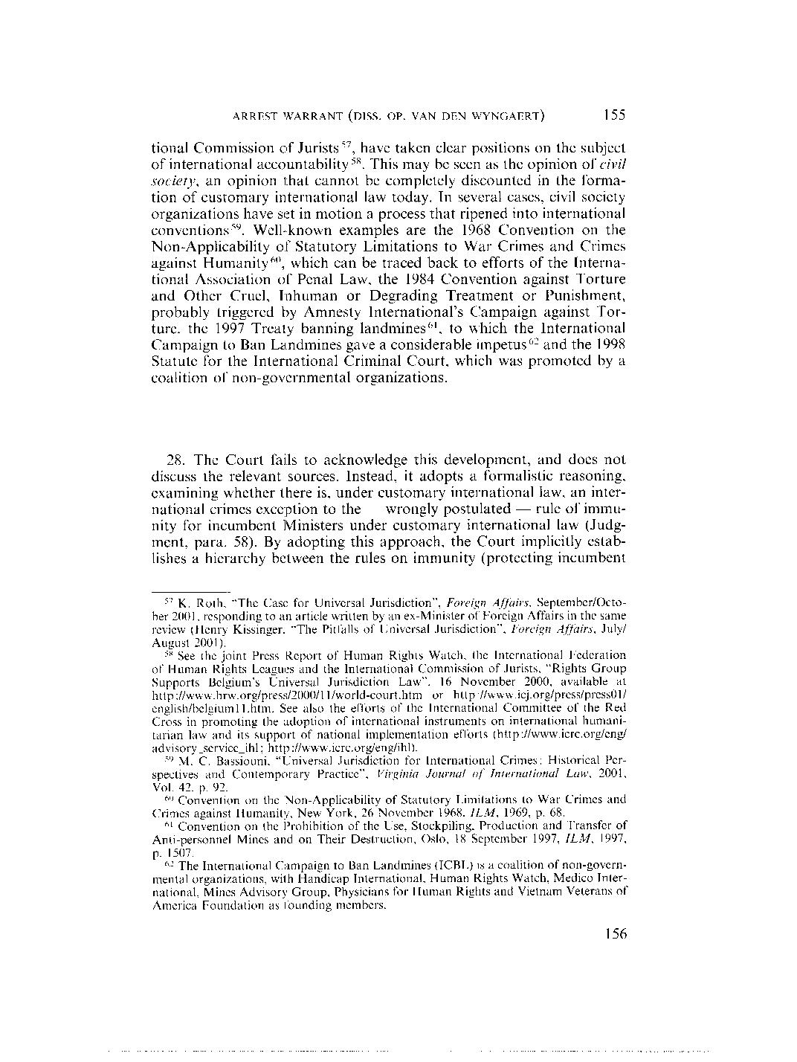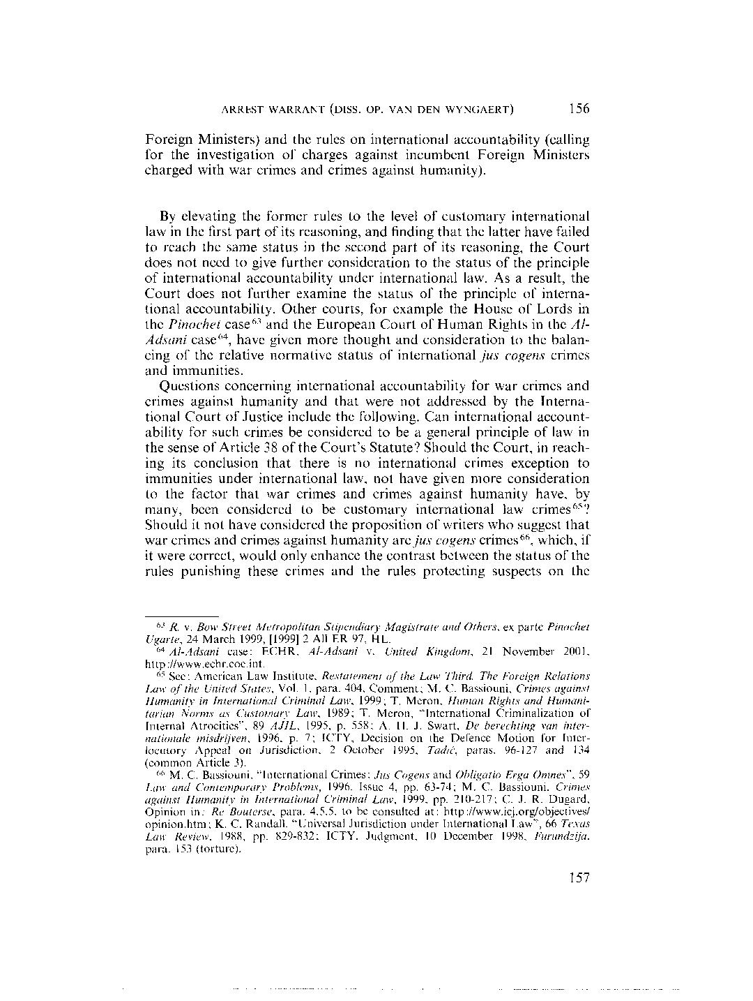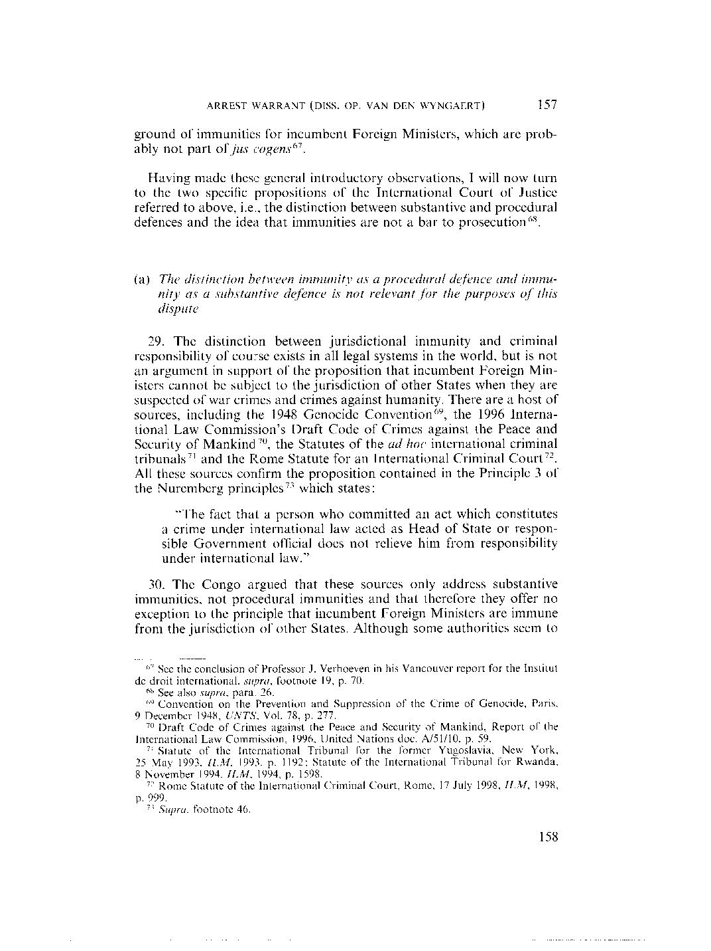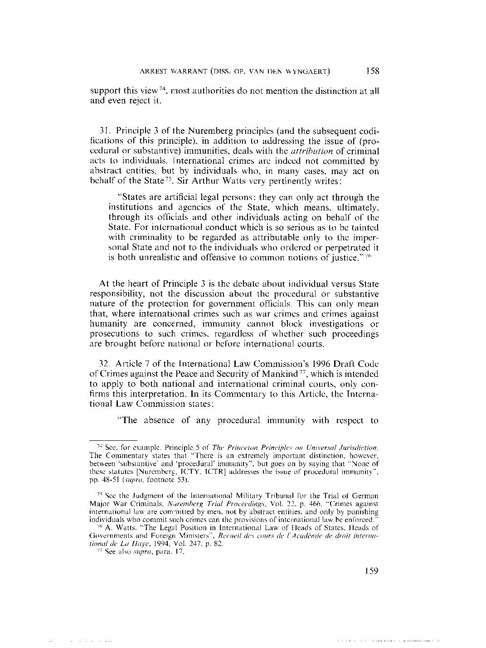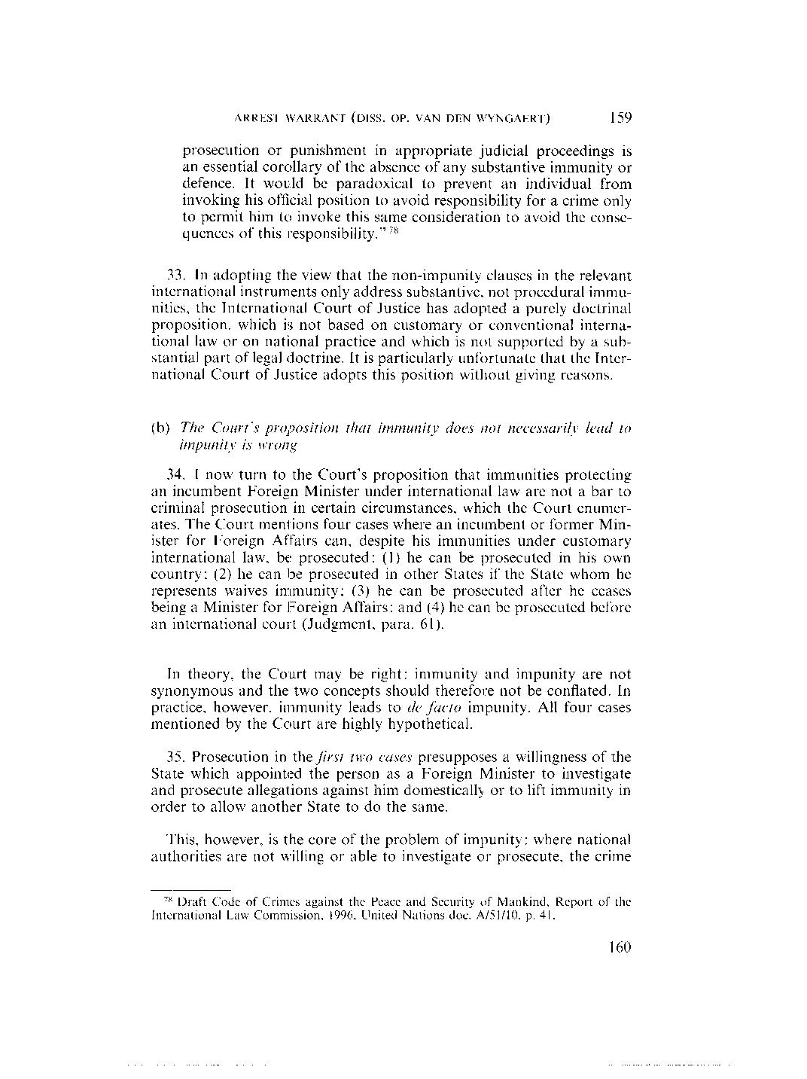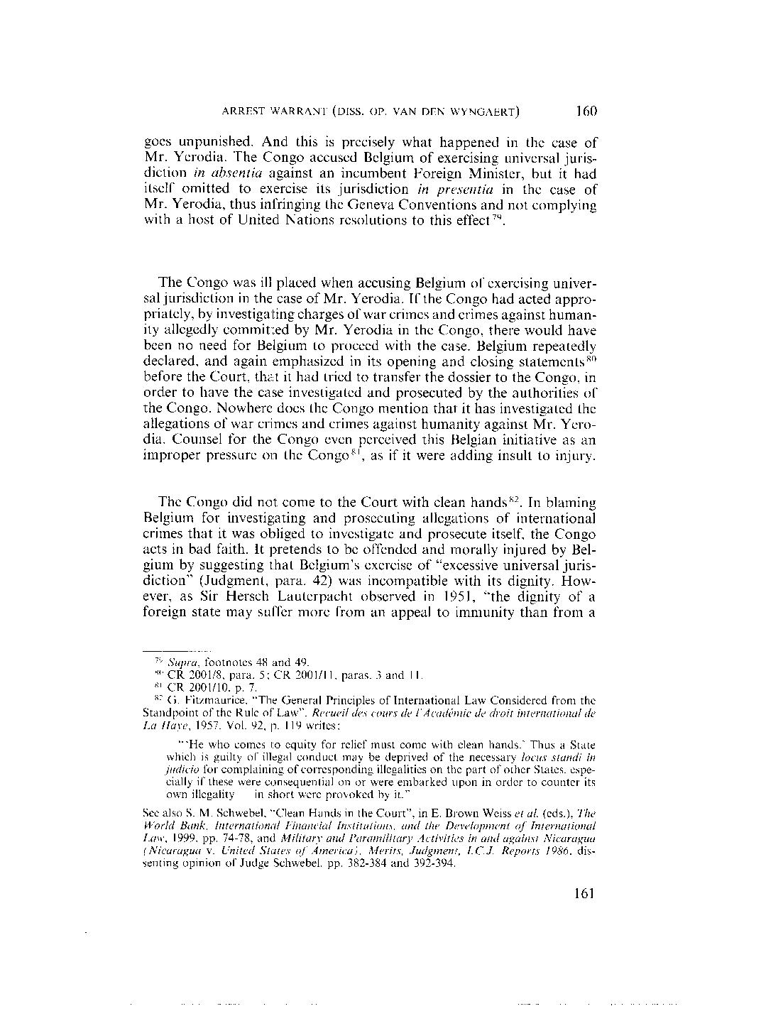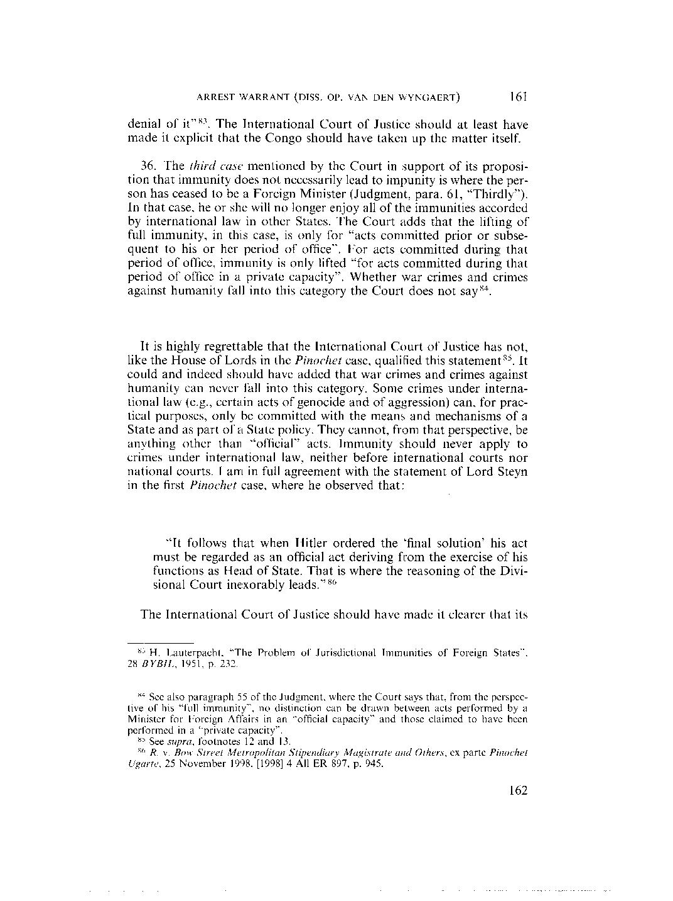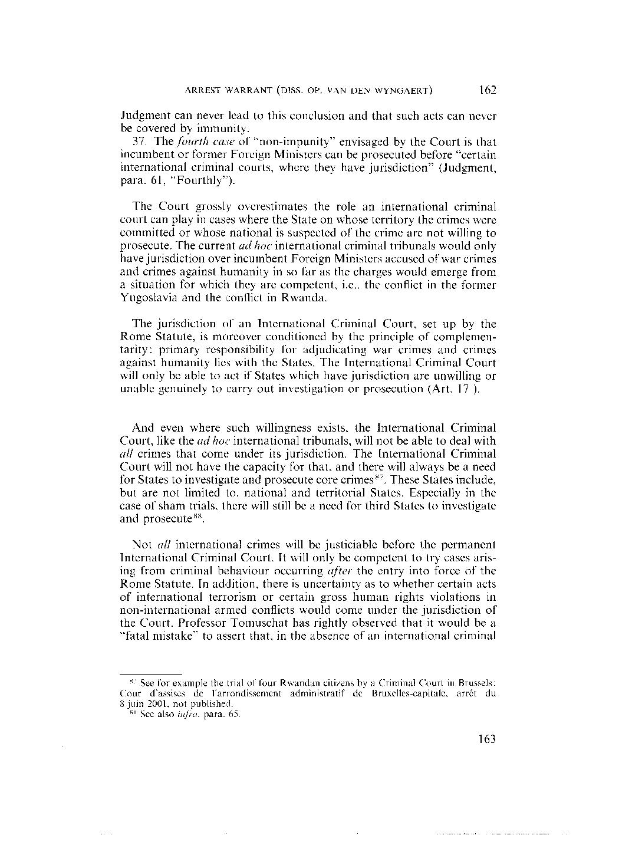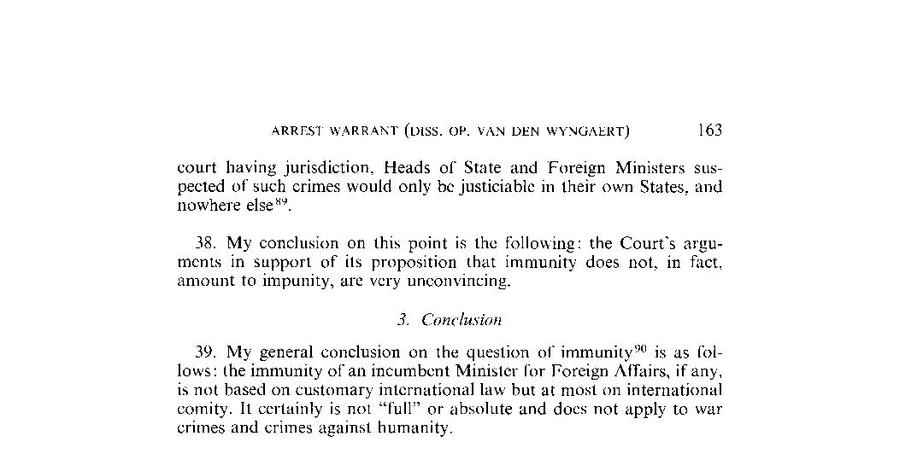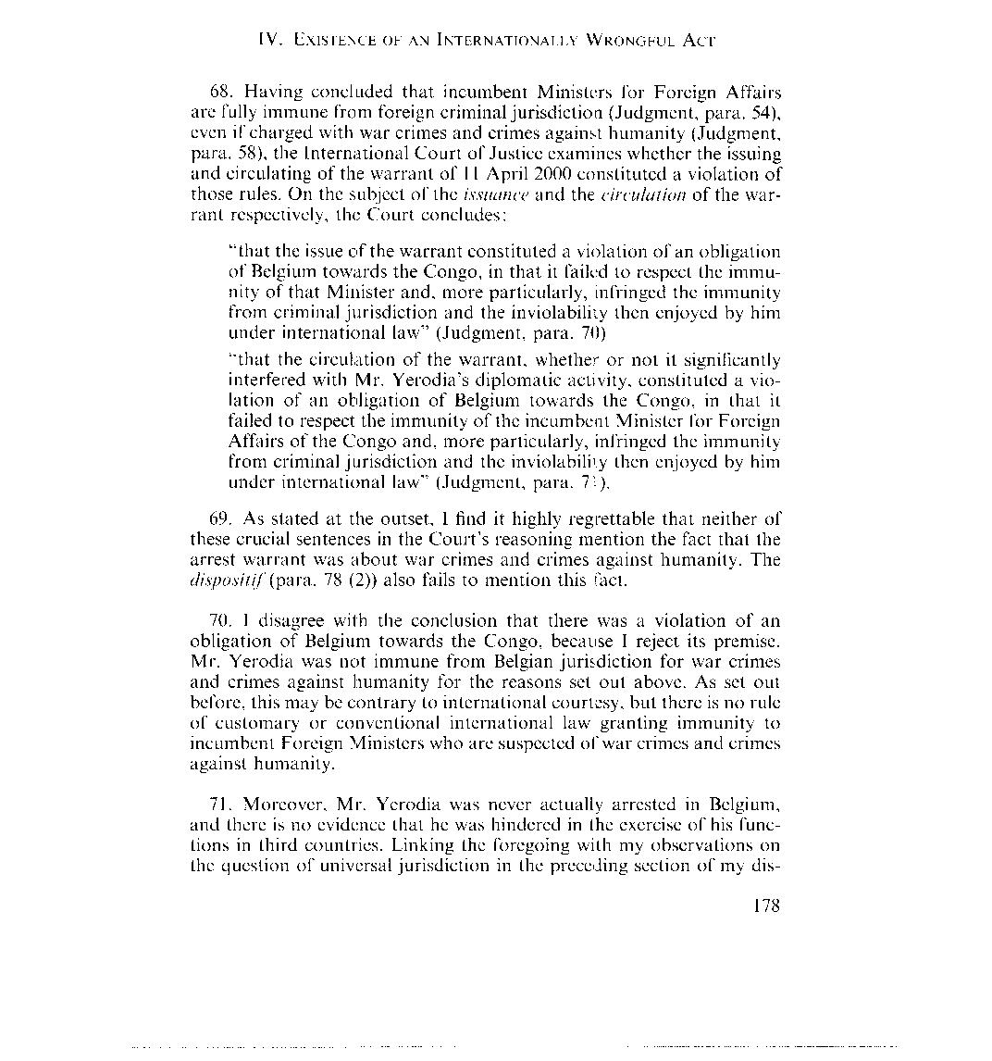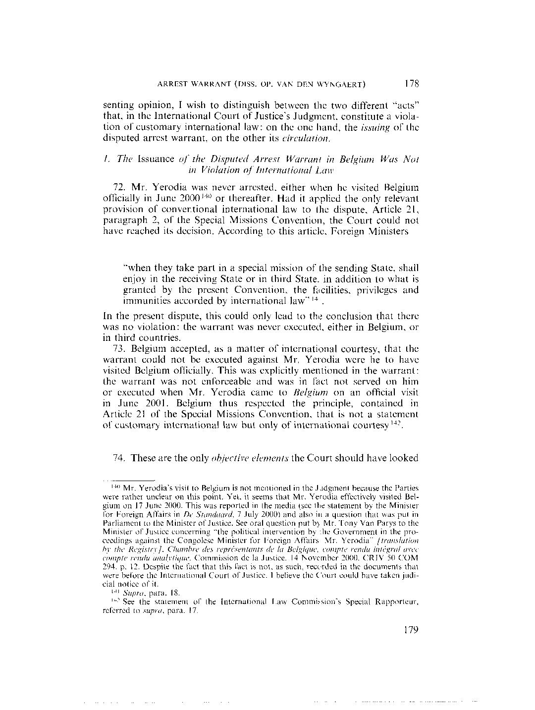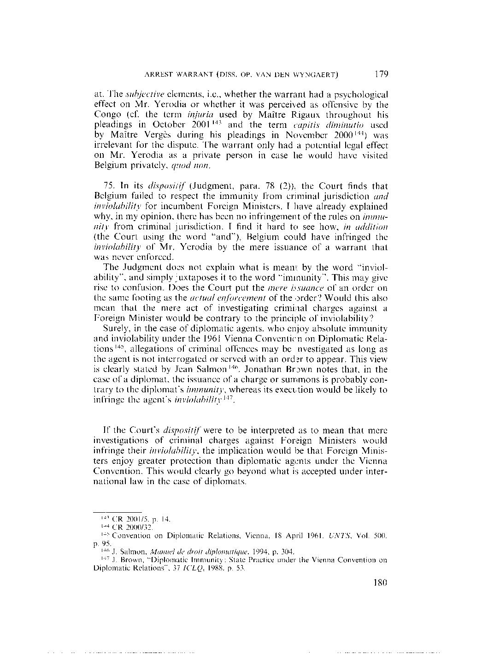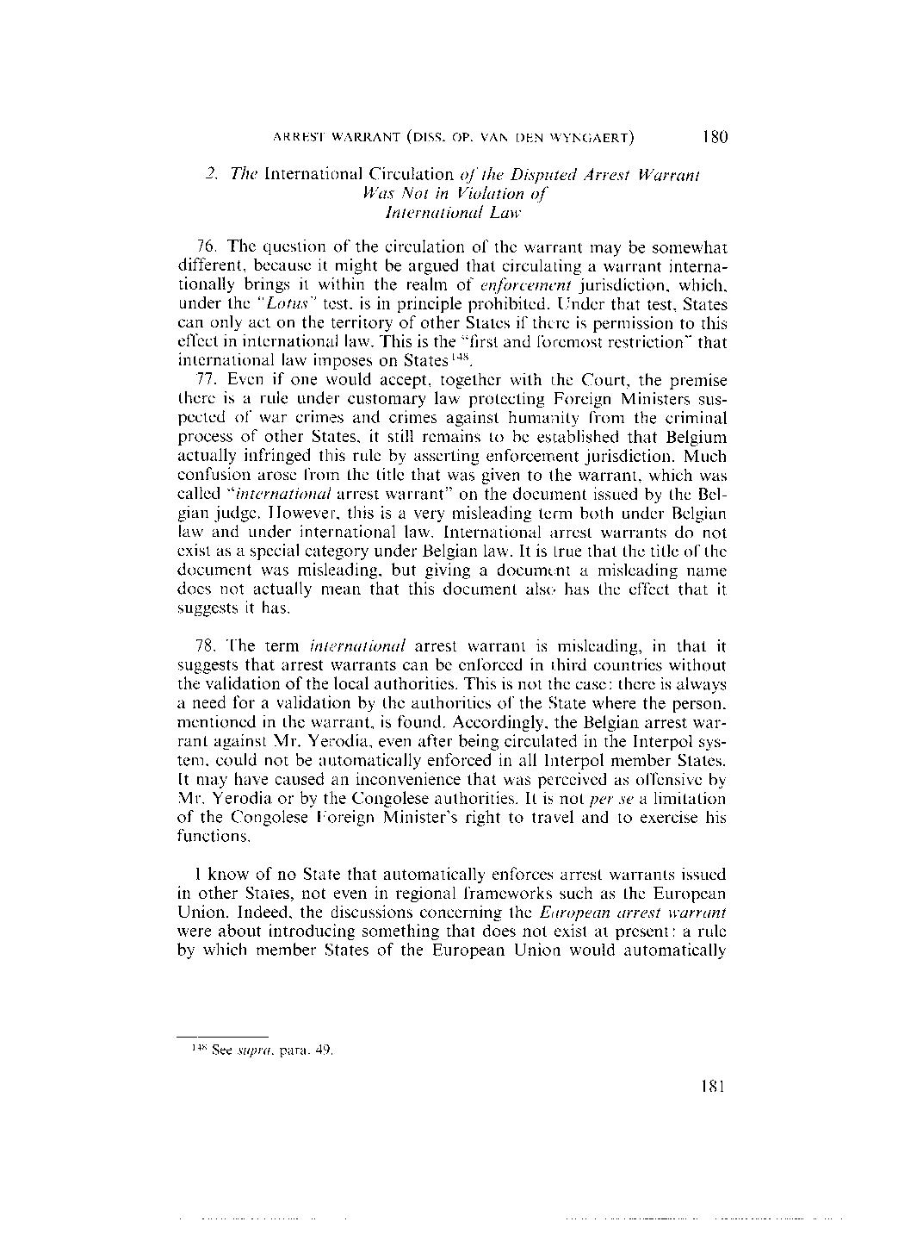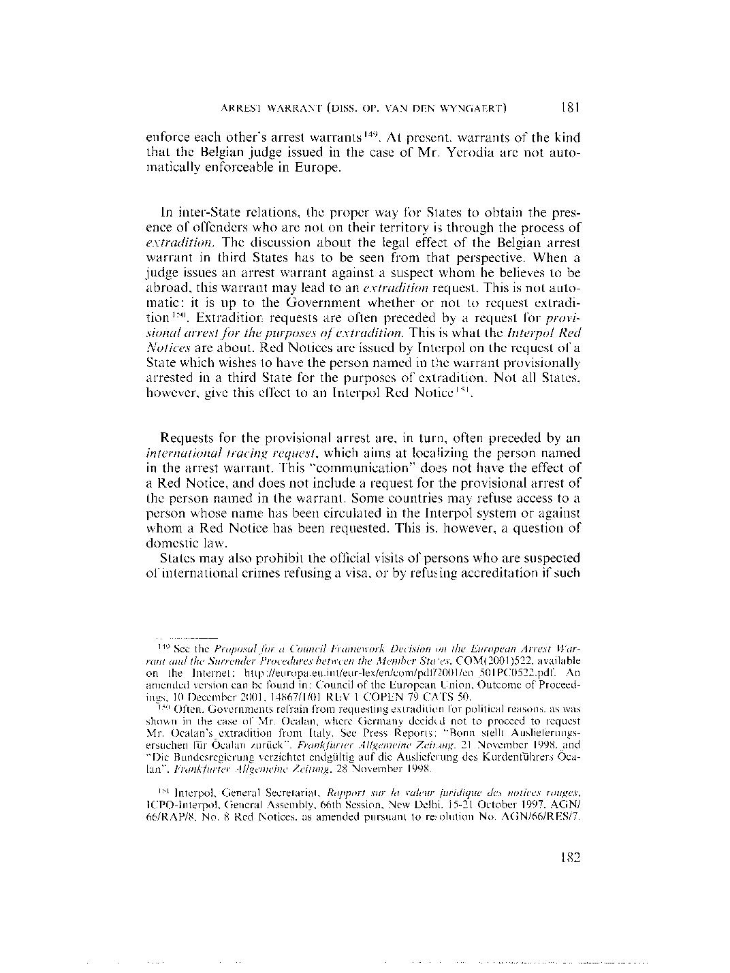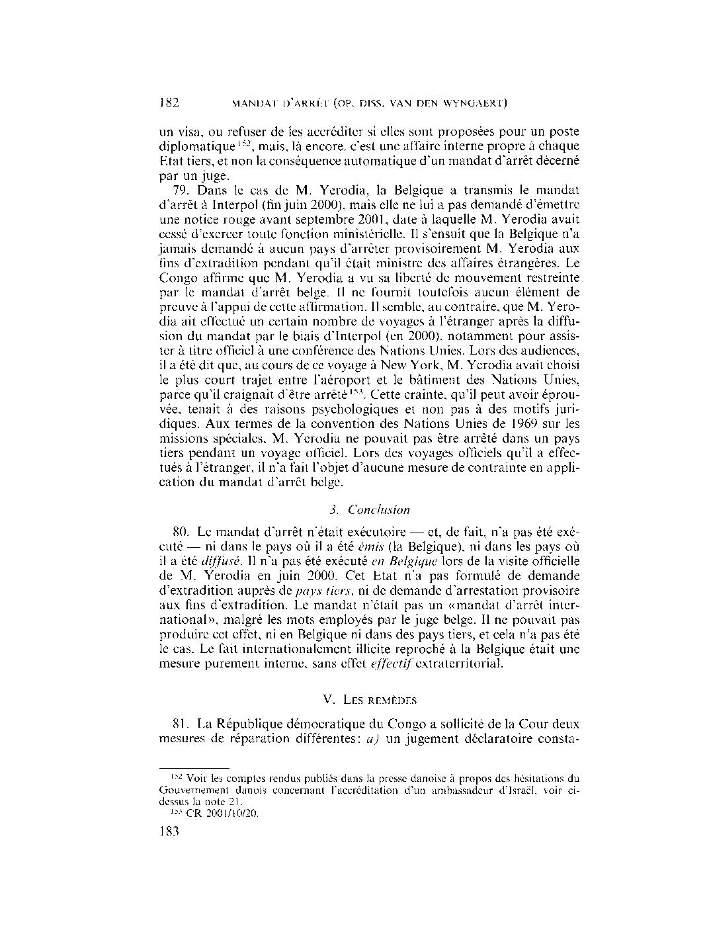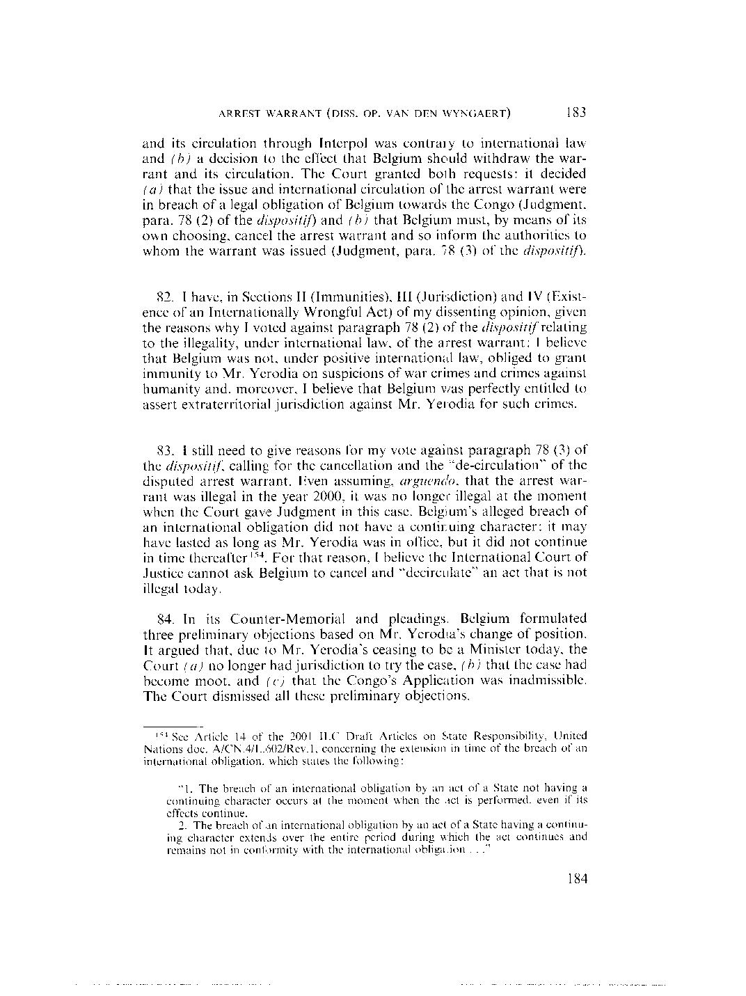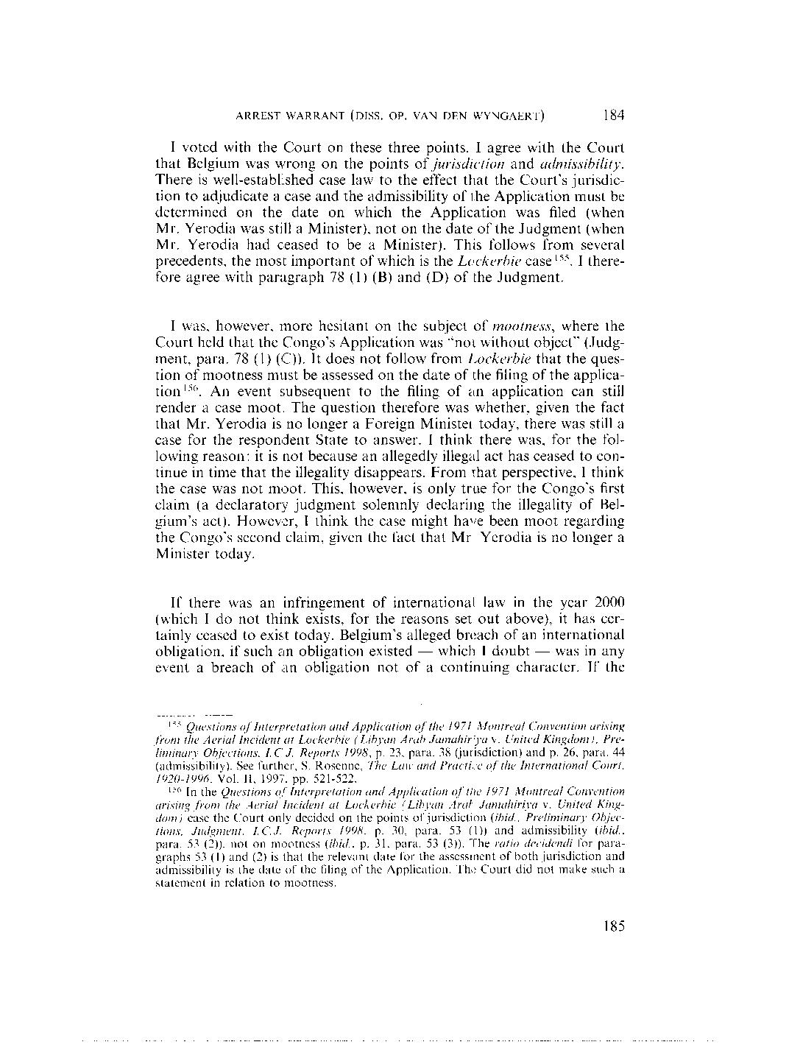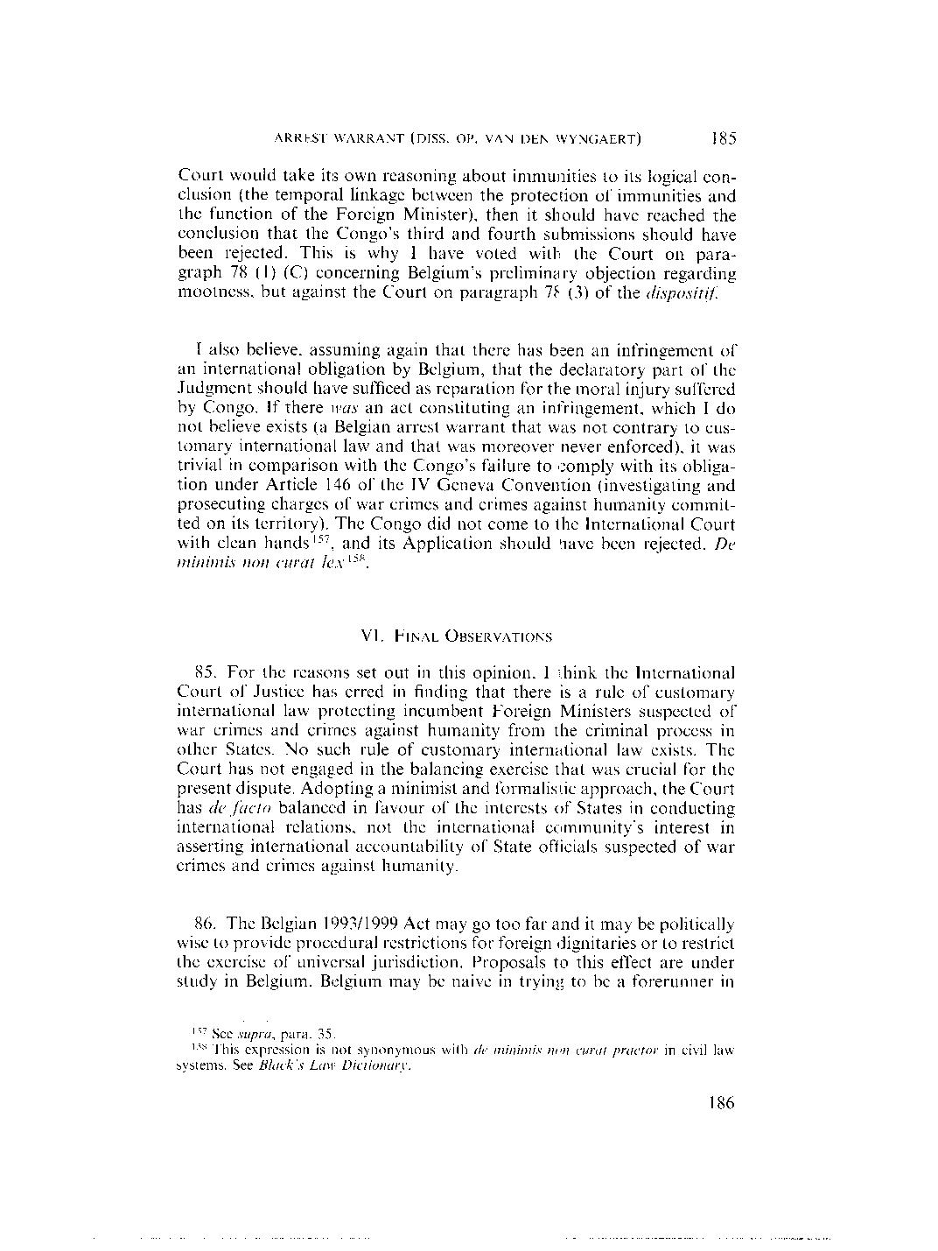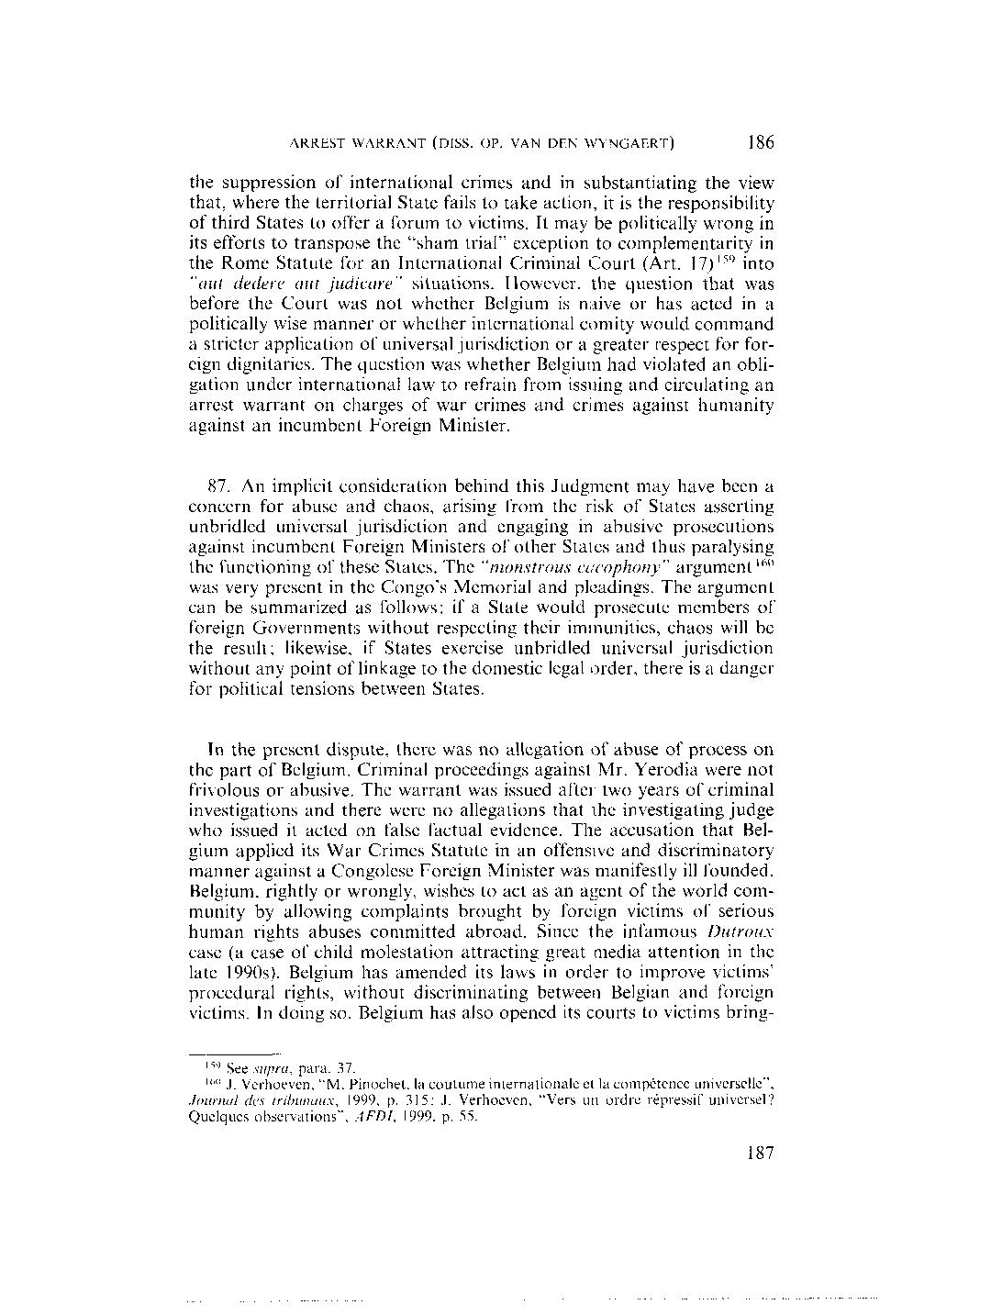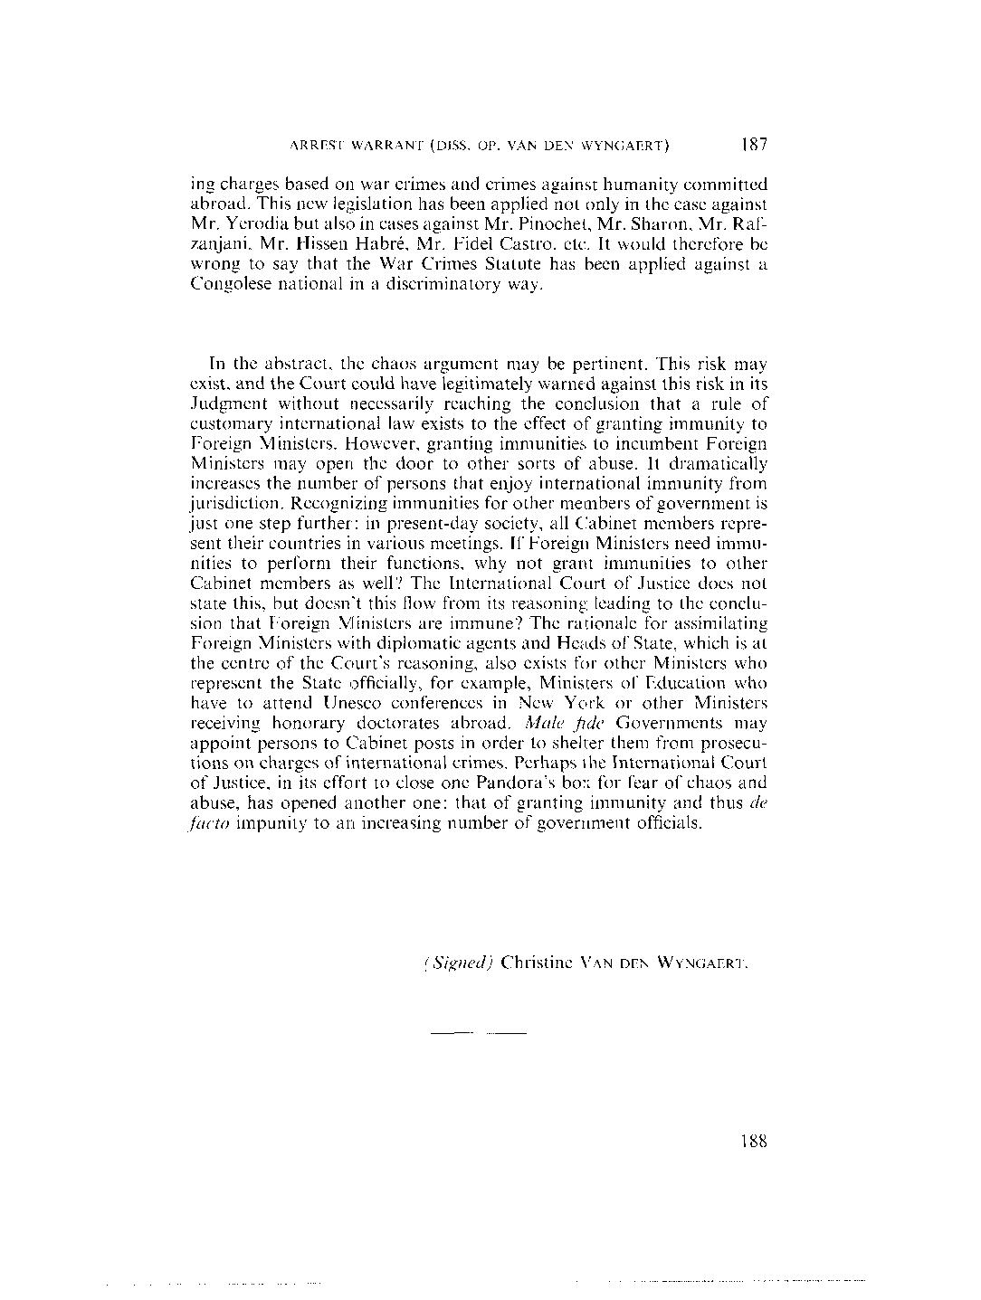

Appendix I: Universal Declaration of Human Rights

Preamble
Whereas recognition of the inherent dignity and of the equal and inalienable rights of all members of the human family is the foundation of freedom, justice and peace in the world,
Whereas disregard and contempt for human rights have resulted in barbarous acts which have outraged the conscience of mankind, and the advent of a world in which human beings shall enjoy freedom of speech and belief and freedom from fear and want has been proclaimed as the highest aspiration of the common people,
Whereas it is essential, if man is not to be compelled to have recourse, as a last resort, to rebellion against tyranny and oppression, that human rights should be protected by the rule of law,
Whereas it is essential to promote the development of friendly relations between nations,
Whereas the peoples of the United Nations have in the Charter reaffirmed their faith in fundamental human rights, in the dignity and worth of the human person and in the equal rights of men and women and have determined to promote social progress and better standards of life in larger freedom,
Whereas Member States have pledged themselves to achieve, in co-operation with the United Nations, the promotion of universal respect for and observance of human rights and fundamental freedoms,
Whereas a common understanding of these rights and freedoms is of the greatest importance for the full realization of this pledge,
Now, Therefore THE GENERAL ASSEMBLY proclaims THIS UNIVERSAL DECLARATION OF HUMAN RIGHTS as a common standard of achievement for all peoples and all nations, to the end that every individual and every organ of society, keeping this Declaration constantly in mind, shall strive by teaching and education to promote respect for these rights and freedoms and by progressive measures, national and international, to secure their universal and effective recognition and observance, both among the peoples of Member States themselves and among the peoples of territories under their jurisdiction.

Article 1.
All human beings are born free and equal in dignity and rights. They are endowed with reason and conscience and should act towards one another in a spirit of brotherhood.

Article 2.
Everyone is entitled to all the rights and freedoms set forth in this Declaration, without distinction of any kind, such as race, colour, sex, language, religion, political or other opinion, national or social origin, property, birth or other status. Furthermore, no distinction shall be made on the basis of the political, jurisdictional or international status of the country or territory to which a person belongs, whether it be independent, trust, non-self-governing or under any other limitation of sovereignty.

Article 3.
Everyone has the right to life, liberty and security of person.

Article 4.
No one shall be held in slavery or servitude; slavery and the slave trade shall be prohibited in all their forms.

Article 5.
No one shall be subjected to torture or to cruel, inhuman or degrading treatment or punishment.

Article 6.
Everyone has the right to recognition everywhere as a person before the law.

Article 7.
All are equal before the law and are entitled without any discrimination to equal protection of the law. All are entitled to equal protection against any discrimination in violation of this Declaration and against any incitement to such discrimination.

Article 8.
Everyone has the right to an effective remedy by the competent national tribunals for acts violating the fundamental rights granted him by the constitution or by law.

Article 9.
No one shall be subjected to arbitrary arrest, detention or exile.

Article 10.
Everyone is entitled in full equality to a fair and public hearing by an independent and impartial tribunal, in the determination of his rights and obligations and of any criminal charge against him.

Article 11.
(1) Everyone charged with a penal offence has the right to be presumed innocent until proved guilty according to law in a public trial at which he has had all the guarantees necessary for his defence.
(2) No one shall be held guilty of any penal offence on account of any act or omission which did not constitute a penal offence, under national or international law, at the time when it was committed. Nor shall a heavier penalty be imposed than the one that was applicable at the time the penal offence was committed.

Article 12.
No one shall be subjected to arbitrary interference with his privacy, family, home or correspondence, nor to attacks upon his honour and reputation. Everyone has the right to the protection of the law against such interference or attacks.

Article 13.
(1) Everyone has the right to freedom of movement and residence within the borders of each state.
(2) Everyone has the right to leave any country, including his own, and to return to his country.

Article 14.
(1) Everyone has the right to seek and to enjoy in other countries asylum from persecution.
(2) This right may not be invoked in the case of prosecutions genuinely arising from non-political crimes or from acts contrary to the purposes and principles of the United Nations.

Article 15.
(1) Everyone has the right to a nationality.
(2) No one shall be arbitrarily deprived of his nationality nor denied the right to change his nationality.

Article 16.
(1) Men and women of full age, without any limitation due to race, nationality or religion, have the right to marry and to found a family. They are entitled to equal rights as to marriage, during marriage and at its dissolution.
(2) Marriage shall be entered into only with the free and full consent of the intending spouses.
(3) The family is the natural and fundamental group unit of society and is entitled to protection by society and the State.

Article 17.
(1) Everyone has the right to own property alone as well as in association with others.
(2) No one shall be arbitrarily deprived of his property.

Article 18.
Everyone has the right to freedom of thought, conscience and religion; this right includes freedom to change his religion or belief, and freedom, either alone or in community with others and in public or private, to manifest his religion or belief in teaching, practice, worship and observance.

Article 19.
Everyone has the right to freedom of opinion and expression; this right includes freedom to hold opinions without interference and to seek, receive and impart information and ideas through any media and regardless of frontiers.

Article 20.
(1) Everyone has the right to freedom of peaceful assembly and association.
(2) No one may be compelled to belong to an association.

Article 21.
(1) Everyone has the right to take part in the government of his country, directly or through freely chosen representatives.
(2) Everyone has the right of equal access to public service in his country.
(3) The will of the people shall be the basis of the authority of government; this will shall be expressed in periodic and genuine elections which shall be by universal and equal suffrage and shall be held by secret vote or by equivalent free voting procedures.

Article 22.
Everyone, as a member of society, has the right to social security and is entitled to realization, through national effort and international co-operation and in accordance with the organization and resources of each State, of the economic, social and cultural rights indispensable for his dignity and the free development of his personality.

Article 23.
(1) Everyone has the right to work, to free choice of employment, to just and favourable conditions of work and to protection against unemployment.
(2) Everyone, without any discrimination, has the right to equal pay for equal work.
(3) Everyone who works has the right to just and favourable remuneration ensuring for himself and his family an existence worthy of human dignity, and supplemented, if necessary, by other means of social protection.
(4) Everyone has the right to form and to join trade unions for the protection of his interests.

Article 24.
Everyone has the right to rest and leisure, including reasonable limitation of working hours and periodic holidays with pay.

Article 25.
(1) Everyone has the right to a standard of living adequate for the health and well-being of himself and of his family, including food, clothing, housing and medical care and necessary social services, and the right to security in the event of unemployment, sickness, disability, widowhood, old age or other lack of livelihood in circumstances beyond his control.
(2) Motherhood and childhood are entitled to special care and assistance. All children, whether born in or out of wedlock, shall enjoy the same social protection.

Article 26.
(1) Everyone has the right to education. Education shall be free, at least in the elementary and fundamental stages. Elementary education shall be compulsory. Technical and professional education shall be made generally available and higher education shall be equally accessible to all on the basis of merit.
(2) Education shall be directed to the full development of the human personality and to the strengthening of respect for human rights and fundamental freedoms. It shall promote understanding, tolerance and friendship among all nations, racial or religious groups, and shall further the activities of the United Nations for the maintenance of peace.
(3) Parents have a prior right to choose the kind of education that shall be given to their children.

Article 27.

(1) Everyone has the right freely to participate in the cultural life of the community, to enjoy the arts and to share in scientific advancement and its benefits.
(2) Everyone has the right to the protection of the moral and material interests resulting from any scientific, literary or artistic production of which he is the author.

Article 28.
Everyone is entitled to a social and international order in which the rights and freedoms set forth in this Declaration can be fully realized.

Article 29.
(1) Everyone has duties to the community in which alone the free and full development of his personality is possible.
(2) In the exercise of his rights and freedoms, everyone shall be subject only to such limitations as are determined by law solely for the purpose of securing due recognition and respect for the rights and freedoms of others and of meeting the just requirements of morality, public order and the general welfare in a democratic society.
(3) These rights and freedoms may in no case be exercised contrary to the purposes and principles of the United Nations.

Article 30.
Nothing in this Declaration may be interpreted as implying for any State, group or person any right to engage in any activity or to perform any act aimed at the destruction of any of the rights and freedoms set forth herein.
UN Archive

