Case No. 762

Difference Relating to Immunity from Legal Process of a Special Reporter (Rapporteur) of the Commission on Human Rights (1999)

Applicant: Dato' Param Cumaraswamy, United Nations Commission on Human Rights Special Reporter* on the Independence of Judges and Lawyers

(*Also referred to as a “Rapporteur” in UN documents)

Respondent: Government of Malaysia

Case No. 762 is a closed case. The enclosed record contains the only references permissible to bring forth before the United Nations International Court of Justice. Mention of materials outside this record constitute grounds for dismissal.

Table of Contents

Case Summary

Statement of Fact

Questions Before the Court

Opinions of the Court
Summary of Opinions
Advisory Opinion (Majority Opinion)
Separate Opinion, Judge Oda
Separate Opinion, Vice-President Weeramantry
Dissenting Opinion, Judge Koroma

Appendix I:
Excerpt from the Convention on the Privileges and Immunities of the United Nations

Appendix II:
Universal Declaration of Human Rights

Case Summary

Court says that Mr. Cumaraswamy is entitled to immunity from legal process

for the words spoken by him during an interview
THE HAGUE, 29 April 1999. The International Court of Justice (ICJ) today handed down its Advisory Opinion on the request of the Economic and Social Council (ECOSOC), one of the six principal organs of the United Nations, in the case concerning the Difference Relating to Immunity from Legal Process of a Special Rapporteur of the Commission on Human Rights.
The Court was of the opinion, by fourteen votes to one, that Article VI, Section 22, of the Convention on the Privileges and Immunities of the United Nations was "applicable" in the case of Dato' Param Cumaraswamy, a Malaysian jurist who was appointed Special Rapporteur on the Independence of Judges and Lawyers by the United Nations Commission on Human Rights in 1994, and that he was "entitled to immunity from legal process of every kind for the words spoken by him during an interview as published in an article in the November 1995 issue of International Commercial Litigation".

Mr. Cumaraswamy currently faces several lawsuits filed in Malaysian courts by plaintiffs who assert that he used defamatory language in the interview and seek damages in a total amount of US$ 112 million. However, according to the United Nations Secretary-General, Mr. Kofi Annan, Mr. Cumaraswamy spoke in his official capacity of Special Rapporteur and was thus immune from legal process by virtue of the above-mentioned Convention.
ECOSOC, of which the Commission on Human Rights is a subsidiary organ, requested an advisory opinion on the issue from the Court in August 1998, after efforts by the Secretary-General to ensure respect for Mr. Cumaraswamy's immunity had not, in his view, achieved the desired result.

In its Advisory Opinion, the Court held that the Government of Malaysia should have informed the Malaysian courts of the finding of the Secretary-General and that these courts should have dealt with the question of immunity as a preliminary issue to be expeditiously decided. It unanimously stated that Mr. Cumaraswamy should be "held financially harmless for any costs imposed upon him by the Malaysian courts, in particular taxed costs".
The Court also found, by thirteen votes to two, that the Government of Malaysia now had "the obligation to communicate [the] advisory opinion to the Malaysian courts, in order that Malaysia's international obligations be given effect and [Mr.] Cumaraswamy's immunity be respected".

Although advisory opinions given by the Court are not generally binding, Article VIII, Section 30, of the above-mentioned Convention provides that those rendered in the event of a difference between the United Nations and a member State "shall be accepted as decisive by the parties". All proceedings in the Malaysian courts have been stayed pending receipt of the opinion.

Reasoning of the Court

The Court first states that ECOSOC's request for an advisory opinion meets the conditions set out in the Statute. The question asked is a legal one and it falls within the scope of the activities of ECOSOC. The Court thus has jurisdiction to answer it.

The Court then recalls that a special rapporteur who is entrusted with a mission for the United Nations must be regarded as an expert on mission within the meaning of Article VI, Section 22, of the Convention on the Privileges and Immunities of the United Nations. It observes that Malaysia has acknowledged that Mr. Cumaraswamy is an expert on mission and that such experts enjoy the privileges and immunities provided for under the Convention in their relations with States parties, including those of which they are nationals.

The Court goes on to consider whether the immunity applies to Mr. Cumaraswamy in the specific circumstances of the case. It points out that the Secretary-General, as the chief administrative officer of the United Nations, has the primary responsibility and authority to assess whether its agents, including experts on mission, acted within the scope of their functions and, where he so concludes, to protect these agents by asserting their immunity. In doing so, the Secretary-General, in accordance with the provisions of the above-mentioned Convention, protects the mission with which the expert is entrusted. The Court observes that, in the present case, the Secretary-General was reinforced in his view that Mr. Cumaraswamy had spoken in his official capacity by the fact that he was referred to several times in the article in International Commercial Litigation in his capacity as Special Rapporteur and that, in 1997, the Commission on Human Rights had extended his mandate for another three years, thereby acknowledging that he had not gone beyond his functions by giving the interview.

Turning to Malaysia's legal obligations, the Court states that, when national courts are seised of a case in which the immunity of a United Nations agent is in issue, they should immediately be notified of any finding by the Secretary-General and give that finding the greatest weight. Questions of immunity are preliminary issues which must be expeditiously decided by national courts in limine litis (at the very outset of the proceedings). Since the conduct of any organ of a State, including its courts, must be regarded as an act of that State, the Court concludes that the Government of Malaysia did not act in accordance with its obligations under international law in the present case.

ICJ Press Release

Statement of Fact

The Commission on Human Rights in 1994 appointed Dato' Param Cumaraswamy, a Malaysian jurist, as the Commission's Special Reporter on the Independence of Judges and Lawyers. His mandate consists of tasks including, inter alia, to enquire into substantial allegations concerning, and to identify and record attacks on, the independence of the judiciary, lawyers and court officials. Mr. Cumaraswamy has submitted four reports to the Commission on the execution of his mandate. After the third report containing a section on the litigation pending against him in the Malaysian civil courts, the Commission, in April 1997, renewed his mandate for an additional three years.

As a result of an article published on the basis of an interview which the Special Reporter gave to a magazine (International Commercial Litigation) in November 1995, two commercial companies in Malaysia asserted that said article contained defamatory words that had "brought them into public scandal and contempt". Each company filed a suit against him for damages amounting to $30 million (approximately US $12 million each), "including exemplary damages for slander".

Acting on behalf of the Secretary-General, the Legal Counsel of the United Nations considered the circumstances of the interview and of the controverted passages of the article and determined that Dato' Param Cumaraswamy was interviewed in his official capacity as Special Reporter on the Independence of Judges and Lawyers that the article clearly referred to his United Nations capacity and to the Special Reporter's global mandate to investigate allegations concerning the independence of the judiciary and that the quoted passages related to such allegations. On 15 January 1997, the Legal Counsel, in a note verbale, "requested the competent Malaysian authorities to promptly advise the Malaysian courts of the Special Reporter's immunity from legal process" with respect to that particular complaint. On 20 January 1997, the Special Reporter filed an application in the High Court of Kuala Lumpur (the trial court in which the suit had been filed) to set aside and/or strike out the plaintiff's' writ, on the ground that the words that were the subject of the suits had been spoken by him in the course of performing his mission for the United Nations as Special Reporter on the Independence of Judges and Lawyers. The Secretary-General issued a note on 7 March 1997 confirming that "the words which constitute the basis of plaintiffs' complaint in this case were spoken by the Special Reporter in the course of his mission" and that the Secretary-General "therefore maintains that Dato' Param. Cumaraswamy is immune from legal process with respect thereto". The Special Reporter filed this note in support of his above-mentioned application.

In spite of representations that had been made by the Office of Legal Affairs, a certificate filed by the Malaysian Minister for Foreign Affairs with the trial court failed to refer in any way to the note that the Secretary-General had issued a few days earlier and that had in the meantime been filed with the court, nor did it indicate that in this respect, i.e., in deciding whether particular words - acts of an expert fell within the scope of his mission, the determination could exclusively be made by the Secretary-General, and that such determination had conclusive effect and therefore had .to be accepted as such by the court. In spite of repeated requests by the Legal Counsel, the Minister for Foreign Affairs refused to amend his certificate or to supplement it in the manner urged by the United Nations.

On 28 June 1997, the competent judge of the Malaysian concluded that she was "unable to hold that the Defendant is absolutely protected by the immunity he claims", in part because she considered that the Secretary-General's note was merely "an opinion" with scant probative value and no binding force upon the court and that the Minister for Foreign Affairs' certificate "would appear to be no more than a bland statement as to a state of fact pertaining to the Defendant's status and mandate as a Special Reporter and appears to have room for interpretation". The Court ordered that the Special Reporter's motion be dismissed with costs, that costs be taxed and paid forthwith by him and that he file and serve his defence within 14 days. On 8 July, the Court of Appeal dismissed Mr. Cumaraswamy’s motion for a stay of execution.

In July 1997, the Legal Counsel called on the Malaysian Government to intervene in the current proceedings so that the burden of any further defence, including any expenses and taxed costs resulting therefrom, could be assumed by the Government; to hold Mr. Cumaraswamy harmless in respect of the expenses he had already incurred or that were being taxed to him in respect of the proceedings so far; and, so as to prevent the accumulation of additional expenses and costs and the further need to submit a defence until the matter of his immunity was definitively resolved between the United Nations and the Government, to support a motion to have the High Court proceedings stayed until such resolution. The Legal Counsel referred to the provisions for the settlement of differences arising out of the interpretation and application of the 1946 Convention that might arise between the Organization and a member State, which are set out in Section 30 of the Convention, and indicated that if the Government decided that it could not or did not wish to protect and to hold harmless the Special Reporter in the indicated manner, a difference within the meaning of those provisions might be considered to have arisen between the Organization and the Government of Malaysia.

Section 30 of the Convention provides as follows: "Section 30: All differences arising out of the interpretation or application of the present convention shall be referred to the International Court of Justice, unless in any case it is agreed by the parties to have recourse to another mode of settlement. If a difference arises between the United Nations on the one hand and a Member on the other hand, a request shall be made for an advisory opinion on any legal question involved in accordance with Article 96 of the Charter and Article 65 of the Statute of the Court. The opinion given by the Court shall be accepted as decisive by the parties."

On 10 July, yet another lawsuit was filed against the Special Reporter. On 11 July, the Secretary-General issued a note corresponding to the one of 7 March 1997 and also communicated a note verbale with essentially the same text to the Permanent Representative of Malaysia with the request that it be presented formally to the competent Malaysian court by the Government. On 23 October and 21 November 1997 new plaintiffs filed third and fourth lawsuits against the Special Reporter. On 27 October and 32 November 1997. the Secretary-General issued identical certificates of the Special Reporter's immunity.

On 7 November 1997, the Secretary-General advised the Prime Minister of Malaysia that a difference might have arisen between the United Nations and the Government of Malaysia and about the possibility of resorting to the International Court of Justice pursuant to Section 30 of the Convention. Nonetheless on 19 February 1998, the Federal Court of Malaysia denied Mr. Cumaraswamy’s application for leave to appeal stating that he was neither a sovereign nor a full-fledged diplomat but merely "an unpaid, part-time provider of information".

The Secretary-General then appointed a Special Envoy, Maitre Yves Fortier of Canada, who, after two official visits to Kuala Lumpur, and after negotiations to reach an out of court settlement had failed, advised that the matter should be referred to the Council to request an advisory opinion from the international Court of Justice. The United Nations had exhausted all efforts to reach either a negotiated settlement or a joint submission through the Council to the International Court of Justice. In this connection, the Government of Malaysia had acknowledged the Organization's right to refer the matter to the Council to request an advisory opinion in accordance with Section 30 of the Convention, advised the Secretary-General's Special Envoy that the United Nations should proceed to do so, and indicated that, while it would make its own presentations to the International Court of Justice, it did not oppose the submission of the matter to that Court through the Council.

Questions Before the Court

- Does Article VI, Section 22, of the Convention on the Privileges and Immunities of the United Nations apply in the case of Dato' Param Cumaraswamy as Special Reporter of the Commission on Human Rights on the Independence of Judges and Lawyers?

- If Article VI, Section 22 applies, is Dato' Parain Cumaraswamy entitled to immunity from legal process of every kind for the words spoken by him during an interview as published in an article in the November 1995 issue of International Commercial Litigation?

- Does the Malaysian courts have the obligation to deal with the question of immunity from legal process as a preliminary issue to be expeditiously decided limine litis (at the beginning of the court procedure)?

Opinions of the Court

Summary of Opinions

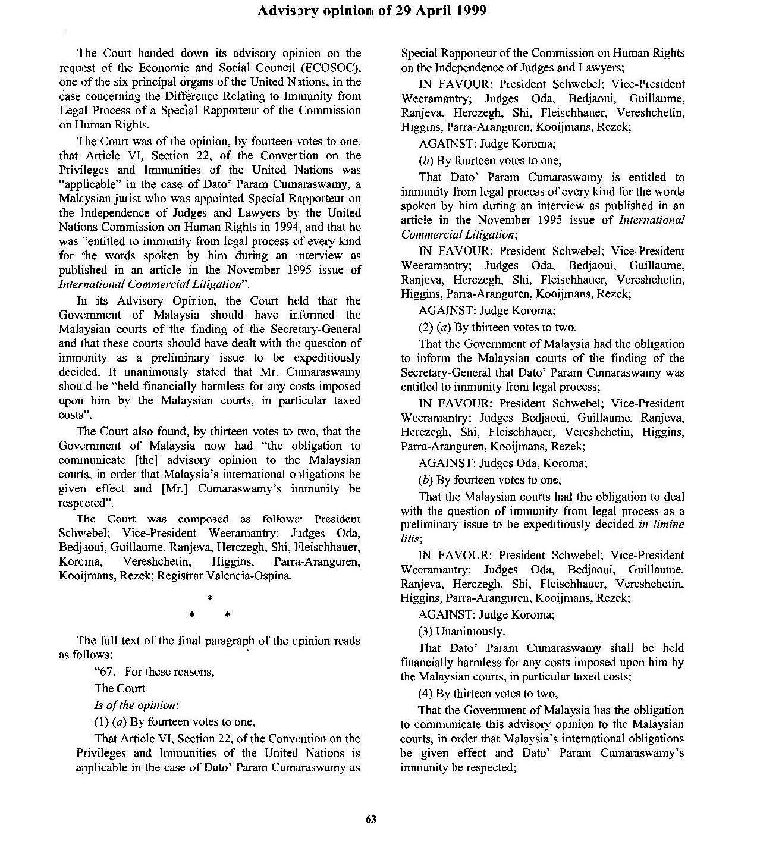
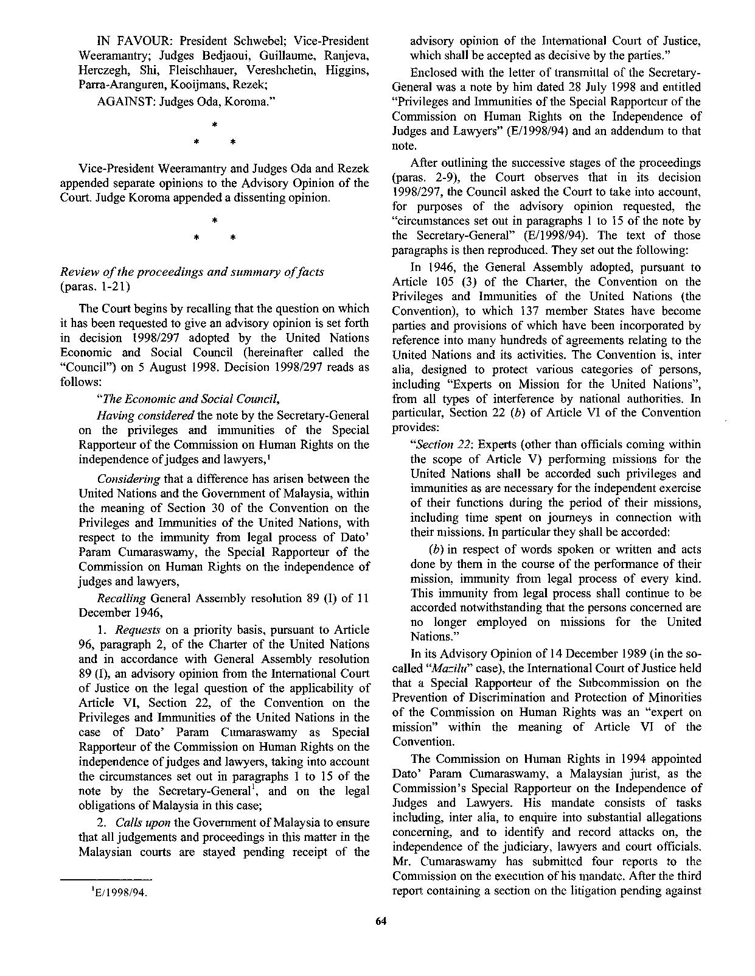

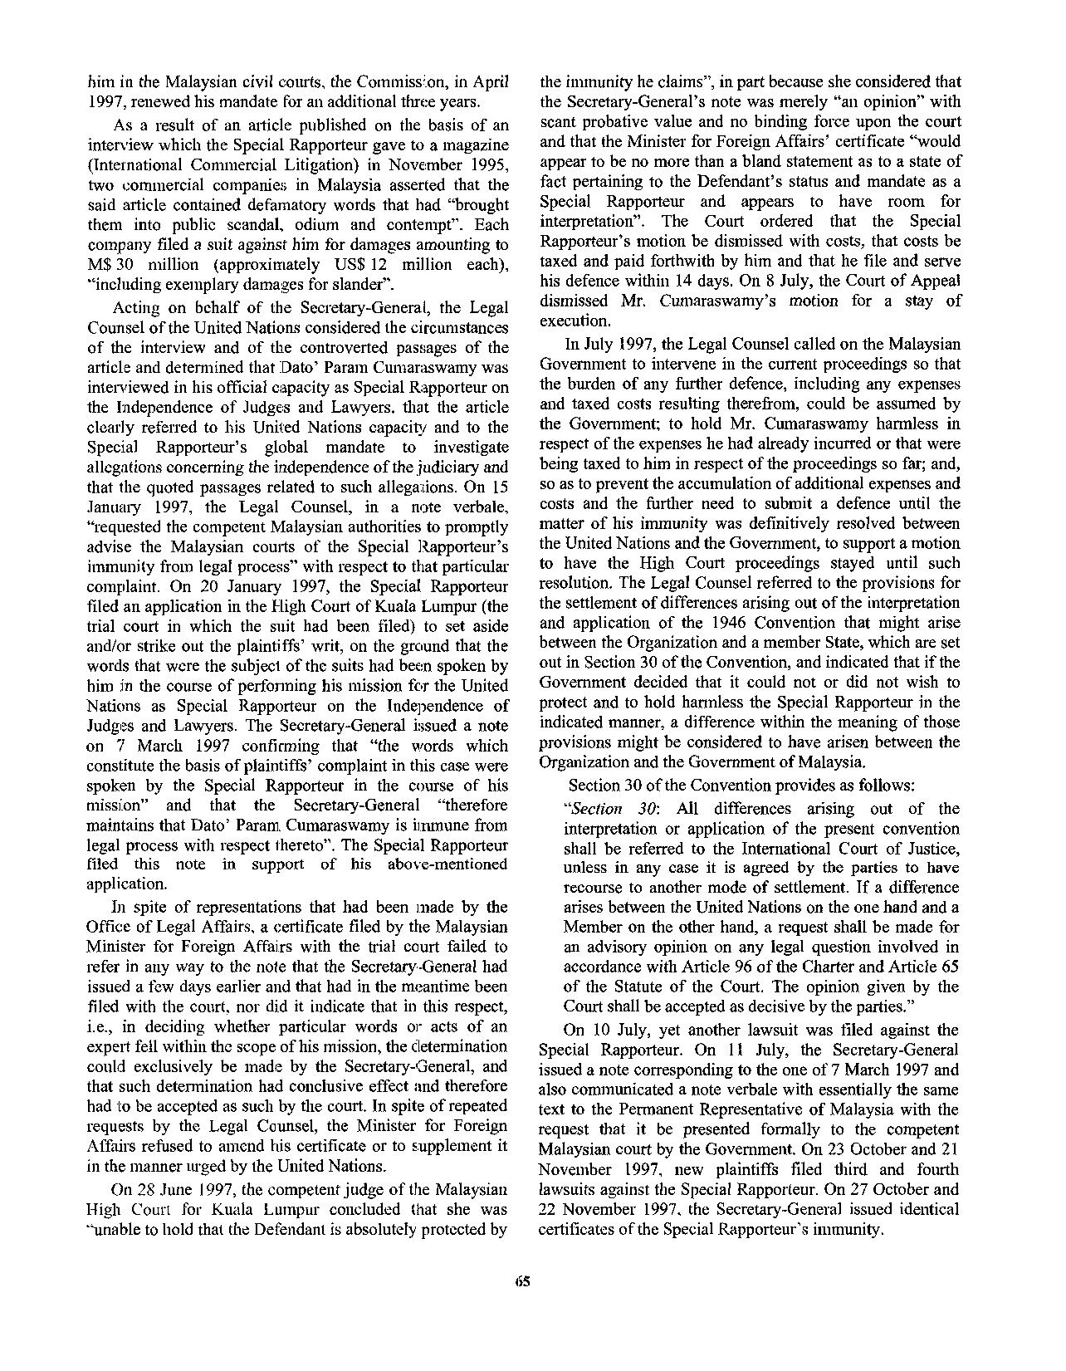

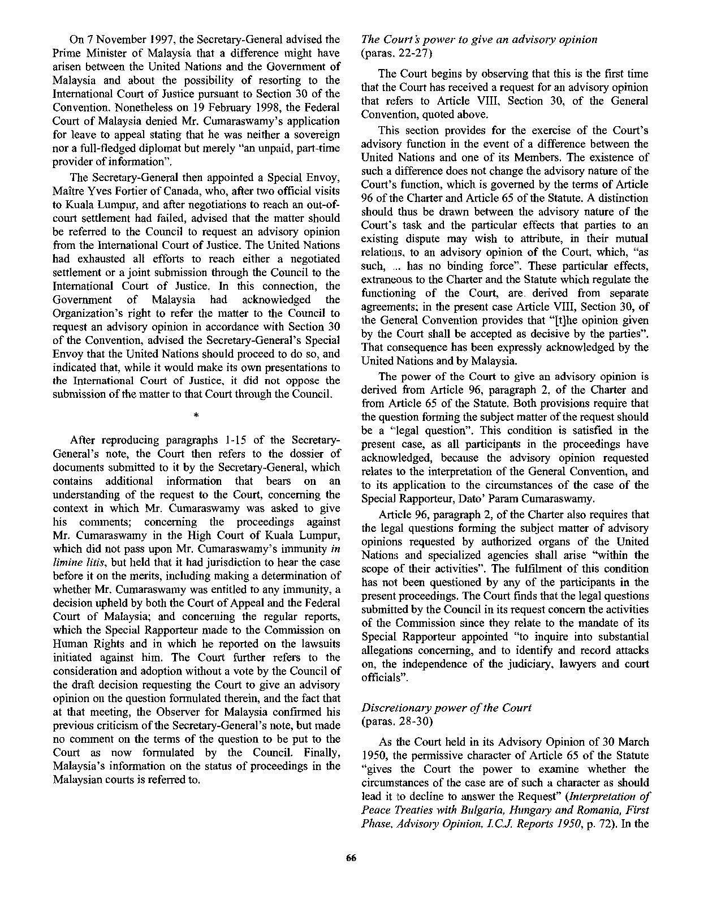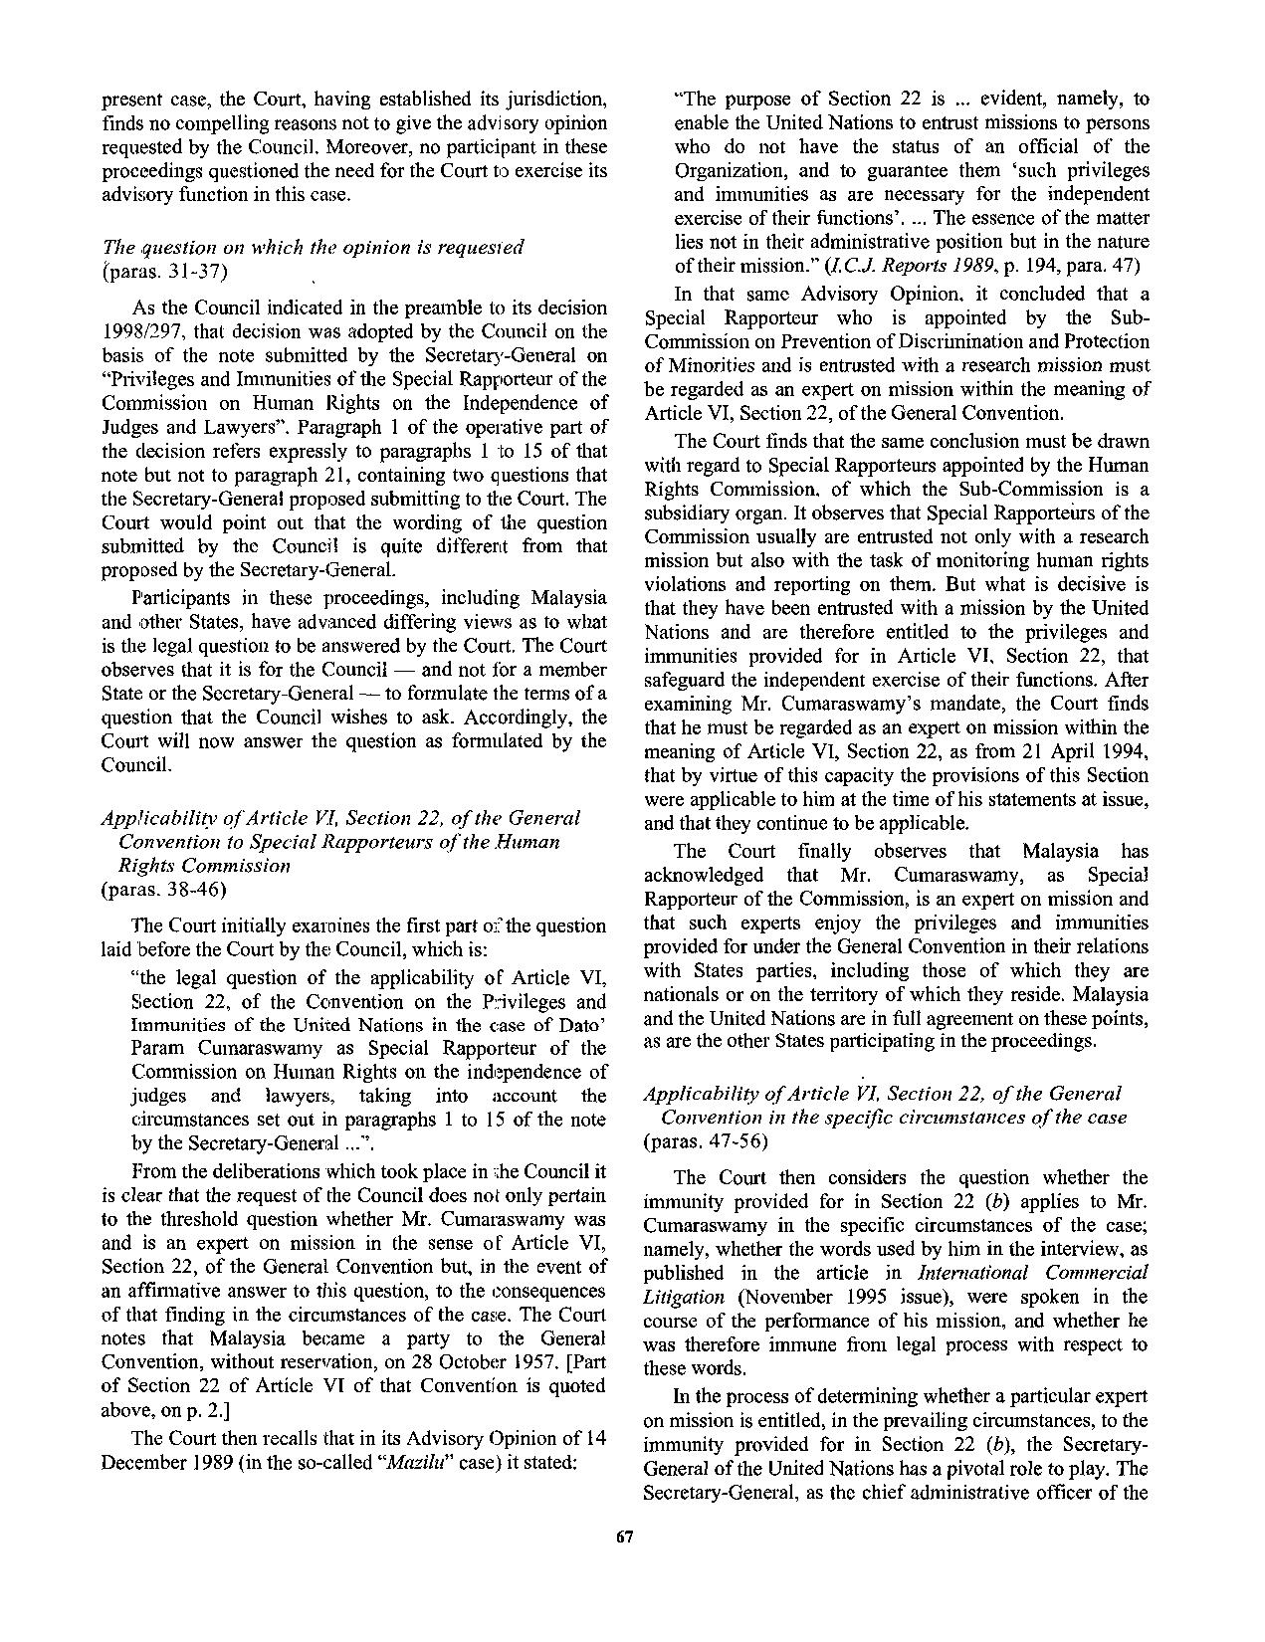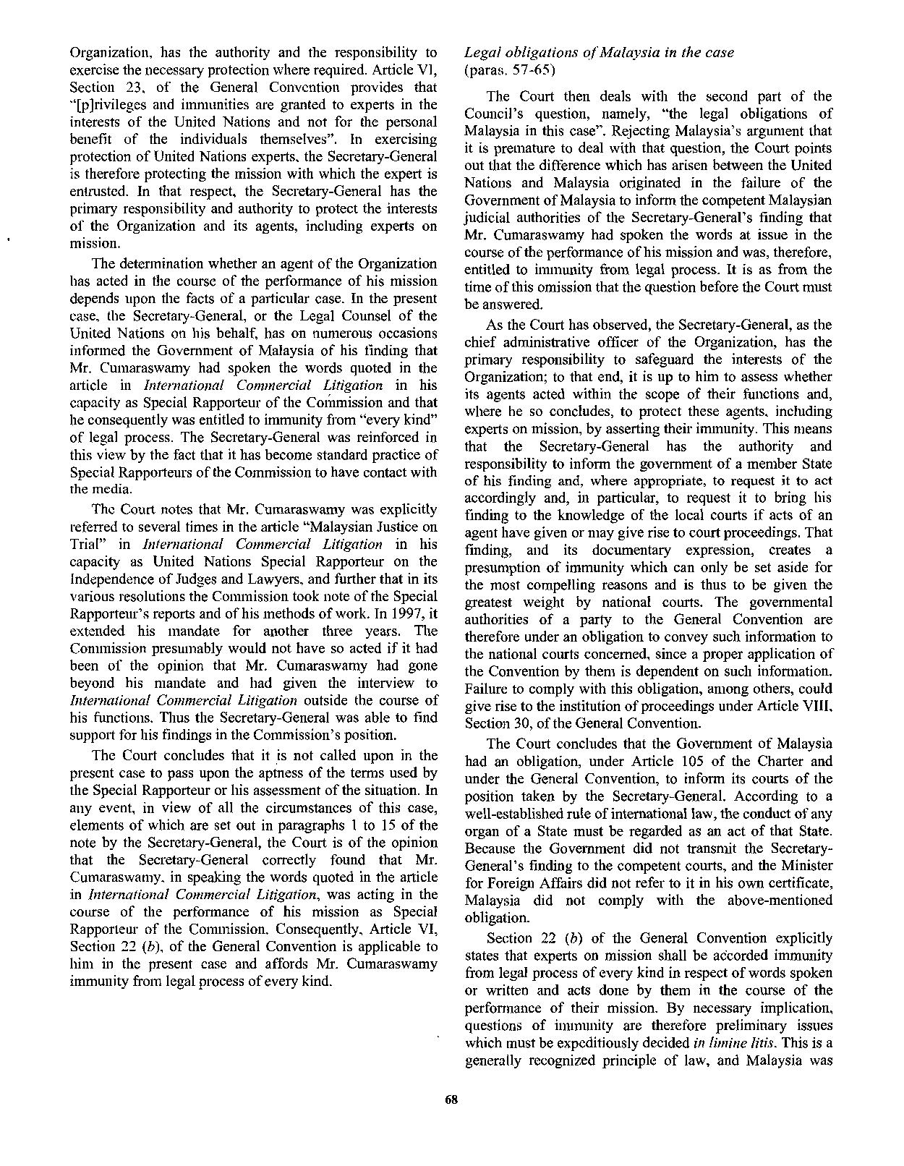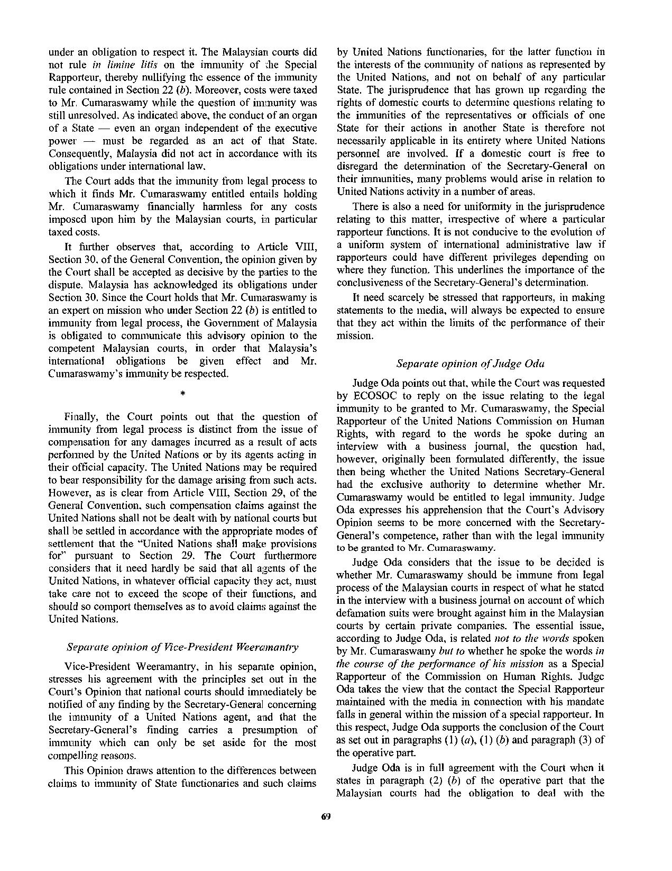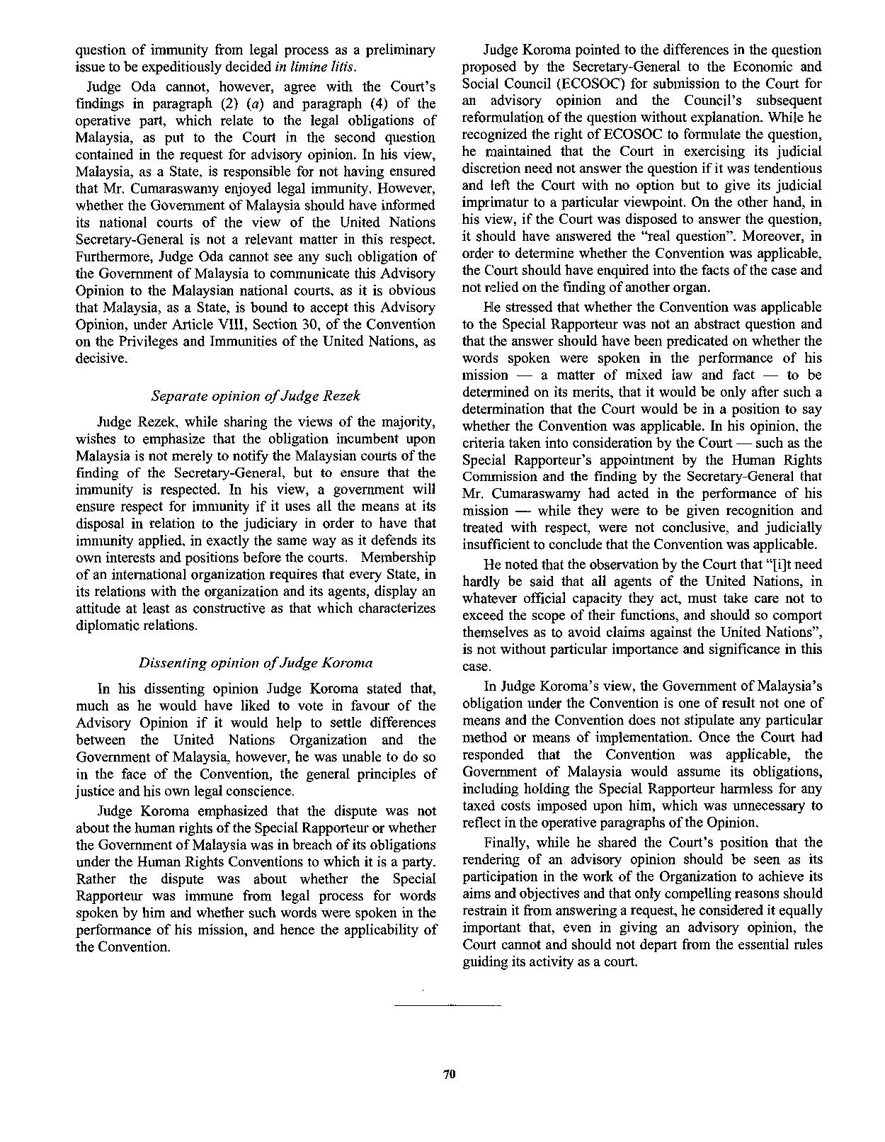

Advisory Opinion (Majority Opinion)

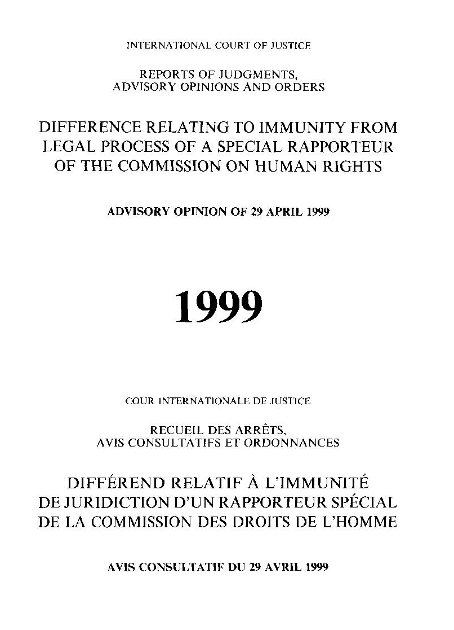

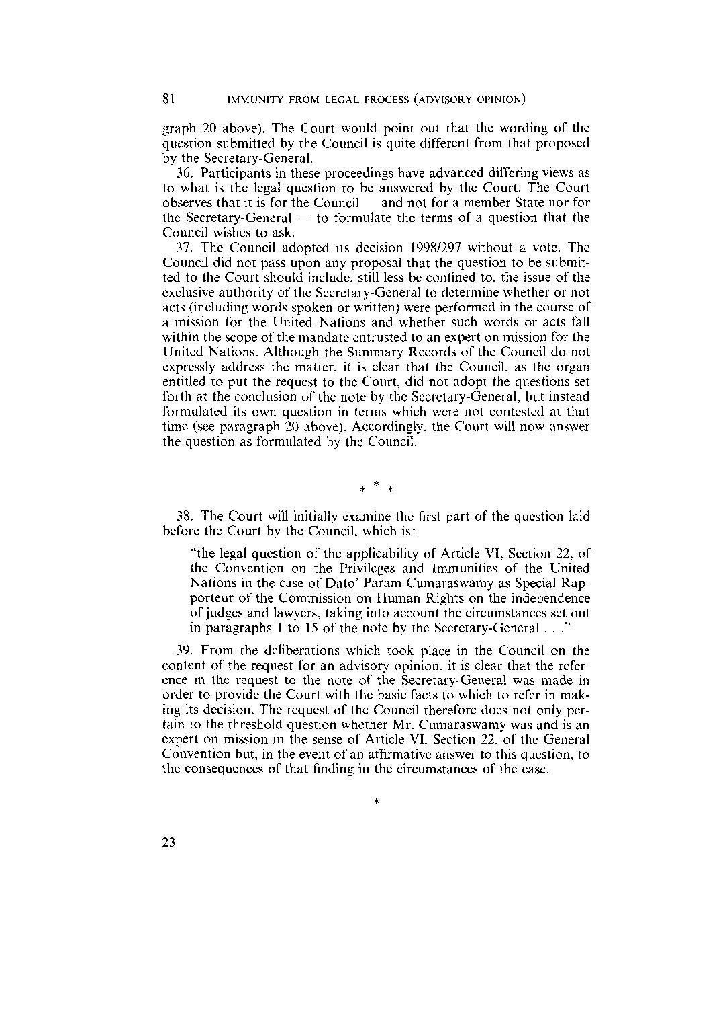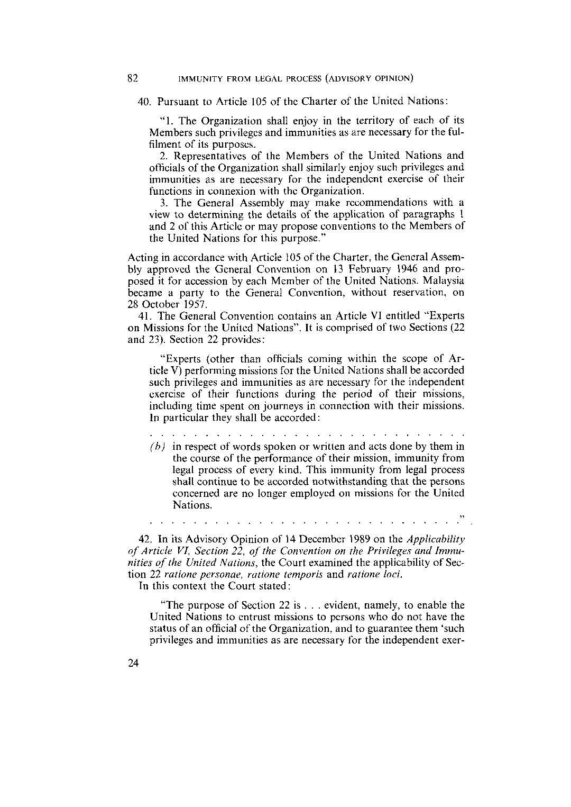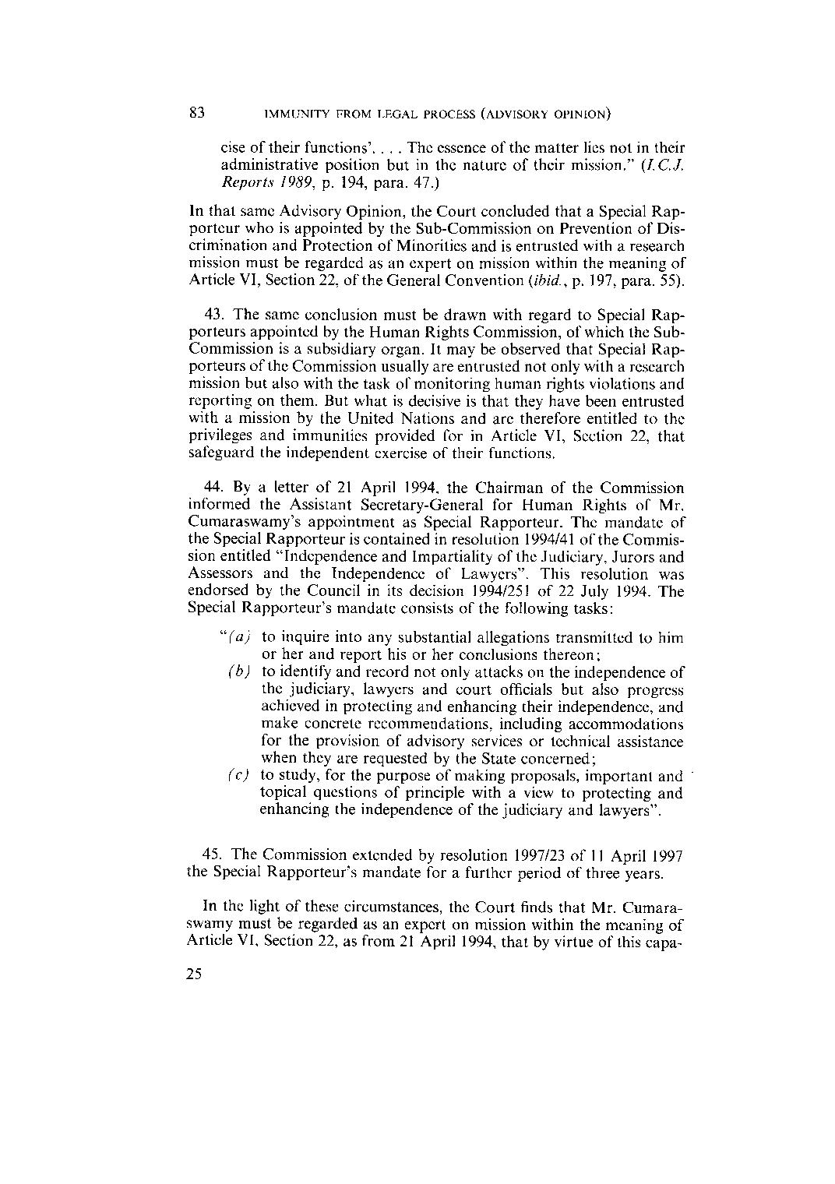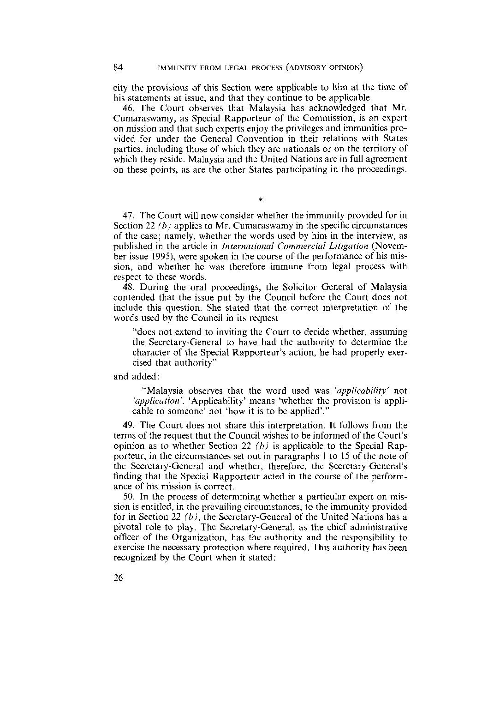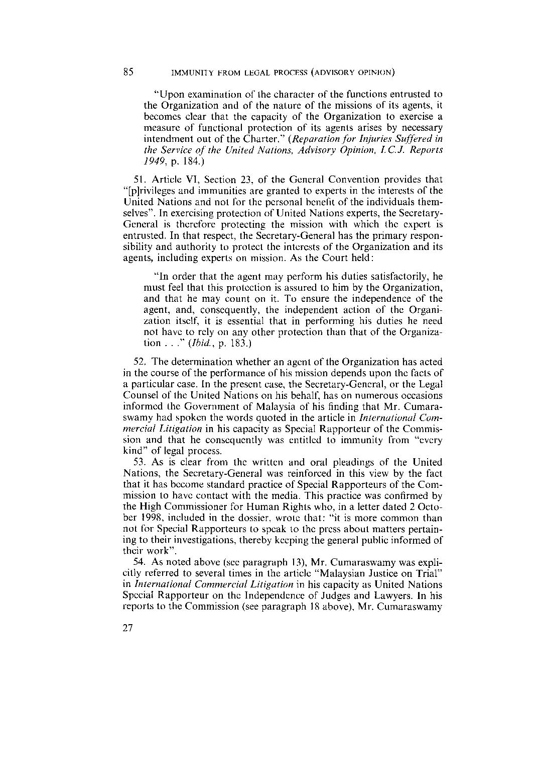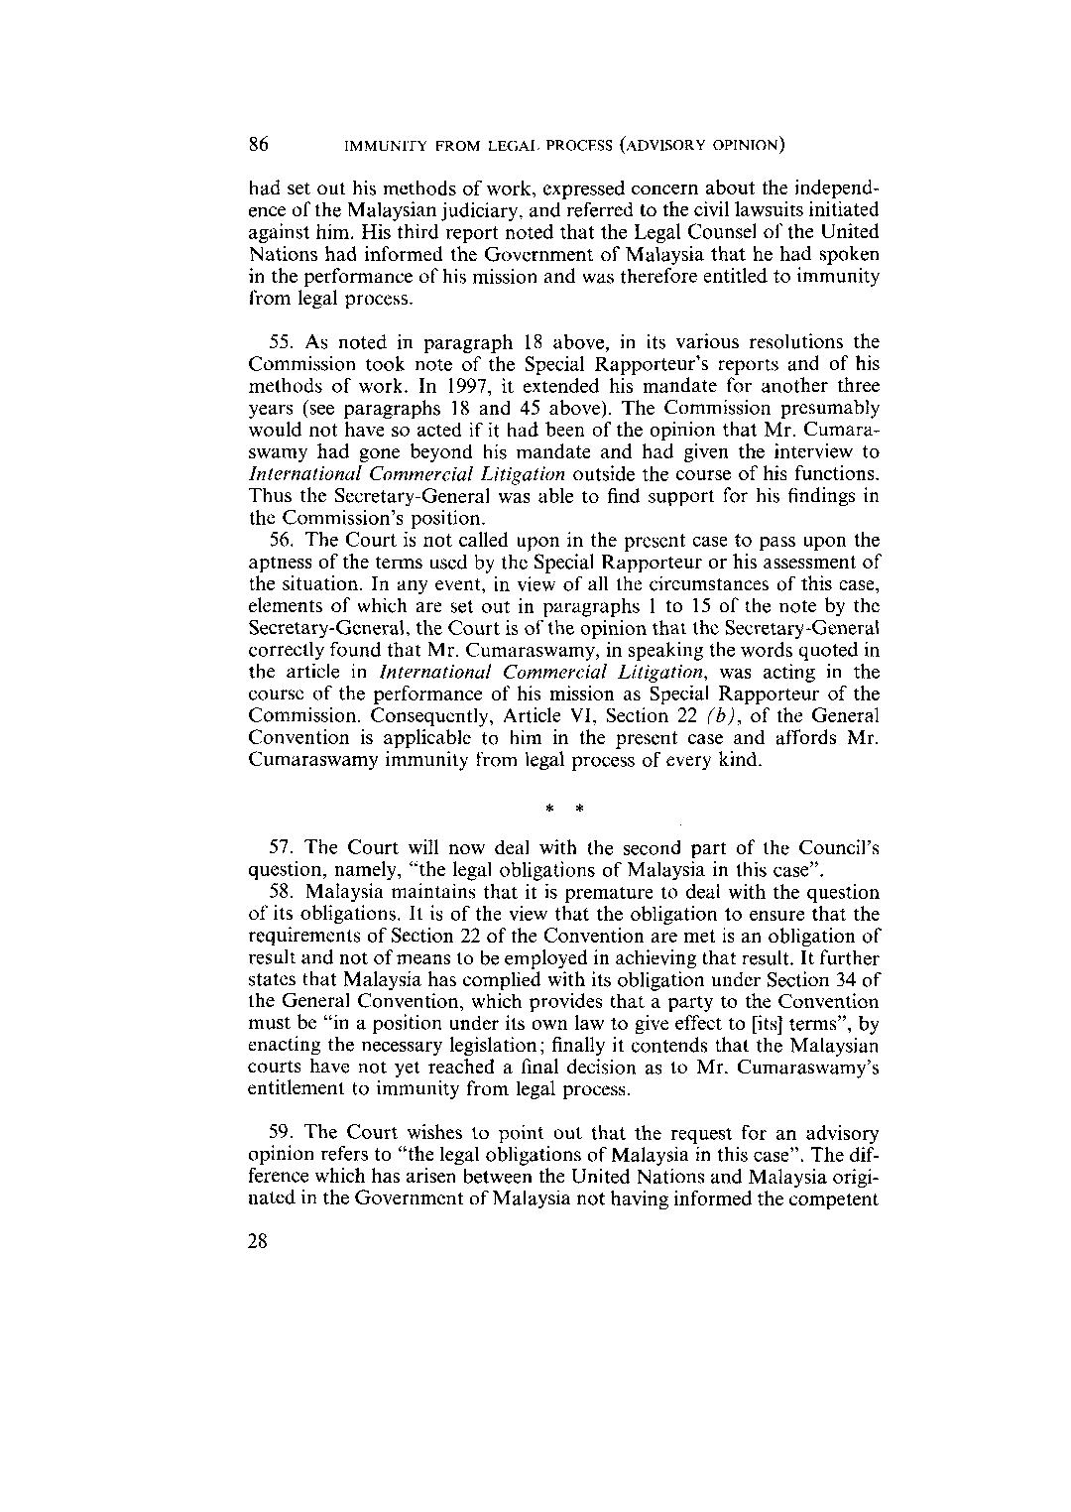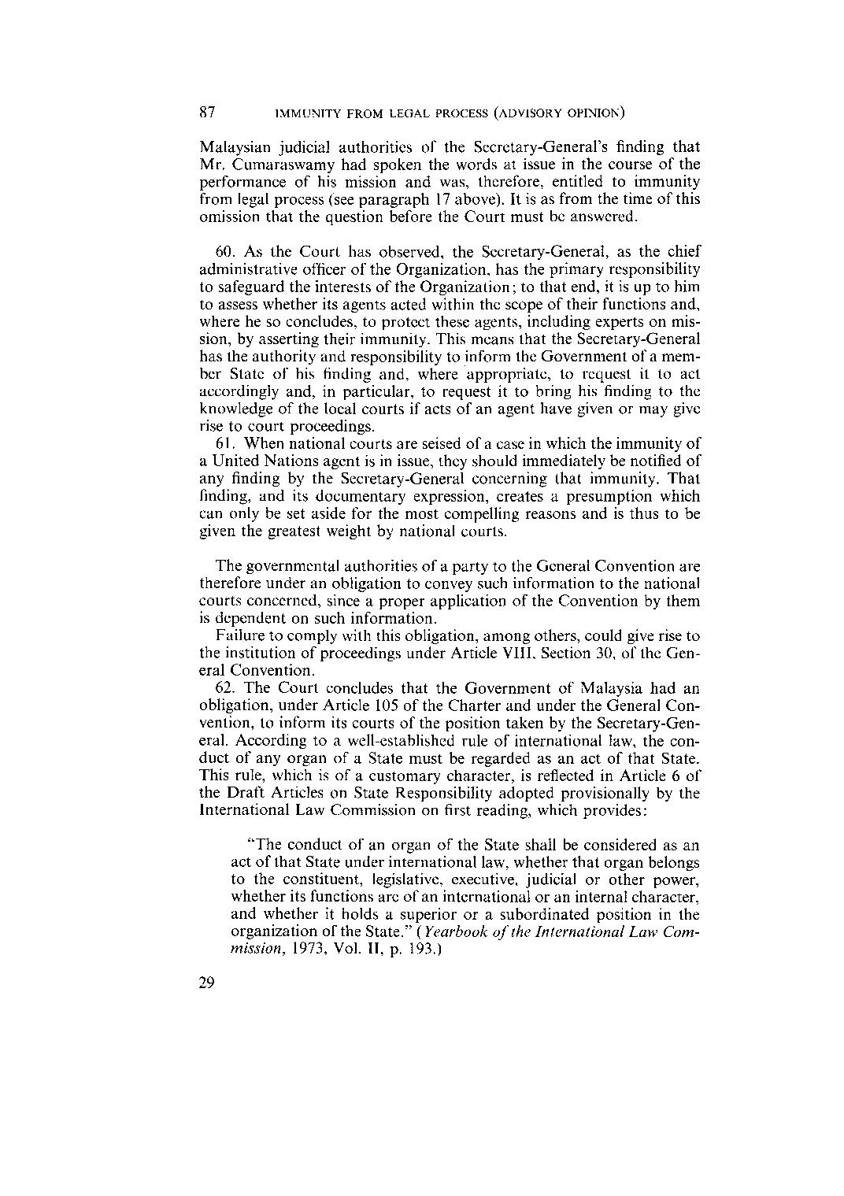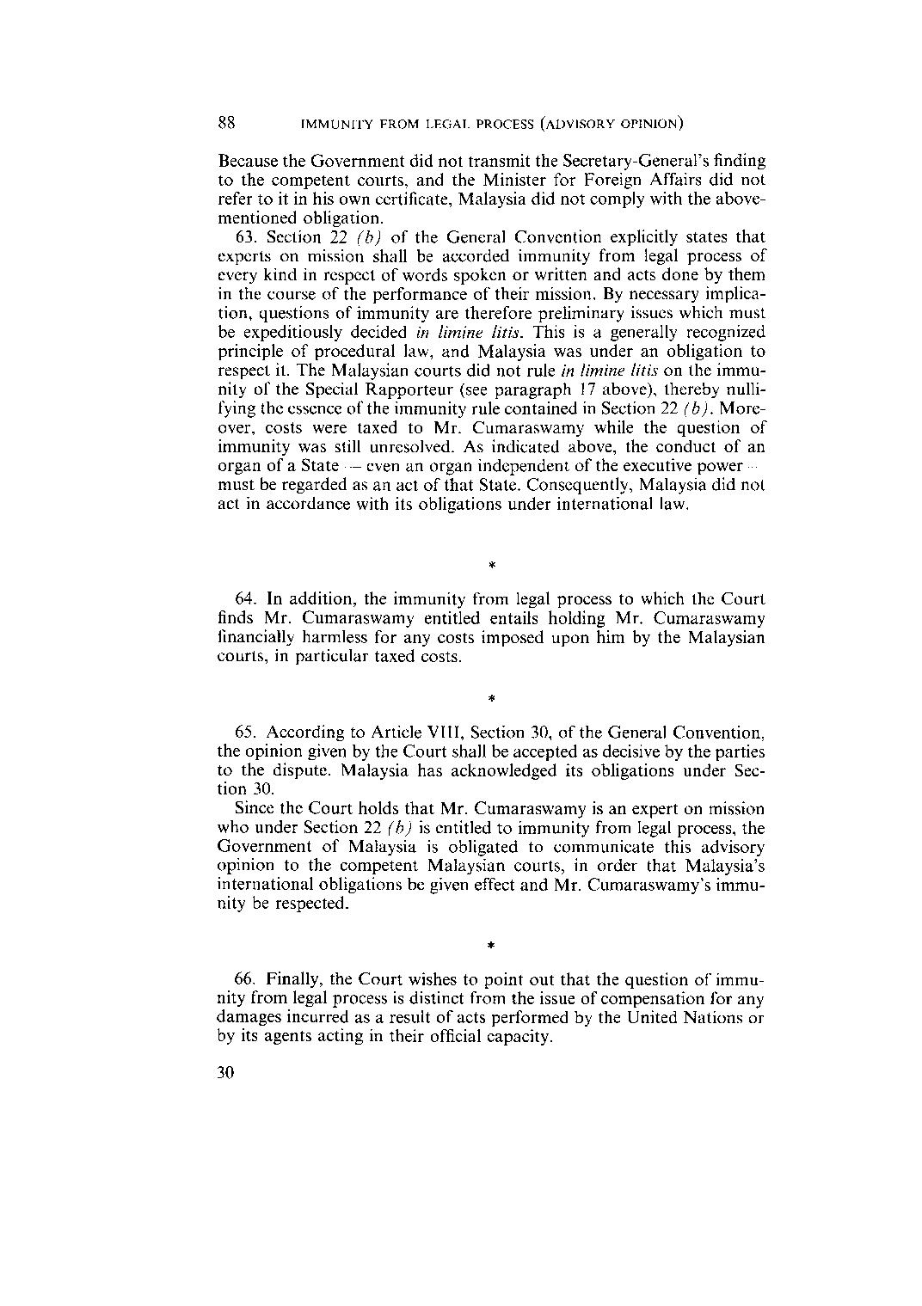

Separate Opinion, Judge Oda
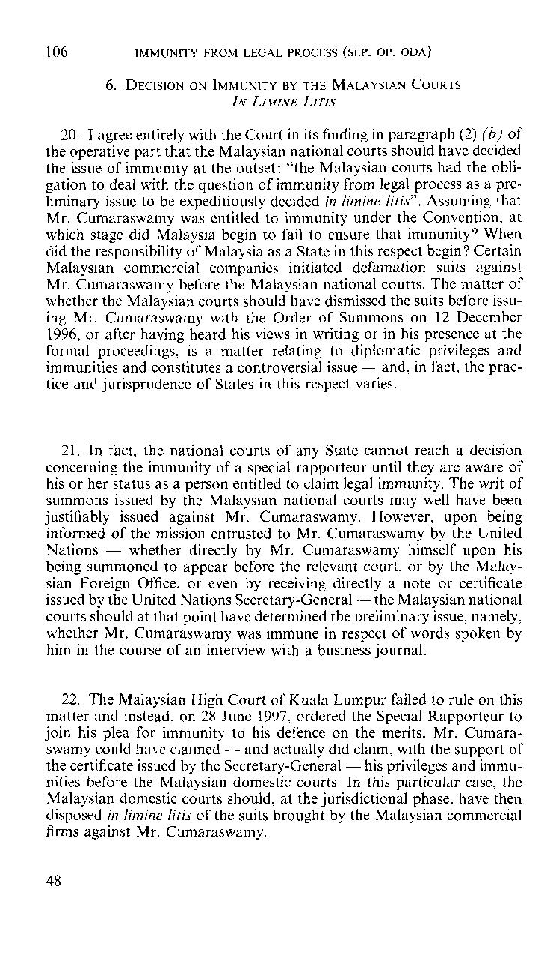

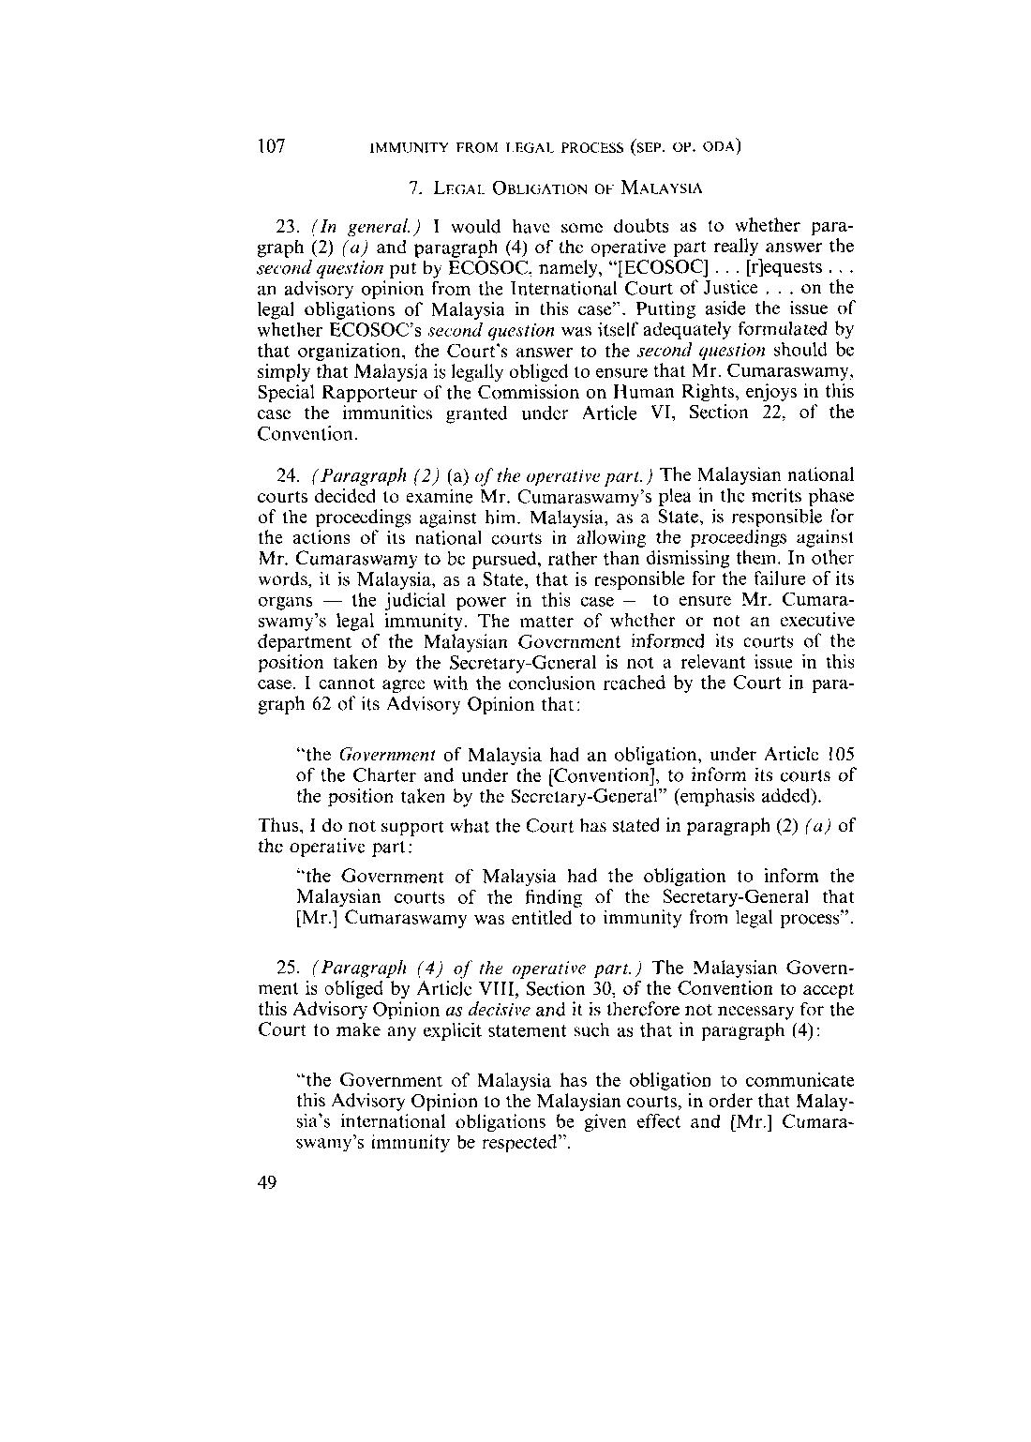

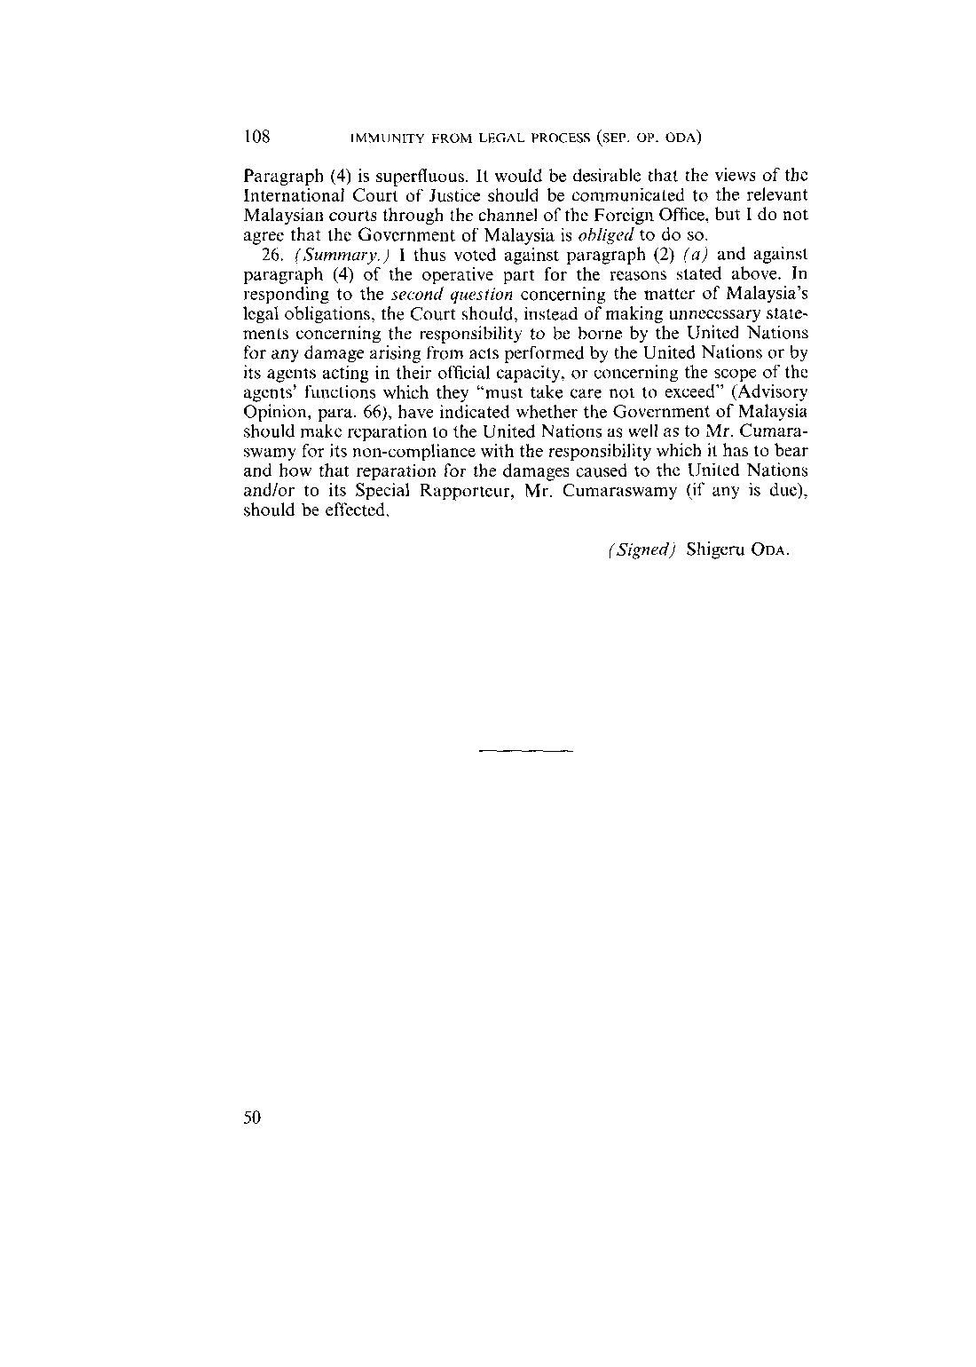

Separate Opinion, Vice-President Weeramantry
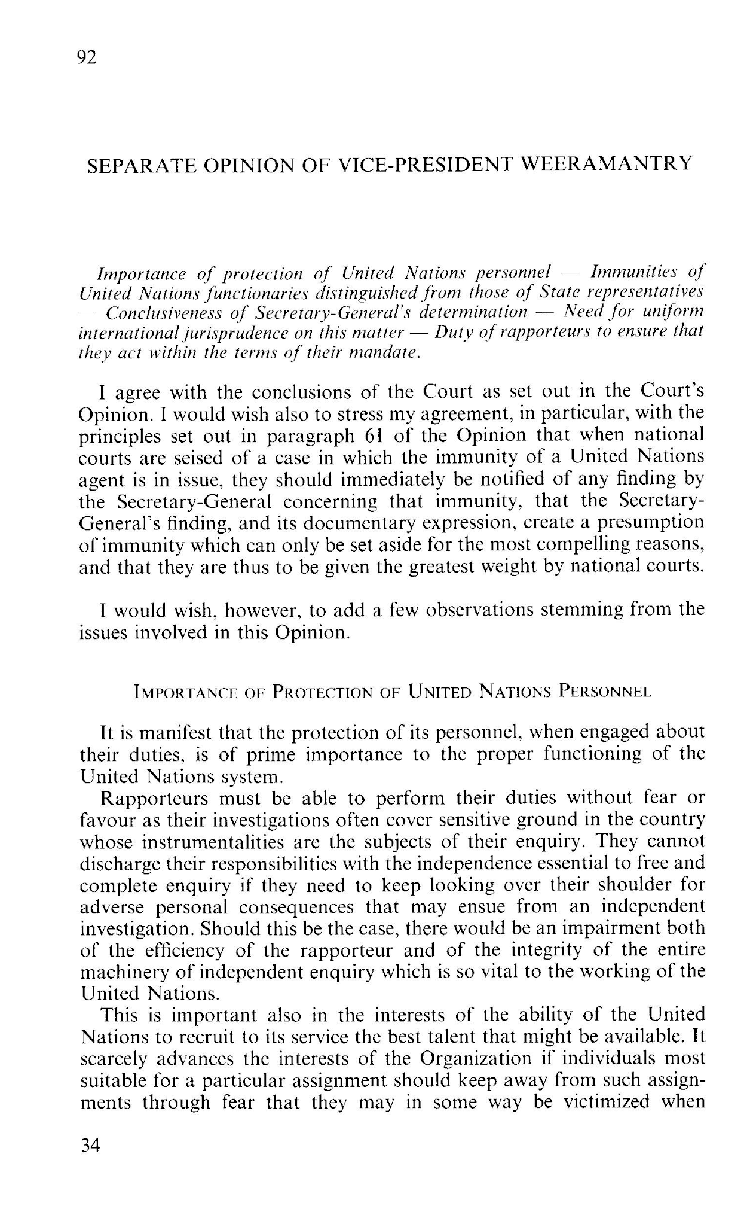

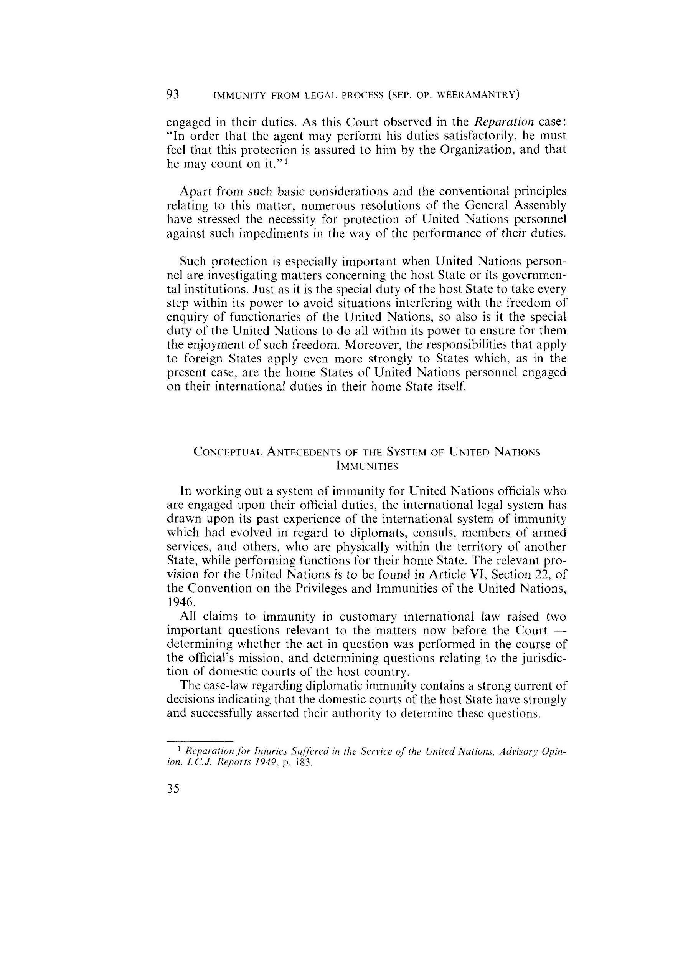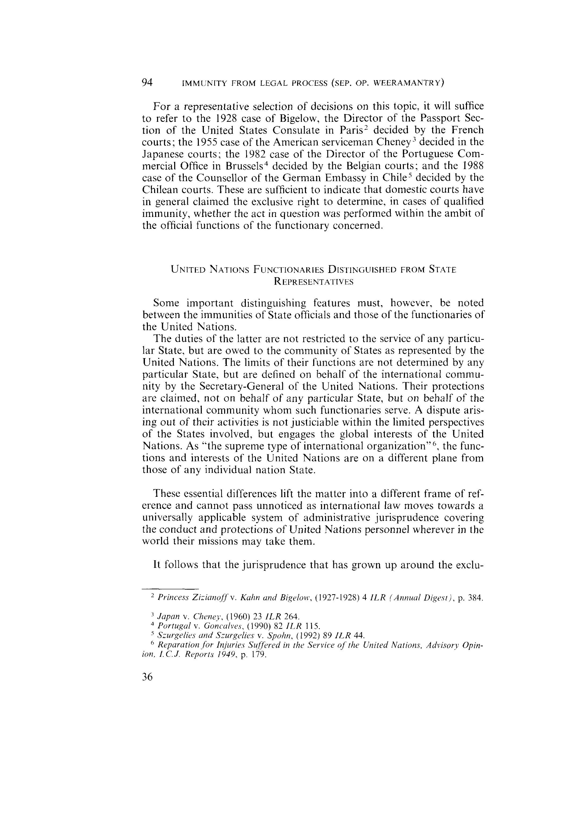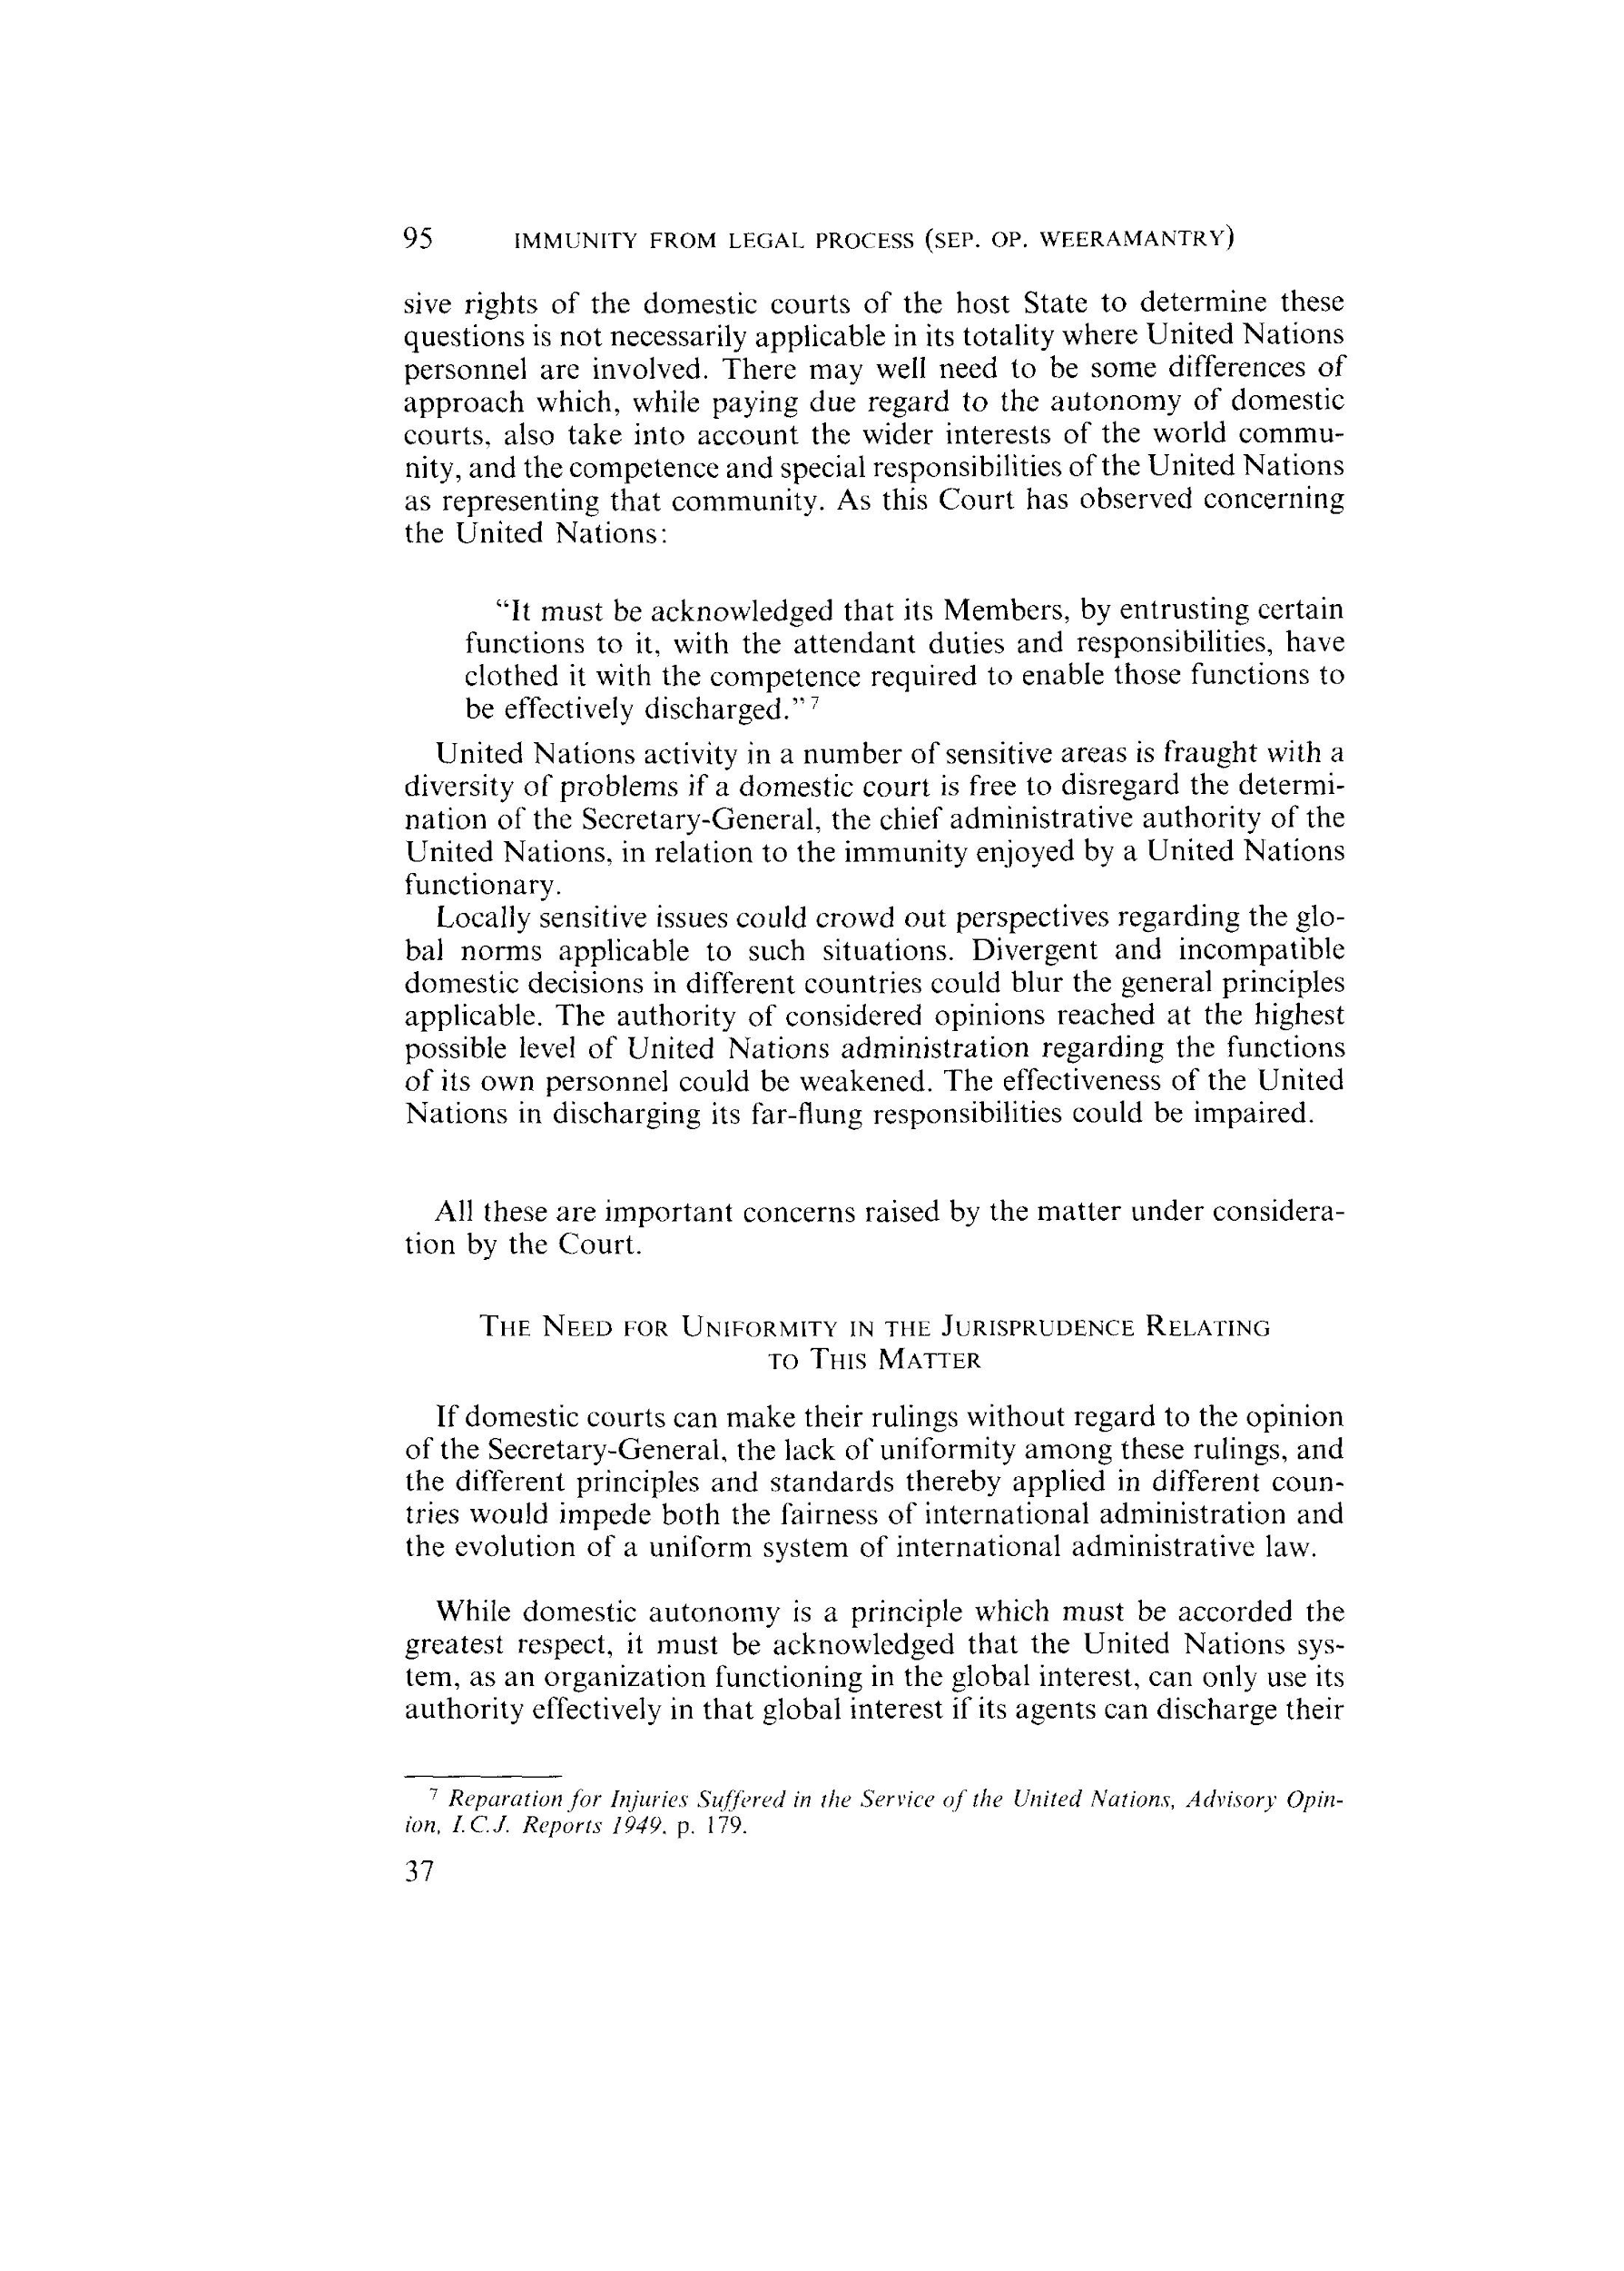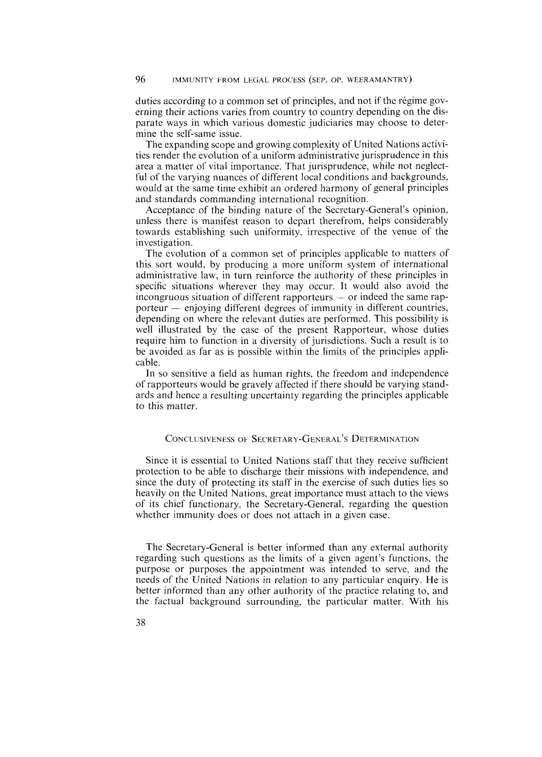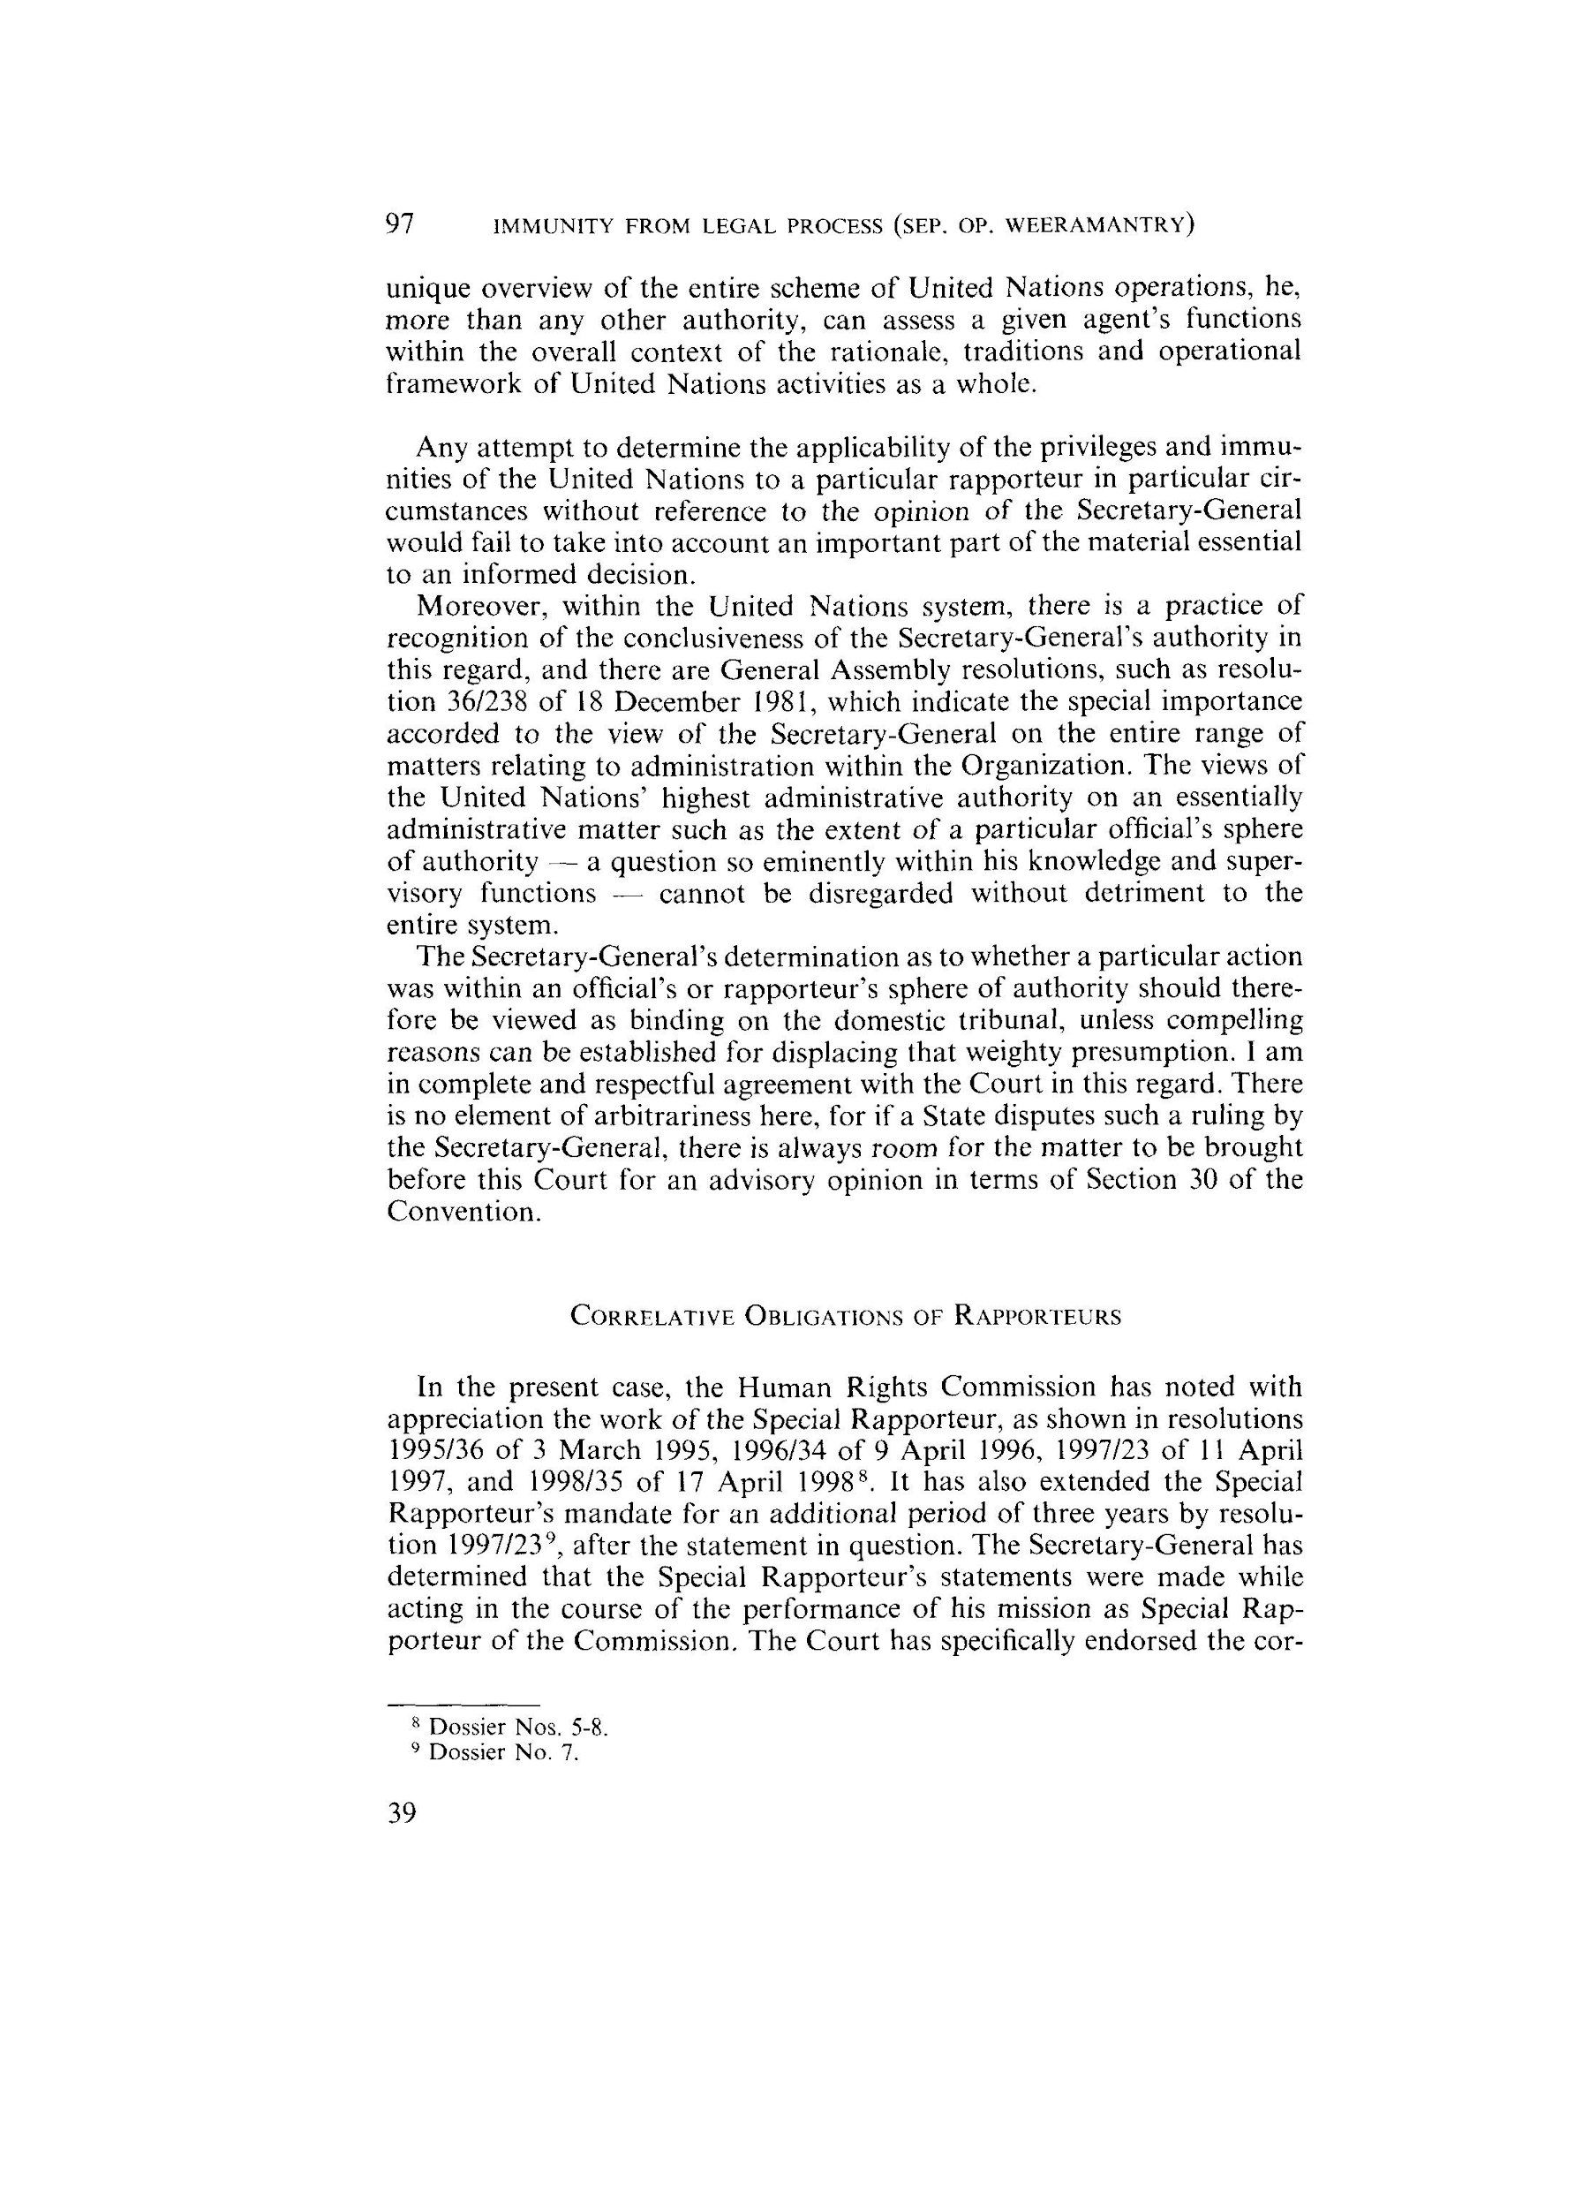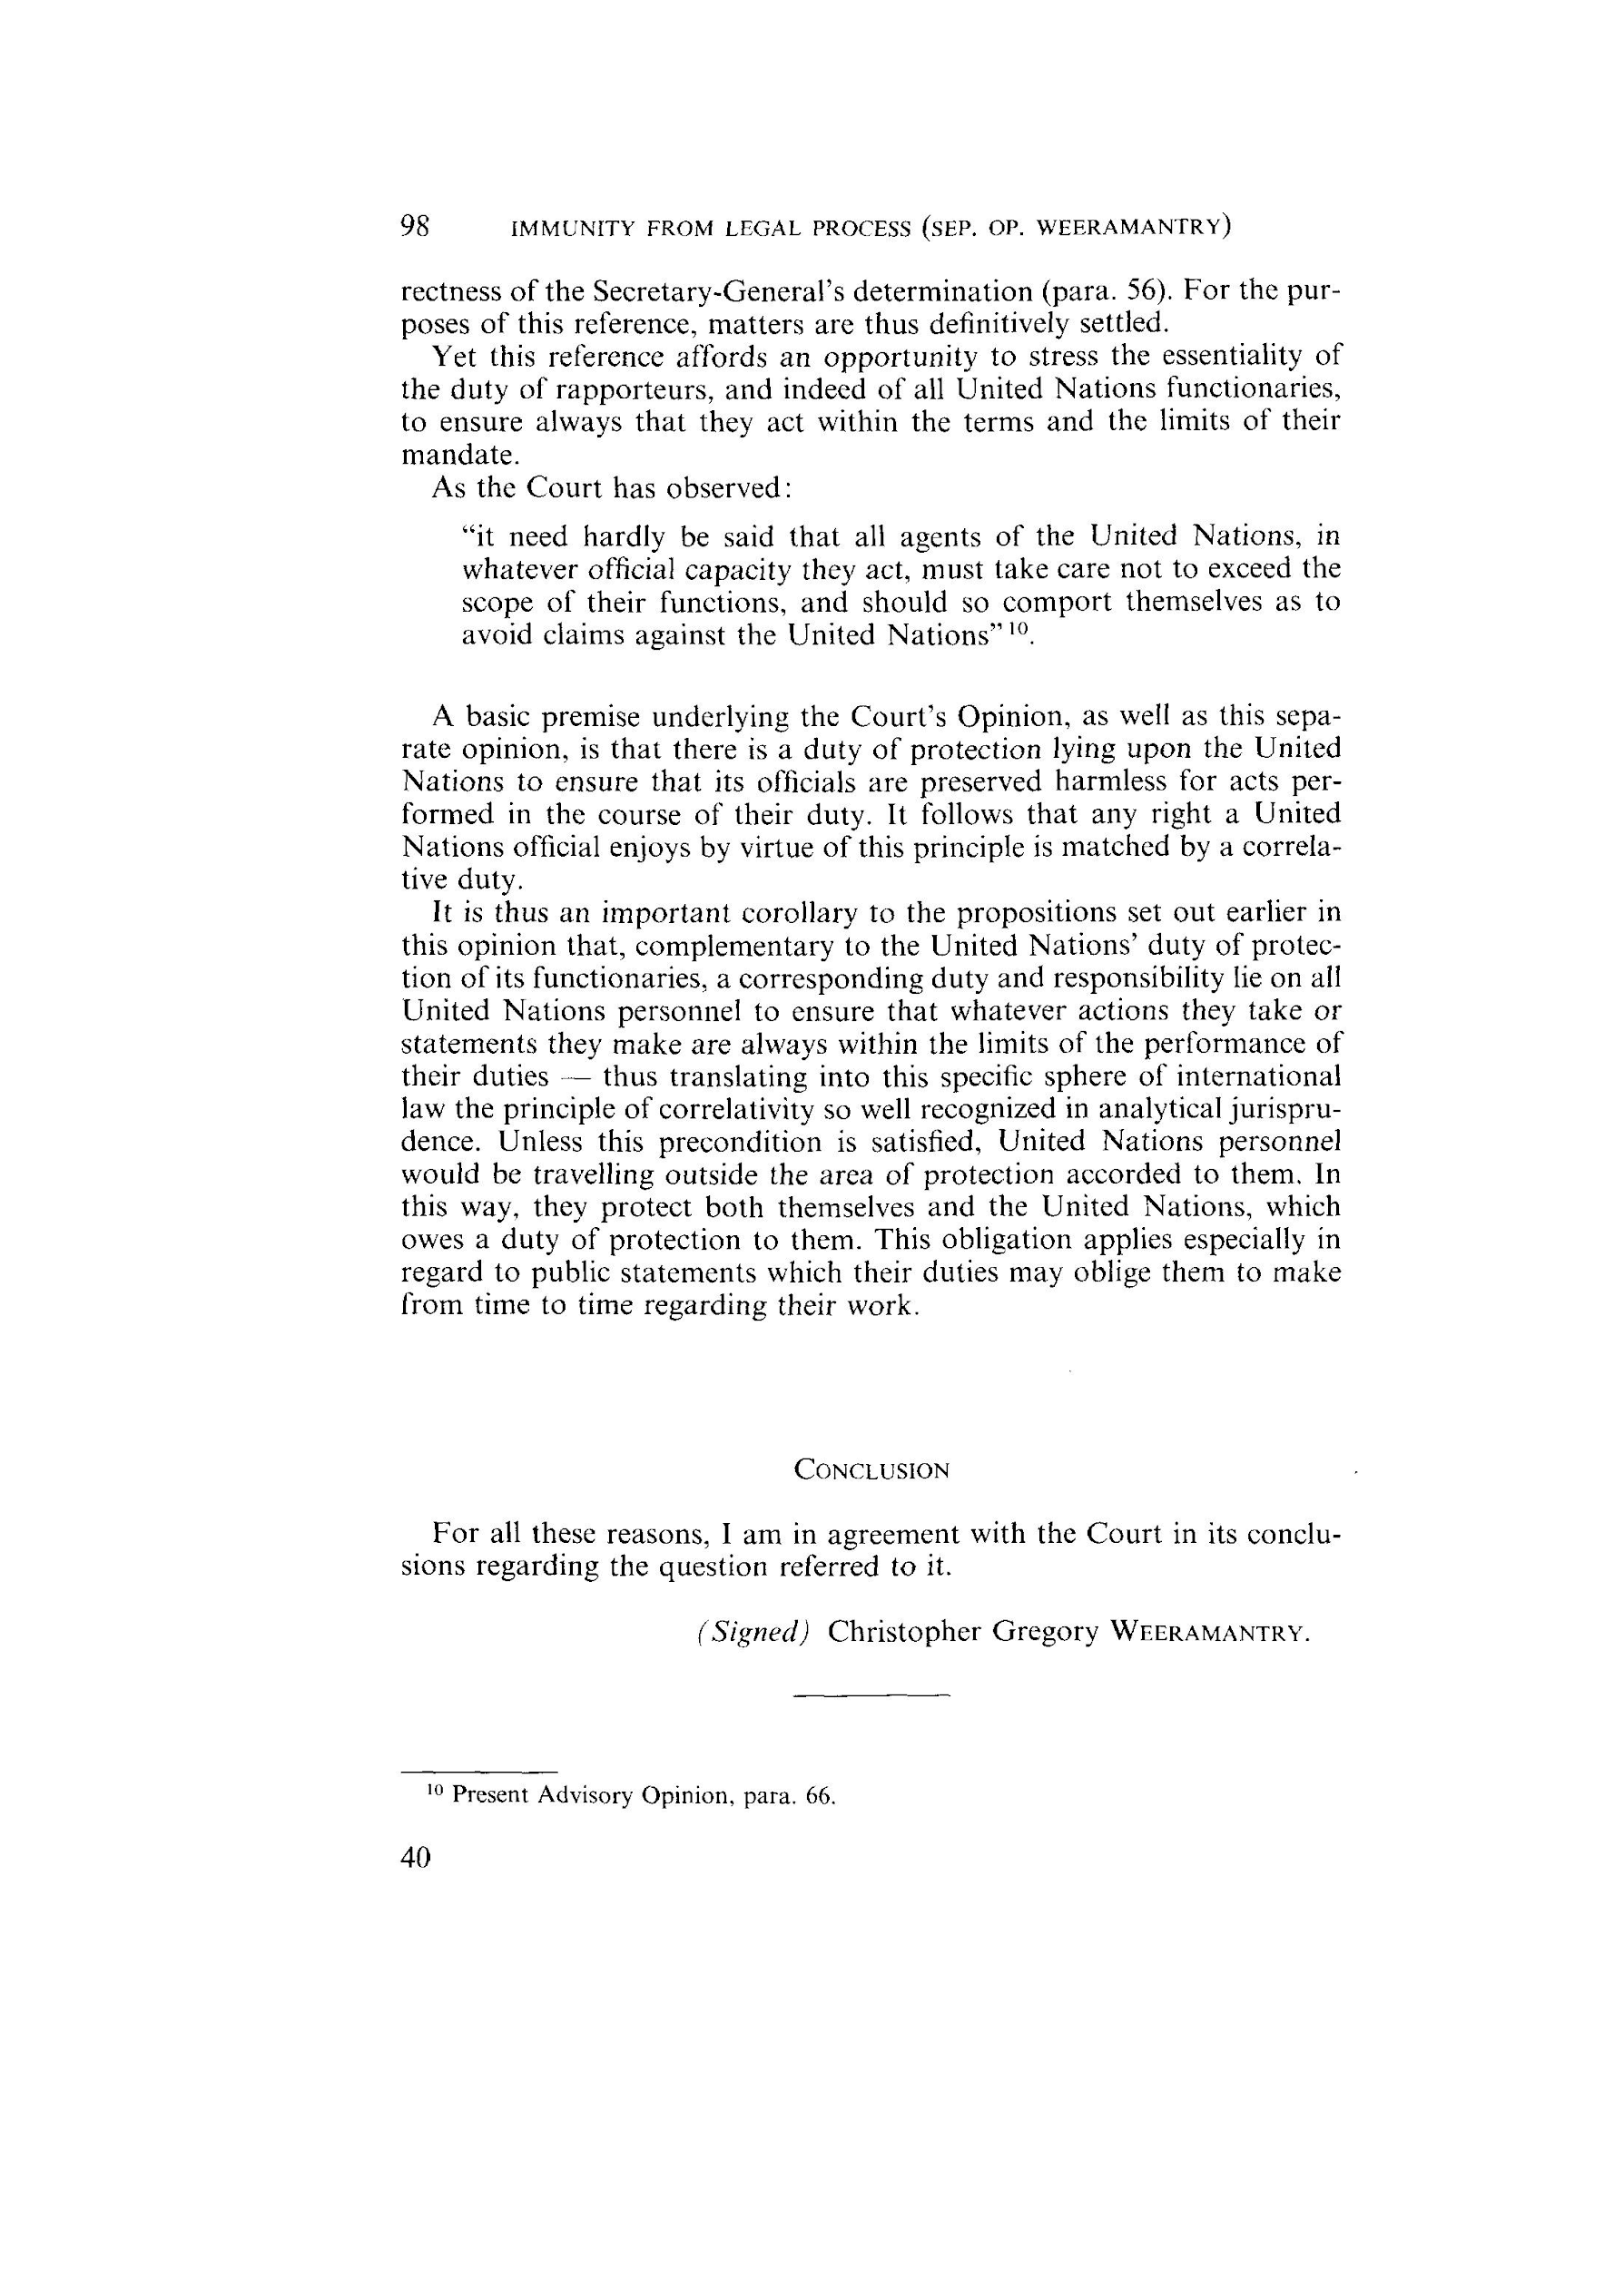

Dissenting Opinion, Judge Koroma
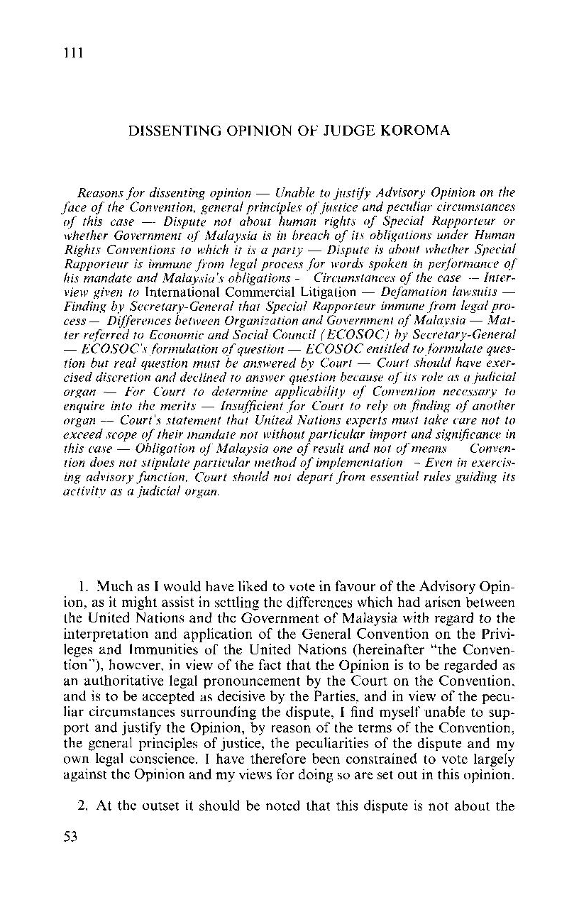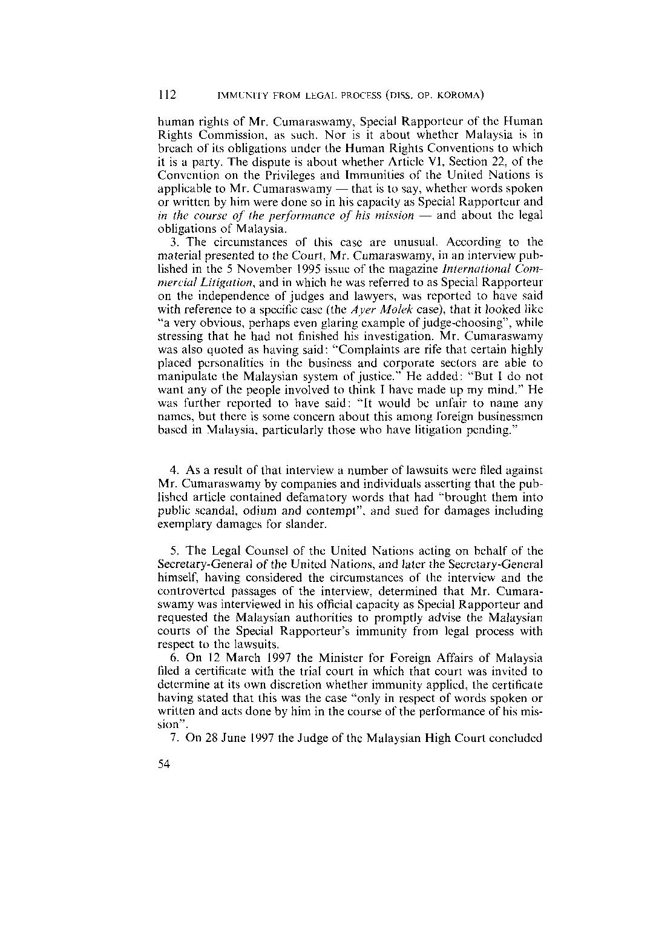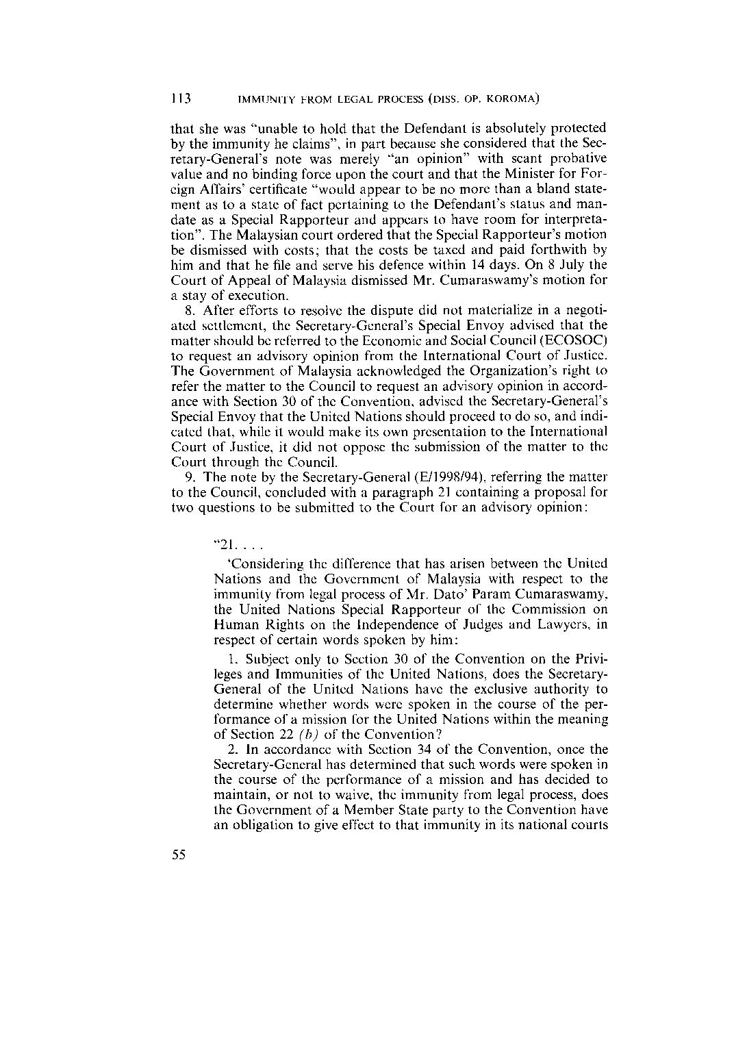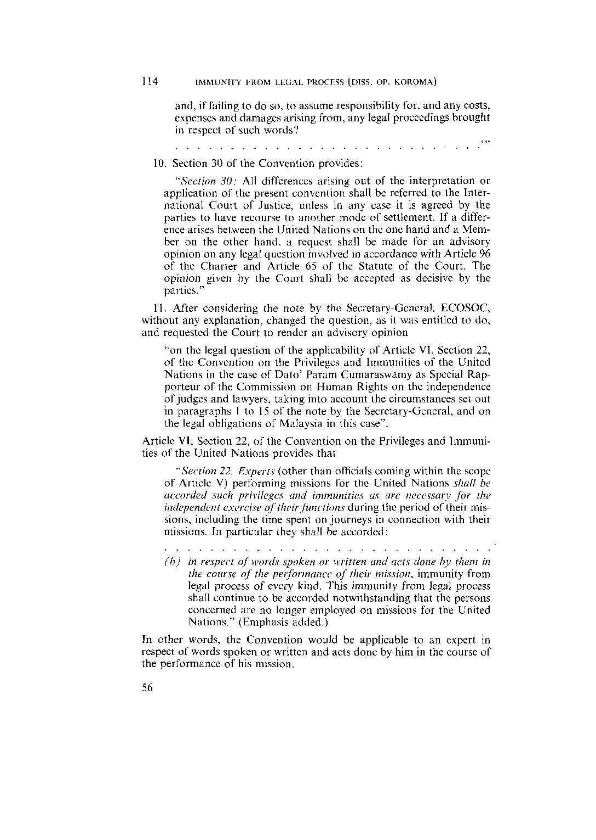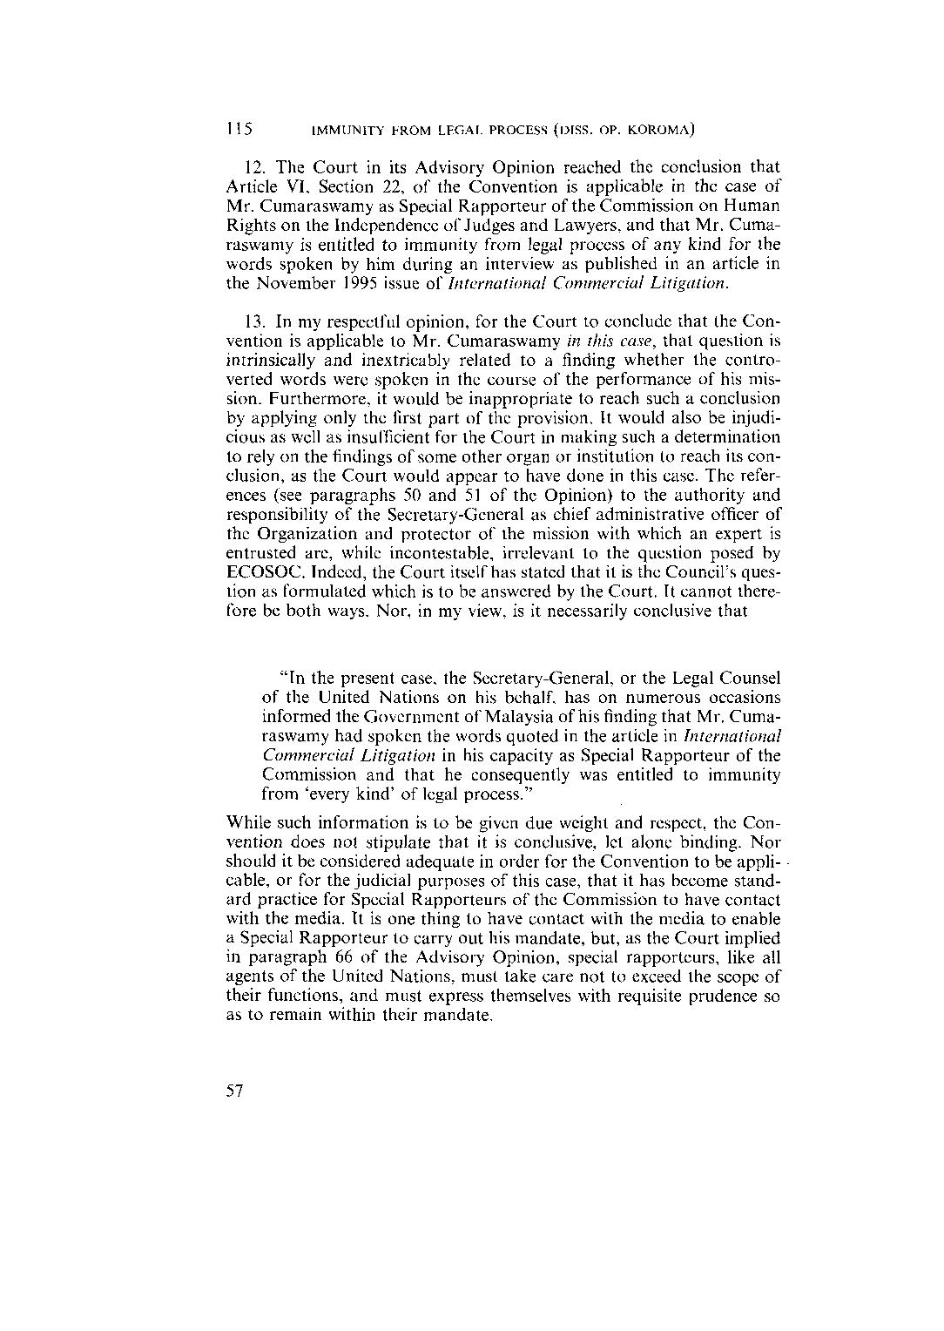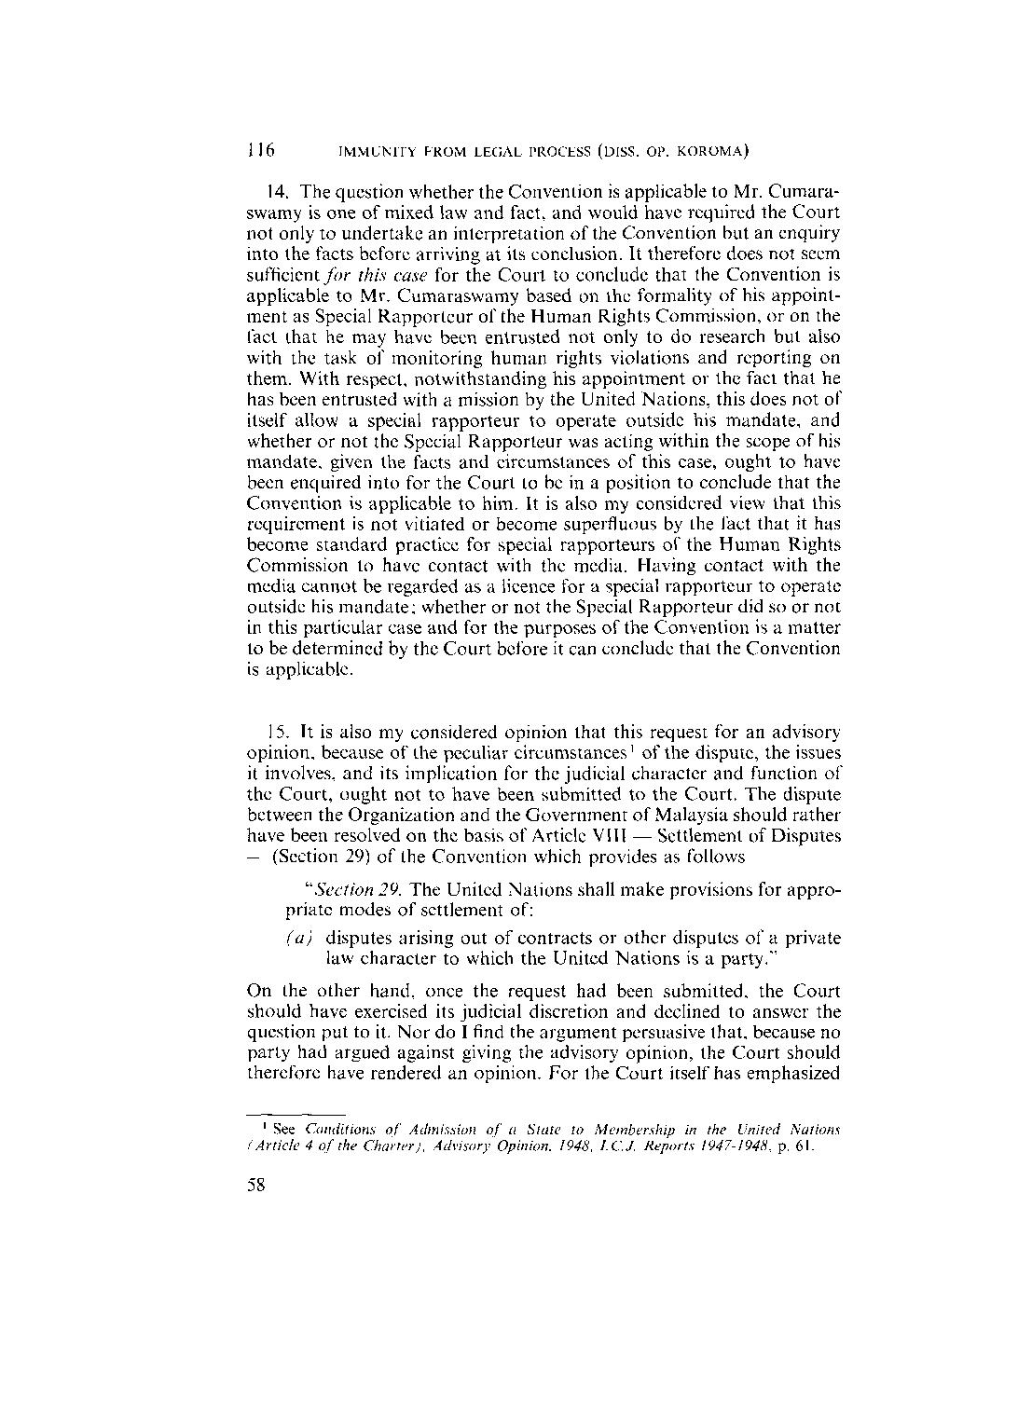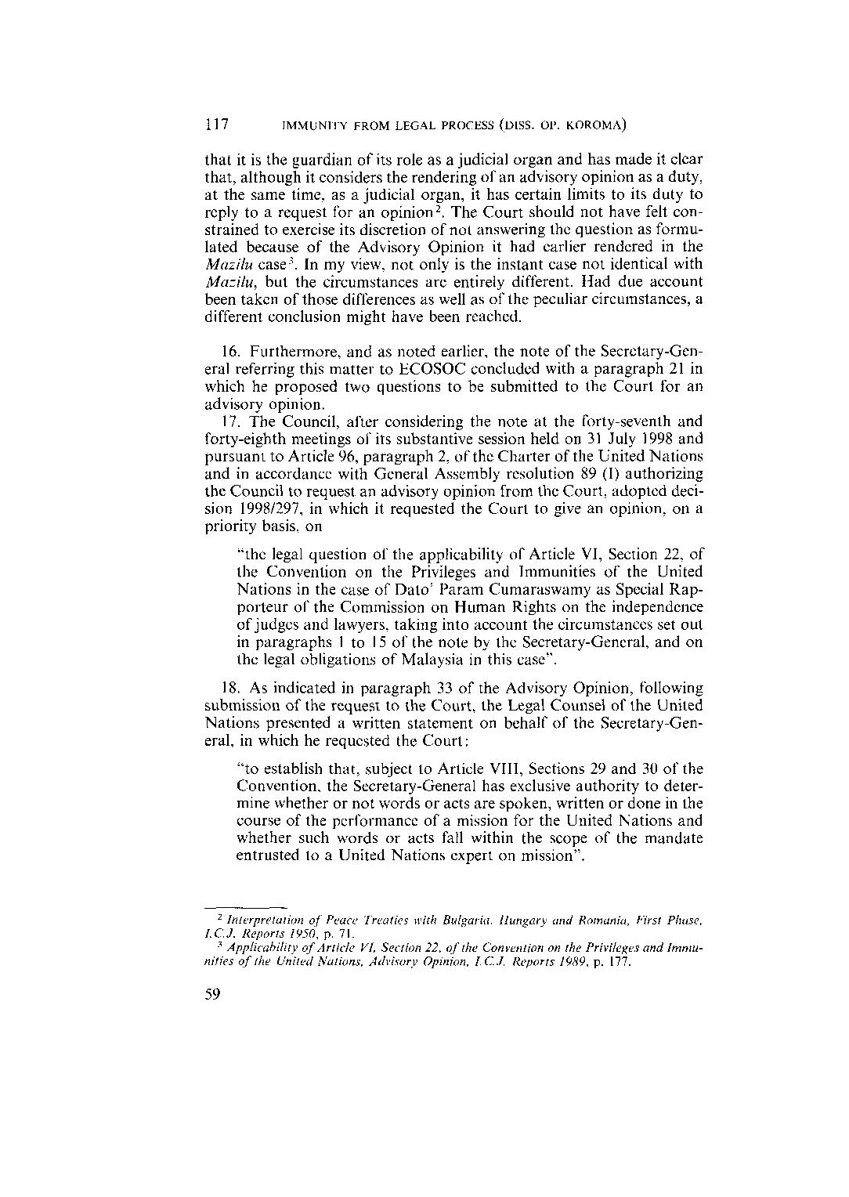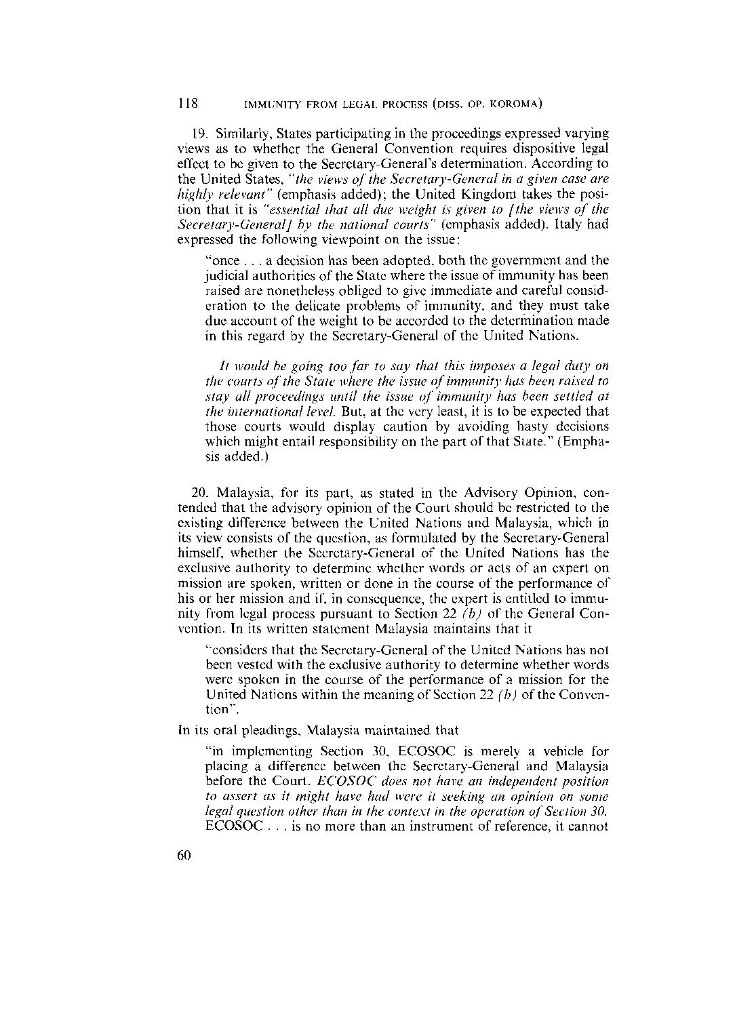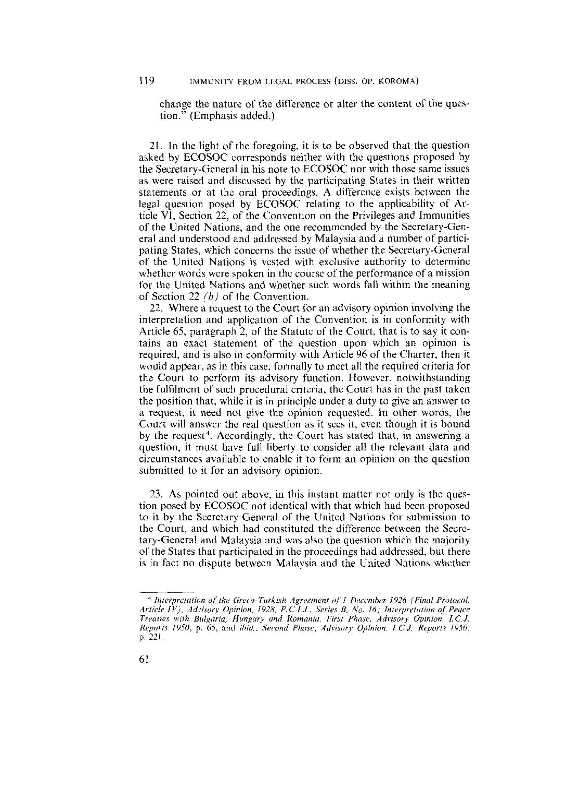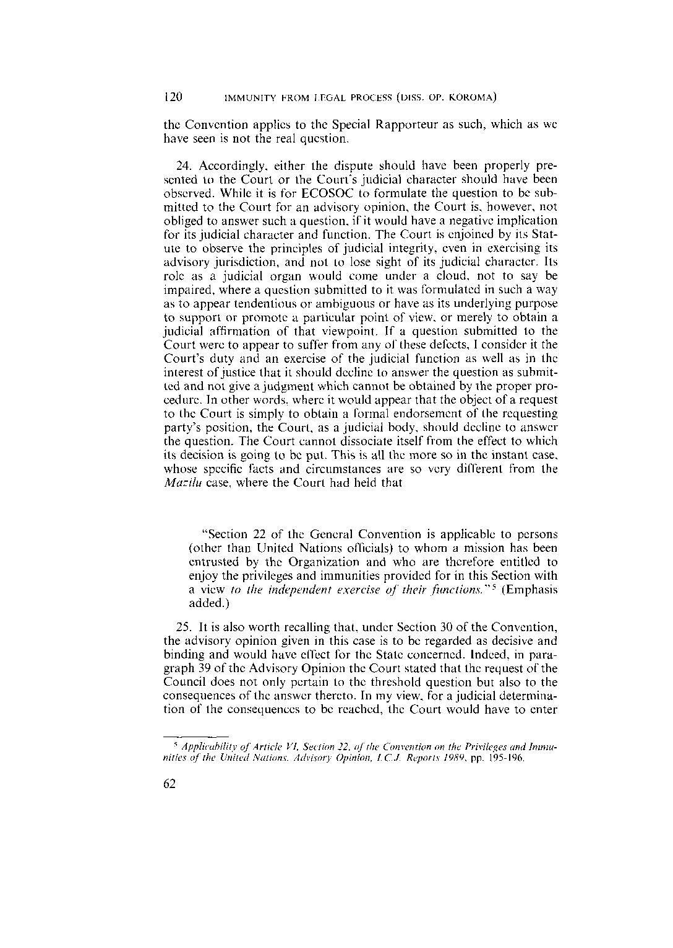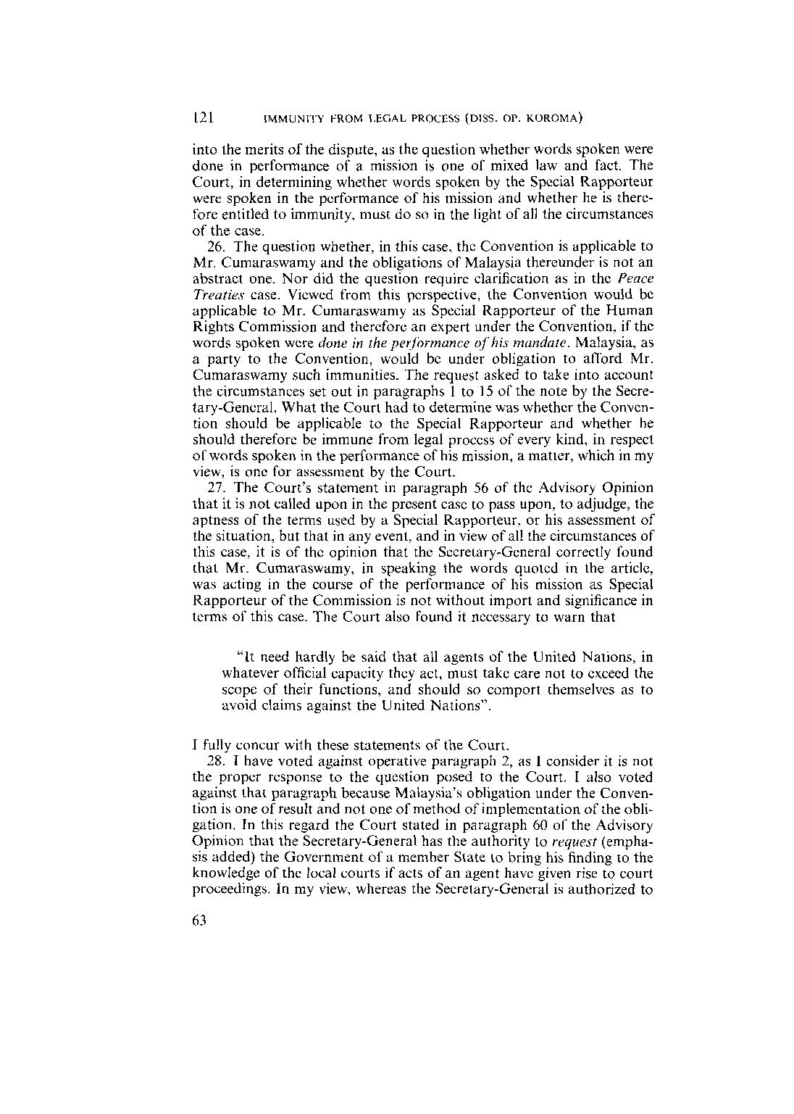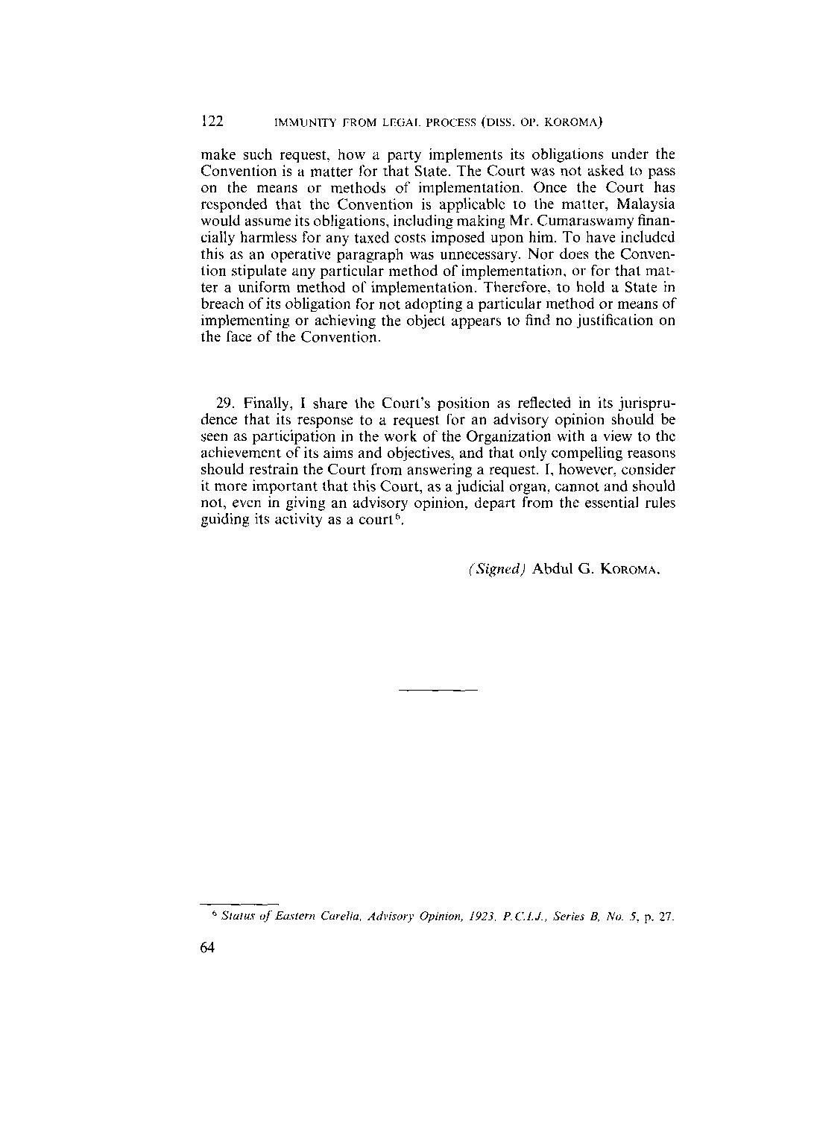

Appendix I:

Excerpt from the Convention on the
Privileges and Immunities of the United Nations

ARTICLE VI

EXPERTS ON MISSIONS FOR THE UNITED NATIONS

SECTION 22. Experts (other than officials coming within the scope of Article V) performing missions for the United Nations shall be accorded such privileges and immunities as are necessary for the independent exercise of their functions during the period of their missions, including the time spent on journeys in con­nection with their missions. In particular they shall be accorded:

(a) immunity from personal arrest or detention and from seizure of their personal baggage;

(b) in respect of words spoken or written and acts done by them in the course of the performance of their mission, immunity from legal process of every kind. This immunity from legal process shall continue to be accorded notwith­standing that the persons concerned are no longer employed on missions for the United Nations;

(c) inviolability for all papers and documents;

(d) for the purpose of their communications with the United Nations, the right to use codes and to receive papers or correspondence by courier or in sealed bags;

(e) the same facilities in respect of currency or exchange restrictions as are accorded to representatives of foreign governments on temporary official missions;

(f) the same immunities and facilities in respect of their personal baggage as are accorded to diplomatic envoys.

SECTION 23. Privileges and immunities are granted. to experts in the interests of the United Nations and not for the personal benefit of the individuals themselves. The Secretary-General shall have the right and the duty to waive the immunity of any expert in any case where, in his opinion, the immunity would impede the course of justice and it can be waived without preju­dice to the interests of the United Nations.

Appendix II: Universal Declaration of Human Rights

Preamble
Whereas recognition of the inherent dignity and of the equal and inalienable rights of all members of the human family is the foundation of freedom, justice and peace in the world,
Whereas disregard and contempt for human rights have resulted in barbarous acts which have outraged the conscience of mankind, and the advent of a world in which human beings shall enjoy freedom of speech and belief and freedom from fear and want has been proclaimed as the highest aspiration of the common people,
Whereas it is essential, if man is not to be compelled to have recourse, as a last resort, to rebellion against tyranny and oppression, that human rights should be protected by the rule of law,
Whereas it is essential to promote the development of friendly relations between nations,
Whereas the peoples of the United Nations have in the Charter reaffirmed their faith in fundamental human rights, in the dignity and worth of the human person and in the equal rights of men and women and have determined to promote social progress and better standards of life in larger freedom,
Whereas Member States have pledged themselves to achieve, in co-operation with the United Nations, the promotion of universal respect for and observance of human rights and fundamental freedoms,
Whereas a common understanding of these rights and freedoms is of the greatest importance for the full realization of this pledge,
Now, Therefore THE GENERAL ASSEMBLY proclaims THIS UNIVERSAL DECLARATION OF HUMAN RIGHTS as a common standard of achievement for all peoples and all nations, to the end that every individual and every organ of society, keeping this Declaration constantly in mind, shall strive by teaching and education to promote respect for these rights and freedoms and by progressive measures, national and international, to secure their universal and effective recognition and observance, both among the peoples of Member States themselves and among the peoples of territories under their jurisdiction.

Article 1.
All human beings are born free and equal in dignity and rights. They are endowed with reason and conscience and should act towards one another in a spirit of brotherhood.

Article 2.
Everyone is entitled to all the rights and freedoms set forth in this Declaration, without distinction of any kind, such as race, colour, sex, language, religion, political or other opinion, national or social origin, property, birth or other status. Furthermore, no distinction shall be made on the basis of the political, jurisdictional or international status of the country or territory to which a person belongs, whether it be independent, trust, non-self-governing or under any other limitation of sovereignty.

Article 3.
Everyone has the right to life, liberty and security of person.

Article 4.
No one shall be held in slavery or servitude; slavery and the slave trade shall be prohibited in all their forms.

Article 5.
No one shall be subjected to torture or to cruel, inhuman or degrading treatment or punishment.

Article 6.
Everyone has the right to recognition everywhere as a person before the law.

Article 7.
All are equal before the law and are entitled without any discrimination to equal protection of the law. All are entitled to equal protection against any discrimination in violation of this Declaration and against any incitement to such discrimination.

Article 8.
Everyone has the right to an effective remedy by the competent national tribunals for acts violating the fundamental rights granted him by the constitution or by law.

Article 9.
No one shall be subjected to arbitrary arrest, detention or exile.

Article 10.
Everyone is entitled in full equality to a fair and public hearing by an independent and impartial tribunal, in the determination of his rights and obligations and of any criminal charge against him.

Article 11.
(1) Everyone charged with a penal offence has the right to be presumed innocent until proved guilty according to law in a public trial at which he has had all the guarantees necessary for his defence.
(2) No one shall be held guilty of any penal offence on account of any act or omission which did not constitute a penal offence, under national or international law, at the time when it was committed. Nor shall a heavier penalty be imposed than the one that was applicable at the time the penal offence was committed.

Article 12.
No one shall be subjected to arbitrary interference with his privacy, family, home or correspondence, nor to attacks upon his honour and reputation. Everyone has the right to the protection of the law against such interference or attacks.

Article 13.
(1) Everyone has the right to freedom of movement and residence within the borders of each state.
(2) Everyone has the right to leave any country, including his own, and to return to his country.

Article 14.
(1) Everyone has the right to seek and to enjoy in other countries asylum from persecution.
(2) This right may not be invoked in the case of prosecutions genuinely arising from non-political crimes or from acts contrary to the purposes and principles of the United Nations.

Article 15.
(1) Everyone has the right to a nationality.
(2) No one shall be arbitrarily deprived of his nationality nor denied the right to change his nationality.

Article 16.
(1) Men and women of full age, without any limitation due to race, nationality or religion, have the right to marry and to found a family. They are entitled to equal rights as to marriage, during marriage and at its dissolution.
(2) Marriage shall be entered into only with the free and full consent of the intending spouses.
(3) The family is the natural and fundamental group unit of society and is entitled to protection by society and the State.

Article 17.
(1) Everyone has the right to own property alone as well as in association with others.
(2) No one shall be arbitrarily deprived of his property.

Article 18.
Everyone has the right to freedom of thought, conscience and religion; this right includes freedom to change his religion or belief, and freedom, either alone or in community with others and in public or private, to manifest his religion or belief in teaching, practice, worship and observance.

Article 19.
Everyone has the right to freedom of opinion and expression; this right includes freedom to hold opinions without interference and to seek, receive and impart information and ideas through any media and regardless of frontiers.

Article 20.
(1) Everyone has the right to freedom of peaceful assembly and association.
(2) No one may be compelled to belong to an association.

Article 21.
(1) Everyone has the right to take part in the government of his country, directly or through freely chosen representatives.
(2) Everyone has the right of equal access to public service in his country.
(3) The will of the people shall be the basis of the authority of government; this will shall be expressed in periodic and genuine elections which shall be by universal and equal suffrage and shall be held by secret vote or by equivalent free voting procedures.

Article 22.
Everyone, as a member of society, has the right to social security and is entitled to realization, through national effort and international co-operation and in accordance with the organization and resources of each State, of the economic, social and cultural rights indispensable for his dignity and the free development of his personality.

Article 23.
(1) Everyone has the right to work, to free choice of employment, to just and favourable conditions of work and to protection against unemployment.
(2) Everyone, without any discrimination, has the right to equal pay for equal work.
(3) Everyone who works has the right to just and favourable remuneration ensuring for himself and his family an existence worthy of human dignity, and supplemented, if necessary, by other means of social protection.
(4) Everyone has the right to form and to join trade unions for the protection of his interests.

Article 24.
Everyone has the right to rest and leisure, including reasonable limitation of working hours and periodic holidays with pay.

Article 25.
(1) Everyone has the right to a standard of living adequate for the health and well-being of himself and of his family, including food, clothing, housing and medical care and necessary social services, and the right to security in the event of unemployment, sickness, disability, widowhood, old age or other lack of livelihood in circumstances beyond his control.
(2) Motherhood and childhood are entitled to special care and assistance. All children, whether born in or out of wedlock, shall enjoy the same social protection.

Article 26.
(1) Everyone has the right to education. Education shall be free, at least in the elementary and fundamental stages. Elementary education shall be compulsory. Technical and professional education shall be made generally available and higher education shall be equally accessible to all on the basis of merit.
(2) Education shall be directed to the full development of the human personality and to the strengthening of respect for human rights and fundamental freedoms. It shall promote understanding, tolerance and friendship among all nations, racial or religious groups, and shall further the activities of the United Nations for the maintenance of peace.
(3) Parents have a prior right to choose the kind of education that shall be given to their children.

Article 27.

(1) Everyone has the right freely to participate in the cultural life of the community, to enjoy the arts and to share in scientific advancement and its benefits.
(2) Everyone has the right to the protection of the moral and material interests resulting from any scientific, literary or artistic production of which he is the author.

Article 28.
Everyone is entitled to a social and international order in which the rights and freedoms set forth in this Declaration can be fully realized.

Article 29.
(1) Everyone has duties to the community in which alone the free and full development of his personality is possible.
(2) In the exercise of his rights and freedoms, everyone shall be subject only to such limitations as are determined by law solely for the purpose of securing due recognition and respect for the rights and freedoms of others and of meeting the just requirements of morality, public order and the general welfare in a democratic society.
(3) These rights and freedoms may in no case be exercised contrary to the purposes and principles of the United Nations.

Article 30.
Nothing in this Declaration may be interpreted as implying for any State, group or person any right to engage in any activity or to perform any act aimed at the destruction of any of the rights and freedoms set forth herein.
UN Archive

