KENTUCKY YMCA YOUTH ASSOCIATION/MCCONNELL CENTER
APPLICATION FOR FINANCIAL ASSISTANCE
The McConnell Center at the University of Louisville is partnering with the Kentucky YMCA Youth Association to provide financial assistance to adults and/or schools attending the civic education programs offered by the KY YMCA. Eligible participants should complete and submit this application to the address shown below.

Type of Application: Individual School

Name of Applicant:

Mailing Address:

City, State, Zip:

Telephone: FAX:

E-mail address:

Amount requested:
Circumstances of individual/school which demonstrate need (must be completed):

Signature Title (if applying for school)

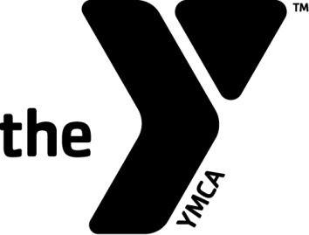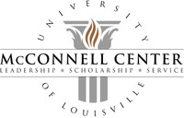
Complete and return form to:
Kentucky YMCA Youth Association
P.O. Box 4285
Frankfort, KY 40604
P 502.227.7028 F 502.227.7030

